1. **INTRODUCTION**
   1. **Overview**

Meta Stream is a Video on Demand Platform that enables people to stream high quality content. Users can choose from wide range of High-Quality Stock videos of different Genres. It also enables the Users to download the content.

We offer Users to

* Search from Wide-range of High-Quality Stock videos.
* Stream any Video at their preferred Resolution.
* Download videos.
* Manage their Activity such as Watch History, Search History and Download History.
* Contribute any Video Suggestions.
  1. **Motivation**

The Search Feature in most of the existing Video on Demand Platforms is not satisfactory. This spoils the overall User Experience. This was the primary motivation for us to develop a Video on Demand Platform with enhanced Search Feature and a better overall User Experience. We also wanted to learn how Video-on-demand Platforms work. So, we wanted to develop a Video-on-demand platform which is Powerful and User-friendly.

* 1. **Problem Definition**

In most of the existing Video-on-demand Platforms, Users are constantly reporting about Inaccurate Search Results and finding it difficult to get their way around. So, this Project is developed with an Efficient Search Algorithm while also being User Friendly.

* 1. **Objectives**
* To improve the search feature on existing VOD's.
* To create a user-friendly interface, to enable users to navigate through the application without any difficulty.
* To give user the ability to like, dislike, download a video.
* To display video statistics like, views, likes, dislikes, downloads, with real-time updating.
* To provide hassle-free direct downloads to user, without redirection to third party sites.
  1. **Scope**

Meta Stream is a Video-on-Demand Platform that enables people to stream High-Quality content. Users can download the content and add Videos to their Watch-list. Users can also choose from wide range of high-quality Stock videos of different Genre.

**Software Requirements Specification**

**for**

**Video-on-Demand Platform (Meta Stream)**

**Version 1.0 approved**

**Prepared by**

**Chitturi Sai Suman – 1602-18-733-097**

**Praneeth Kapila – 1602-18-733-116**

**Vasavi College of Engineering**

**30-09-2020**

1. **Introduction**

**1.1. Purpose**

The purpose of this document is to present a detailed description of the Open-Source Web Application, Video-on-Demand Platform “Meta Stream”. It will explain the purpose and features of the application, the interfaces, what the application will do and the constraints under which it must operate. This document is intended for users of the application and potential developers.

**1.2. Document Conventions**

This Document was created based on the IEEE template for System Requirement Specification Documents.

**1.3. Intended Audience and Reading Suggestions**

* Typical Users, who are looking for some Entertainment.
* Programmers who are interested in working on the project by further developing it or fix existing bugs.

**1.4. Product Scope**

Meta Stream is a Video-on-Demand Platform that enables people to stream High-Quality content. Users can download the content and add Videos to their Watch-list. Users can also choose from wide range of high-quality Stock videos of different Genre.

**1.5. References**

[1]. <https://www.geeksforgeeks.org/web-technology/html-css/>

[2]. <https://www.w3schools.com/>

[3]. <https://www.w3.org/>

**2. Overall Description**

**2.1. Product Perspective**

Meta Stream was developed for anyone who is interested in watching High-Quality Videos. It is an open source project, and it has a very active developer team to support it and provide feedback to users. It offers cross-platform support.

**2.2. Product Functions**

**2.2.1. Admin Functions**

**2.2.1.1. Login**

|  |  |
| --- | --- |
| **Use Case:** | Login |
| **Primary Actor:** | Admin |
| **Goal in Context:** | Managing the Web – Application |
| **Scenario:** | 1. The system prompts the admin for their username and password.  2. The admin enters username and password.  3. The system gets password registered to the username.  4. The system verifies the password and sets the admin’s authorization.  5. The admin is given access to the application to perform their job. |

**2.2.1.2. Management Selection**

|  |  |
| --- | --- |
| **Use Case:** | Management Selection |
| **Primary Actor:** | Admin |
| **Goal in Context:** | Accessing to sub-menu |
| **Scenario:** | 1. Admin selects between stream management and user management. |

**2.2.1.3. Stream Management**

|  |  |
| --- | --- |
| **Use Case:** | Stream Management |
| **Primary Actor:** | Admin |
| **Goal in Context:** | Changing access rights of a stream |
| **Scenario:** | 1. The admin enters stream management interface.  2. The admin selects the stream that he/she wants to manage.  3. The admin changes the access rights of the stream on the menu.  4. New access rights of the stream are set. |

**2.2.1.4. Add Stream**

|  |  |
| --- | --- |
| **Use Case:** | Add Stream |
| **Primary Actor:** | Admin |
| **Goal in Context:** | Adding new stream to Media Server |
| **Scenario:** | 1. Admin clicks Add button in stream Management Window.  2. Window asks for the configuration settings of stream.  3. Admin enters the configuration settings.  4. Admin clicks OK button.  5. Stream is added to Stream List. |

**2.2.1.5. Remove Stream**

|  |  |
| --- | --- |
| **Use Case:** | Remove Stream |
| **Primary Actor:** | Admin |
| **Goal in Context:** | Removing stream from Media Server |
| **Scenario:** | 1. Admin chooses a stream from Stream list.  2. Admin clicks Remove button.  3. Stream is removed from Stream List |

**2.2.1.6. User Management**

|  |  |
| --- | --- |
| **Use Case:** | User Management |
| **Primary Actor:** | Admin |
| **Goal in Context:** | Changing access rights of a user |
| **Scenario:** | 1. The admin enters user management interface.  2. The admin selects the user that he/she wants to manage from the user list.  3. The admin changes the access rights of the user.  4. New access rights of the user are set. |

**2.2.1.7. Add User**

|  |  |
| --- | --- |
| **Use Case:** | Add User |
| **Primary Actor:** | Admin |
| **Goal in Context:** | Adding new user to Relational Database |
| **Scenario:** | 1. Admin clicks Add button in User Management Window.  2. Admin enters the user details.  3. Admin clicks OK button.  4. User is added to database. |

**2.2.1.8. Remove User**

|  |  |
| --- | --- |
| **Use Case:** | Remove User |
| **Primary Actor:** | Admin |
| **Goal in Context** | Removing user from Relational Database |
| **Scenario:** | 1. Admin chooses a user from User list. 2. Admin clicks Remove button.  3. User is removed from User List |

**2.2.1.9. Use-Case Diagrams**

In these diagrams, ‘Add Stream’ and ‘Remove Stream’ use-cases are specific operations of ‘Manage Stream’. Similarly, ‘Add User’ and ‘Remove User’ use-cases are specific operations of ‘Manage User’.

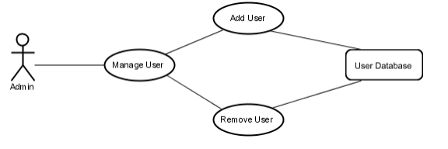

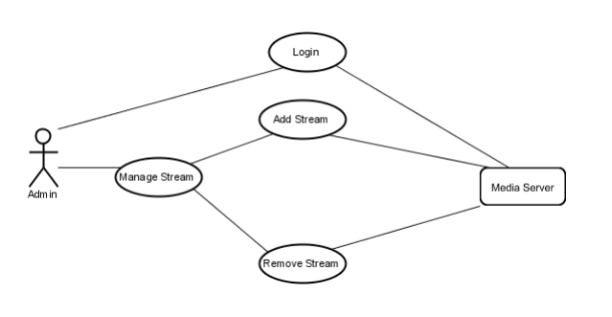

**2.2.2. User Functions**

**2.2.2.1. Log in**

|  |  |
| --- | --- |
| **Use Case:** | Login |
| **Primary Actor:** | User |
| **Goal in Context:** | Accessing to the system |
| **Scenario:** | 1. The application prompts the user for their username and password.  2. The user enters username and password.  3. The application gets password registered to the username  4. The application verifies the password and sets the users authorization.  5. The user is given access to the application to perform their job. |

**2.2.2.2. Stream Selection**

|  |  |
| --- | --- |
| **Use Case:** | Stream selection |
| **Primary Actor:** | User |
| **Goal in Context:** | Selecting a stream to access |
| **Scenario:** | 1. User logs into the application.  2. After login screen, user is provided a list of streams that she/he can use.  3. User selects a stream and data flow starts. |

**2.2.2.3. Media Player Functions**

|  |  |
| --- | --- |
| **Use Case:** | Media player functions |
| **Primary Actor:** | User |
| **Goal in Context:** | Controlling playback |
| **Scenario-1:** | User presses play button to start data flow and play it. |
| **Scenario-2:** | User presses pause button to pause the stream at the current frame. |
| **Scenario-3** | User adjusts volume level from the volume bar. |
| **Scenario-4** | User adjusts Resolution of video dynamically during playback. |

**2.2.2.4. Use-Case Diagrams**

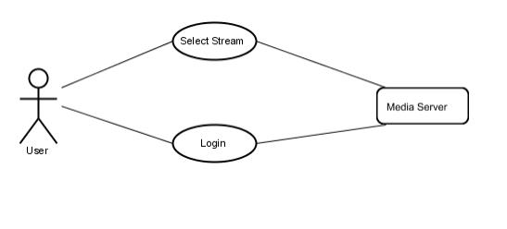

**2.2.3. System Functions**

**2.2.3.1. Load Check**

|  |  |
| --- | --- |
| **Use Case:** | Load Check |
| **Primary Actor:** | System Agent |
| **Goal in Context:** | Checking the load on web servers |
| **Scenario:** | 1. Waits for a pre-determined time interval.  2. Checks the current load on each reverse proxy web server.  3. If a webserver serves more than a predetermined number of clients, an idle web server is activated. |

**2.2.3.2. Add Feed**

|  |  |
| --- | --- |
| **Use Case:** | Add Feed |
| **Primary Actor:** | System Agent |
| **Goal in Context:** | Activating an idle web server |
| **Scenario:** | 1. Agent decides that a new web server is needed. 2. An idle web server is activated, and it starts to stream data to clients. |

**2.2.3.3. Remove Feed**

|  |  |
| --- | --- |
| Use Case: | Remove Feed |
| Primary Actor: | System Agent |
| Goal in Context | Stopping a web server |
| Scenario: | 1. Agent decides that less active web servers are enough.  2. One web server stops streaming and its clients are distributed among other active servers. |

**2.2.3.4. Use-Case Diagrams**

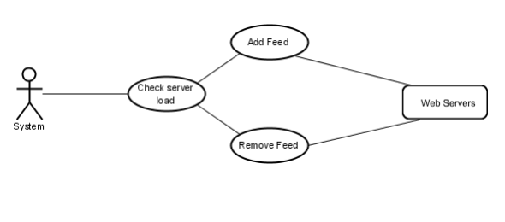

**2.3. User Classes and Characteristics**

* Typical Users, who are looking for some Entertainment.
* Programmers who are interested in working on the project by further developing it or fix existing bugs.

**2.4. Operating Environment**

* Operating System
  1. Windows
  2. Linux
* Application Server
  1. Apache Tomcat v9.0
* Media Server
  1. Google Cloud
* Database
  1. MySQL

**2.5. Design and Implementation Constraints**

The Application uses modular design where every feature is wrapped into a separate module and the modules depend on each other through well-written APIs. There are several APIs available to make plugin development easy.

**2.5.1. Frontend**

The Frontend is implemented using HTML, CSS and Java Script.

**2.5.2. Backend**

**2.5.2.1. Backend Application**

The Backend consists of server-side application designed using Java/Python that serves requests of clients.

**2.5.2.2. Database**

Database used is MySQL. It is used for storing User Information and Content Information.

**2.5.2.3. Server**

Server used is Apache Tomcat v9.0

**2.5.2.4. Storage**

The application uses Google Cloud Storage to store media.

**2.6. User Documentation**

Online help and FAQs are provided in the User Documentation

**2.7. Assumptions and Dependencies**

* Media streams are working fine.
* Streams and server have enough bandwidth.
* System has low latency.
* Video processing and networking libraries are available on the system.

**3. External Interface Requirements**

**3.1.1. Admin Interfaces**

**3.1.1.1. Login Window**

Admins should login to the application before using application management operations. This login window is the first thing the users face when they attempt to access the application. They shall be able to continue using the application upon entering a valid username and password.

**3.1.1.2. Management Selection Window**

Admins see management options which are Stream Management and User Management in this window.

**3.1.1.3. Stream Management Window**

This window lists available Stream feeds of the application. Admins can open dialogues for adding Streams to the application and removing them from the application using buttons on this window.

**3.1.1.4. Add Stream Window**

This window prompts admins to enter configuration options of target stream. After entering correct settings stream will be added to available stream feeds list.

**3.1.1.5. Remove Stream Window**

This window prompts admins to approve removing target stream.

**3.1.1.6. User Management Window**

Admins should be able to list all users with their access levels in this window. There should be options to adjust users’ access levels.

**3.1.1.7. Add User Window**

Admins should be able to add new users in this window.

**3.1.1.8. Remove User Window**

Admins should be able to confirm or cancel user removal operation.

**3.1.2. User Interfaces**

**3.1.2.1. Login Window**

Users should login to the application before listing the available Stream feeds and viewing them.

**3.1.2.2. Stream Selection Window**

Users display the Stream selection window after successful login. They see the list of available Stream feeds that they can view in this window.

**3.1.2.3. Media Player Window**

Users see media player window when they want to view a Stream feed. This window has a media player with play/pause, sound volume buttons.

**3.2. Hardware Interfaces**

* **Streaming in 1080P FHD**

Processor: **2.4Ghz** (dual core) or **3.5Ghz** (single Core) processor.

Graphics: **Nvidia/ATi** having bare minimum **256MB Video RAM** and **core clock 600Mhz.**

* **Streaming in 2160P UHD**

Processor: **2.6Ghz** (dual core) or **4.0Ghz** (single Core) processor.

Graphics: **Nvidia/ATi** having bare minimum 512**MB Video RAM** and **core clock 1.0Ghz.**

**3.3. Software Interfaces**

* + JavaScript must be enabled for browser playback.
  + Popup and Ad-blockers can inhibit playback.
  + Flash: 15 or higher.
  + Browser: Internet Explorer 9.0 or later, Mozilla Firefox 17 or later, Google Chrome 36 or later, Safari 5.0 or later.

**3.4. Communication Interfaces**

[Our Application uses both streaming protocols and HTTP-based protocols](https://www.streamingmedia.com/Articles/ReadArticle.aspx?ArticleID=84496). Streaming protocols like [Real-Time Messaging Protocol (RTMP)](https://www.wowza.com/blog/rtmp-streaming-real-time-messaging-protocol) enable speedy video delivery using dedicated streaming servers, whereas HTTP-based protocols rely on regular web servers to optimize the viewing experience and quickly scale.

**4. System Features**

This section demonstrates Meta Stream’s most prominent features and explains how they can be used.

**4.1. Personalized Recommendations**

Based on previously watched videos, videos of the similar Genre are recommended to the users.

**4.2. Enhance Search Results**

Users can filter search results based on several attributes such as Most Popular, Upload date, Rating etc.

**4.3. User Reviews**

Users can rate and review the videos they watch. These reviews are publicly visible.

**4.4. Downloadable Content**

Videos can be downloaded to the User’s Local Machine in their preferred Resolution.

**5. Other Nonfunctional Requirements**

**5.1. Performance Requirements**

The Application requires a system with at least a 2400 MHz CPU and 256 MB of VRAM and core clock of 600Mhz. Performance depends on the quality of Video and as a result, the system requirements for videos with higher quality are more demanding.

**5.2. Safety Requirements**

To ensure that no one of Meta Stream’s users loses any data while using it (due to a crash or a bug of some kind) the developer team updates the Application regularly. There is a bug tracker available where users can report any bugs, they have encountered so that the developers can fix it in the next release.

**5.3. Security Requirements**

Meta Stream does not have any security requirements and thus any type of user can use it without any additional privileges.

**5.4. Software Quality Attributes**

Due to its well designed and easy to use interface it can be used by anyone without much skill. However, users must already have a basic knowledge of using a Web Browser.

**5.5. Business Rules**

Sensitive information such as Name and Email will be private and will not be shared to 3rd party advertising companies. The Application is designed in such a way that the User Activity is not accessible by anyone (including the admin).

**6. Other Requirements**

In order to get Seamless Streaming Experience, users require high-speed internet with a speed of 20 Mbps. As the videos are of high quality, they occupy significant storage space. So, before downloading them, users shall make sure there is enough local storage space.

**Appendix A: Glossary**

* HTTP: Hypertext Transfer Protocol
* GHz: Giga Hertz
* MHz: Mega Hertz
* FHD: Full High-Definition
* UHD: Ultra High-Definition
* MB: Mega Byte
* Mbps: Mega bit per second
* RAM: Random access memory
* VRAM: Video RAM

**Appendix B: Analysis Models**

* + **Data Flow Diagram**

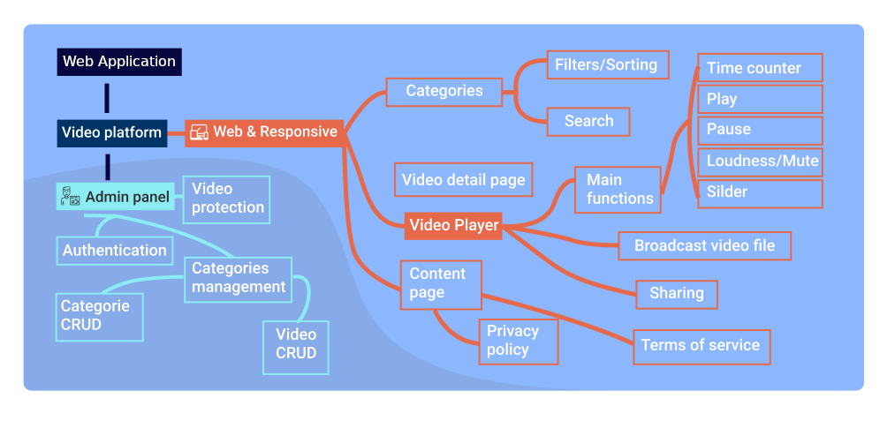

**Appendix C: To Be Determined List**

1. We intend to add “Continue Watching” feature if possible.
2. We are looking to collaborate with Content Creators for paid content.
3. We are looking for adding Payment Integration to the Application.

**3. Activities**

The following list specifies User Activities while using our Application.

* User Registration: In order to use our Application, user must have an Account.
* User Login: To continue using the application, user mush Log In.
* User Log out: User can log out of the application anytime.
* Watch a Video: User can select and watch any video from wide range of Stock Videos.
* Search a Video: User can Search any Video of his/her choice using the Search feature provided in the Application.
* Like or Dislike a Video: User can wish to Like or Dislike a Video.
* Download a Video: If User wants to save Videos Offline, he/she can download using the Download Feature.
* Manage Credentials: User can alter his/her Login Credentials anytime.
* Manage Activity: User can View or delete his/her Account Activity such as Watch History, Search History and Download History.
* Contribute: User can contribute Video Ideas or Suggestions and the Admin team will try to upload the Video at the earliest.

**4. Implementation**

**4.1. Project Hierarchy**

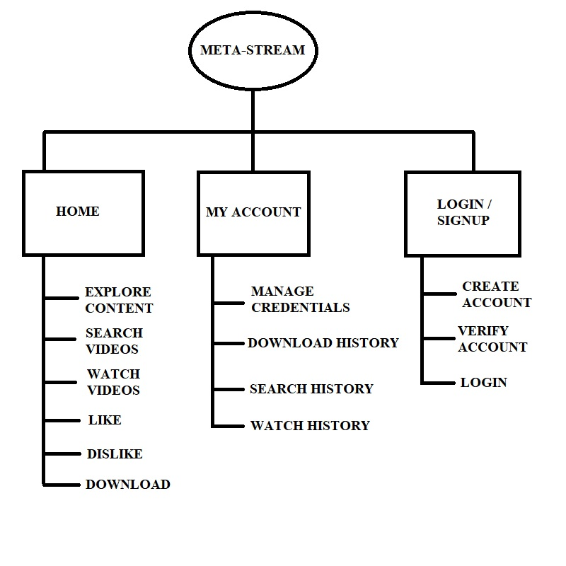

The above chart depicts the Project Hierarchy of Meta Stream. The same is the Hierarchy implemented at root folder from which the Server serves the files. These nodes consist of several other files such as HTML scripts, CSS stylesheets, JavaScript Files, PHP scripts etc., which constitute the Skeleton of Project.

By default, the server serves files from the node “Meta-Stream/home/”. Navigation to other nodes is provided in the UI. For the website to be compatible to all major browsers, the Navigation is set to Relative.

**4.2. The Google Drive API**

The entire Video Content was uploaded to Google Drive, which offers 15 Gigabytes of free storage space, without altering the Quality of Content. Google Drive API was setup to retrieve the File Data using Node JS scripts. These Scripts are Generic but require two Important Credentials, namely the Drive API Key and the Client ID.

The files uploaded to the Cloud Storage follow certain Constraints, such as the Camel-case naming Convention and each Video file has its own Thumbnail which is also uploaded along with it. The following details of files should be retrieved for the application to work.

* **File ID:** File ID is the unique identity given to each file present in Cloud Storage. It is a String of Length 33. It can be used to retrieve several other attributes using backend Scripts. File ID is globally unique, which means, anyone with Necessary Permissions can access the file provided the File ID, without a Google Account.
* **File Name:** Each File in Drive has a file name associated with it. These are also retrieved so that they can be used in the Application while displaying the details of a Video.
* **Web View Link:** A link for opening the file in a relevant Google editor or viewer in a browser. It is the same link that is used in the Video Playback page which enables dynamic Video Playback supporting regular activities such as Play, Pause, Adjust Resolution etc.
* **Download Link:** It is an explicitly defined URL, which is obtained from the file ID and additional URL Header and Footer. For instance, the download URL of a file can be created using the File ID and the API Key, in the following way:

Download Link = Header + file id + Footer + API Key. Where

Header = ‘<https://www.googleapis.com/drive/v3/files/>’

Footer = ‘<?alt=media&key=>’

The API Script is used only once, to create entries in database table from the information fetched. The following is the code typically one can use to accomplish it.

**4.2.1. Google Drive API using Node JS – Source code**

const fs = require('fs');

const readline = require('readline');

const {google} = require('googleapis');

var mysql = require('mysql');

var con = mysql.createConnection({

  host: "localhost",

  user: "root",

  password: "",

  database: "videodatabase"

});

con.connect(function(err) {

  if (err) throw err;

  console.log("Connected!");

});

// If modifying these scopes, delete token.json.

const SCOPES = ['https://www.googleapis.com/auth/drive',

'https://www.googleapis.com/auth/drive.appdata',

'https://www.googleapis.com/auth/drive.file',

'https://www.googleapis.com/auth/drive.metadata',

'https://www.googleapis.com/auth/drive.metadata.readonly',

'https://www.googleapis.com/auth/drive.photos.readonly',

'https://www.googleapis.com/auth/drive.readonly',];

// The file token.json stores the user's access and refresh tokens, and is

// created automatically when the authorization flow completes for the first

// time.

const TOKEN_PATH = 'token.json';

// Load client secrets from a local file.

fs.readFile('credentials.json', (err, content) => {

    if (err) return console.log('Error loading client secret file:', err);

    // Authorize a client with credentials, then call the Google Drive API.

    authorize(JSON.parse(content), listFiles);

});

/**

 * Create an OAuth2 client with the given credentials, and then execute the

 * given callback function.

 * @param {Object} credentials The authorization client credentials.

 * @param {function} callback The callback to call with the authorized client.

 */

function authorize(credentials, callback) {

    const {client_secret, client_id, redirect_uris} = credentials.installed;

    const oAuth2Client = new google.auth.OAuth2(

    client_id, client_secret, redirect_uris[0]);

// Check if we have previously stored a token.

    fs.readFile(TOKEN_PATH, (err, token) => {

        if (err) return getAccessToken(oAuth2Client, callback);

        oAuth2Client.setCredentials(JSON.parse(token));

        callback(oAuth2Client);

    });

}

/**

 * Get and store new token after prompting for user authorization, and then

 * execute the given callback with the authorized OAuth2 client.

 * @param {google.auth.OAuth2} oAuth2Client The OAuth2 client to get token for.

 * @param {getEventsCallback} callback The callback for the authorized client.

 */

function getAccessToken(oAuth2Client, callback) {

    const authUrl = oAuth2Client.generateAuthUrl({

    access_type: 'offline',

    scope: SCOPES,

});

console.log('Authorize this app by visiting this url:', authUrl);

const rl = readline.createInterface({

    input: process.stdin,

    output: process.stdout,

});

rl.question('Enter the code from that page here: ', (code) => {

    rl.close();

    oAuth2Client.getToken(code, (err, token) => {

    if (err) return console.error('Error retrieving access token', err);

    oAuth2Client.setCredentials(token);

    // Store the token to disk for later program executions

    fs.writeFile(TOKEN_PATH, JSON.stringify(token), (err) => {

        if (err) return console.error(err);

        console.log('Token stored to', TOKEN_PATH);

    });

    callback(oAuth2Client);

    });

});

}

/**

 * Lists the names and IDs of up to 10 files.

 * @param {google.auth.OAuth2} auth An authorized OAuth2 client.

 */

function listFiles(auth) {

    const drive = google.drive({version: 'v3', auth});

    drive.files.list({

        pageSize: 1000,

        fields: 'nextPageToken, files(id, name, hasThumbnail, webViewLink, iconLink, videoMediaMetadata)',

        orderBy: 'name',

    }, (err, res) => {

        if (err) return console.log('The API returned an error: ' + err);

        const files = res.data.files;

        if (files.length) {

        var source = "https://drive.google.com/uc?export=view&id=";

        var videoPrefix = "https://drive.google.com/file/d/";

        var videoSuffix = "/preview";

        var fileName = "";

        var fileid = "";

        var ind = 0;

        var count = 0;

        var thumb = "";

        var views = 0;

        var downloads = 0;

        var likes = 0;

        var dislikes = 0;

        var videofileid = "";

        var API_key = "<YOUR_API_KEY>";

        var header = "https://www.googleapis.com/drive/v3/files/";

        var footer = "?alt=media&key=";

        var sql = "TRUNCATE TABLE video;";

        con.query(sql,function(err,result){

            if(err) throw err;

            console.log("Truncated");

        });

        files.map((file) => {

            var nameOfFile = file.name;

            if(nameOfFile.includes(".mp4")) {

                fileName = file.name;

                fileid = videoPrefix +  file.id + videoSuffix;

                videofileid = file.id;

            }

            else if(nameOfFile.includes("_thumb.png")) {

                thumb = source + file.id;

                var dlink = header + videofileid + footer + API_key;

                var sql = "INSERT INTO video (filename, fileid, thumbnail, downloadlink, views, downloads, likes, dislikes) VALUES ?";

                var values = [[fileName, fileid, thumb, dlink, views, downloads, likes, dislikes]];

                con.query(sql, [values], function (err, result) {

                    if (err) throw err;

                    count++;

                });

            }

        });

    }

        else {

            console.log('No files found.');

        }

    });

}

**4.3 CREATING TABLES OF CATEGORIES AND KEYWORDS IN VIDEO DATABASE.**

In our application, each Video has additional attributes namely Category and Keywords. These attributes are entered into the Server database by Admin using Node JS scripts.

**4.3.1. Node JS script for inserting into Categories table.**

var Nature = [2,3,14,33,47,48,49,58,68,91,93];

var Animal = [6,11,12,19,20,21,22,37,38,39,42,43,44,53,54,59,72,73,74,81,83,84,85,96,97];

var Technology = [23,25,29,35,62,64,65,66,71,77,90,95];

var Architecture = [1,4,9,13,15,16,17,26,27,55,75,89,100];

var landscape = [7,8,30,34,46,57,67,70,78,79,80,86,94];

var Others = [5, 10, 18, 24, 28, 31, 32, 36, 40, 41, 45, 50, 51, 52, 56, 60, 61, 63, 69, 76, 82, 87, 88, 92, 98, 99];

// Above is entered Manually by Admin.

var mysql = require('mysql');

var con = mysql.createConnection({

  host: "localhost",

  user: "root",

  password: "",

  database: "videodatabase"

});

con.connect(function(err) {

  if (err) throw err;

  console.log("Connected!");

});

var sql = "TRUNCATE TABLE category;";

con.query(sql,function(err,result) {

    if(err) throw err;

    console.log("Truncated");

})

var id = 1;

for(var i = 0; i< Nature.length;i++) {

    var sql = "INSERT INTO category (id, videoid, category) VALUES ?";

    var values = [[id,Nature[i],"nature"]];

    con.query(sql, [values], function (err, result) {

        if (err) throw err;

    });

    id++;

}

for(var i=0;i<Architecture.length;i++) {

    var sql = "INSERT INTO category (id, videoid, category) VALUES ?";

    var values = [[id,Architecture[i],"architecture"]];

    con.query(sql, [values], function (err, result) {

        if (err) throw err;

    });

    id++;

}

for(var i =0; i<Animal.length;i++) {

    var sql = "INSERT INTO category (id, videoid, category) VALUES ?";

    var values = [[id,Animal[i],"animal"]];

    con.query(sql, [values], function (err, result) {

        if (err) throw err;

    });

    id++;

}

for(var i =0 ;i<Technology.length;i++) {

    var sql = "INSERT INTO category (id, videoid, category) VALUES ?";

    var values = [[id,Technology[i],"technology"]];

    con.query(sql, [values], function (err, result) {

        if (err) throw err;

    });

    id++;

}

for(var i =0;i<landscape.length;i++) {

    var sql = "INSERT INTO category (id, videoid, category) VALUES ?";

    var values = [[id,landscape[i],"landscape"]];

    con.query(sql, [values], function (err, result) {

        if (err) throw err;

    });

    id++;

}

for(var i =0;i<Others.length;i++) {

    var sql = "INSERT INTO category (id, videoid, category) VALUES ?";

    var values = [[id,Others[i],"others"]];

    con.query(sql, [values], function (err, result) {

        if (err) throw err;

    });

    id++;

}

**4.3.2. Node JS script for inserting into Keywords table.**

var mysql = require('mysql');

var con = mysql.createConnection({

  host: "localhost",

  user: "root",

  password: "",

  database: "videodatabase"

});

con.connect(function(err) {

  if (err) throw err;

  console.log("Connected!");

});

var arr = [['aerial','city','drone','building','buildings','top','view','urban'],

['aerial','crops','crop','fields','agriculture'],

['aerial','crops','crop','fields','agriculture'],

['aerial','city','drone','building','buildings','top','view','urban'],

['aeroplane','airplane','landing','airport','runway'],

['animal','fauna','meerkat','wildlife','life','wild','animals'],

['sea','beach','sand','aerial','water','ocean'],

['sea','beach','sand','aerial','water','ocean','coconut','tree'],

['animation','animated','bigben','ben','big','moon','time','lapse'],

['street','bike','ride','motor','cycle'],

['bird','birds','eating','nuts','animal','animals'],

['bird','sparrow','stream','puddle','drink','birds','animal','animals'],

['architecture','bridge','water','landscape'],

['flower','bud','leaf','blossom','time','lapse','flowers'],

['buddha','golden','gold','idol','god','buddhism'],

['buddha','golden','gold','idol','god','buddhism','sleeping','aerial','view'],

['buddha','golden','gold','idol','god','buddhism','sleeping','mountain'],

['ammunition','ammo','bullets','gun','pistol','guns','bullet'],

['animal','cat','cats','animals'],

['animal','cat','cats','tree','curios','animals'],

['animal','cat','cats','animals'],

['animal','cat','cats','animals'],

['code','monitor','javascript','java','html','coding','programming'],

['coffee','cup','pour','pouring','cups'],

['coffee','cup','pour','pouring','machine','vending','cups'],

['construction','machine','labour','crane'],

['construction','labour','machine','aerial','top','view'],

['cosmos','plasma','graphics','visual','effect','effects','graphic'],

['stopwatch','watch','ten','seconds','digital','time','second'],

['beach','couple','coconut','tree','trees','sea','water','walk'],

['cruise','ship','military','water'],

['boy','cycling','road','street','city'],

['dandelion','blossom','flower','bud','time','lapse','flowers'],

['desert','landscape','sand','earth'],

['digital','technology','draw','drawing','sketching','apple'],

['stunt','dirt','bike','aerial','view','drone'],

['dog','play','catch','ball','river','fun','animal','dogs','animals'],

['dog','play','animal','ball','dogs','animals'],

['dog','slow','motion','dogs'],

['earth','space','sun','india','planet','solar','system','celestial'],

['coffee','filter','pour'],

['aquarium','fish','fishes','water','animal','animals'],

['fish','aquatic','life','fishes','water','animals','animal'],

['fishes','ocean','sea','water','fish','under','animal','animals'],

['aerial','water','fly','view','river','lake'],

['fog','foggy','island','nature'],

['forest','wood','nature','tree','trees','woods'],

['couple','cycle','cycling','friend'],

['couple','cycle','cycling','friend'],

['glacier','train','express','aerial','view','transport'],

['gym','workout','work','exercise','exercize','trainer','weight','dumbbell'],

['time','hour','glass','hourglass','sand','bliss','stopwatch','watch'],

['humming','bird','fauna','fly','animal','animals'],

['humming','bird','slow','motion','slowmotion','flower','nectar','animal','animals'],

['intersection','aerial','view','road','city','buildings','urban'],

['race','kartracers','racers','racer','kart','track','racing'],

['lake','water','float'],

['leaves','wind'],

['fishes','lionfish','lion','aquarium','water','aqua','fish','animal','animals'],

['pistol','gun','load','bullets','bullet','arms','ammunition','ammo','guns'],

['london','tourism','bridge','tour','world','visit'],

['macro','gears','technology','clock','watch'],

['paper','draw','drawing','color','sketch','portrait'],

['matrix','animation','digital','green','text','code'],

['meeting','meetings','office','work','laptop','discussion','discuss','discussing'],

['mother','board','circuit','capacitor','chip','technology','chips','circuits'],

['mountains','clouds','nature','fog','hills','mountain'],

['wood','woods','forest','tour','walk','forests','trees','tree'],

['painting','brush','color','portrait','canvas'],

['peninsula','nature','sunset','sun','landscape','landscapes'],

['photo','studio','camera','capture','snap','photoshoot','shoot'],

['play','playing','dog','woman','happy','funny','animal','dogs','animals'],

['puppy','dog','beach','play','animal','dogs','animals'],

['mirror','puppy','dog','play','playing','funny','dogs','animal','animals'],

['pyramids','pyramid','eqypt','landscape','landscapes'],

['cam','camera','dashcam','rear','footage','car','travel','city'],

['technology','research','chemicals','experiment','conical','flask'],

['landscape','canyon','river','landscapes'],

['landscape','river','cliff','hill','mountain','waterfall','waterfalls','landscapes'],

['sea','waves','water','ocean'],

['seal','beach','animal','aquatic','marine','wildlife','animals'],

['pencil','sketch','draw','canvas','sketching','drawing','painting'],

['snail','small','tiny','slow','life','animals','animal'],

['snail','small','tiny','slow','animals','life','animal'],

['snake','animal','bush','snakes','plant','animals','animal'],

['landscape','mountain','snow','ice','glacier','landscapes'],

['space','shuttle','technology','science','rocket','launch','research','apollo','spacecraft','mission'],

['sea','surf','surfers','waves'],

['temple','devotion','devotional','sacred','temples'],

['timer','minute','one','seconds','second','sixty','60','digital','stopwatch','1'],

['tornado','nature','wind','calamity','calamities','disaster','natural'],

['city','traffic','light','road','night','roads'],

['car','vintage','forest','woods','journey','forests','trees','trip','tour'],

['waterfalls','water','fall','mountain','nature','landscape'],

['digital','welcome','hologram','graphics','technology','visual','effects'],

['white','tiger','whitetiger','animal','animals'],

['woman','carry','dog','animal','animals'],

['painting','paint','canvas','drawing','draw','art'],

['labour','machine','work','cutting','saw','cut','machines'],

['aerial','building','working','site','construction','view']

];

var sql = "TRUNCATE TABLE keywords;";

con.query(sql,function(err,result){

  if(err) throw err;

  console.log("Truncated");

  console.log("Now Inserting");

})

var id = 1;

for(var i=0;i<100;i++) {

    for(var j=0;j<arr[i].length;j++,id++) {

        var sql = "INSERT INTO keywords (id, videoid, keyword) VALUES ?";

        var values = [[id,i+1,arr[i][j]]];

        con.query(sql, [values], function (err, result) {

            if (err) throw err;

        });

    }

}

**4.4. THE USER DATABASE**

**4.4.1. THE ‘USERS’ TABLE**

**4.4.1.1. TABLE SCHEMA**

|  |  |  |  |
| --- | --- | --- | --- |
| **ID** | **FULLNAME** | **EMAIL** | **PASSWORD** |
| 1 | JOHN | [john321@gmail.com](mailto:john321@gmail.com) | $2y$10$WCOtyp4uIkTYk |
| 2 | JOSEPH | [joseph123@gmail.com](mailto:joseph123@gmail.com) | $2y$10$0l8hpbwyW9Xmi |

The USERS table consists of four Columns

**ID**: Unsigned Integer, Auto Increment, Primary Key, Not Null

**FULLNAME**: varchar(64), Not Null

**EMAIL**: varchar(64), Not Null

**PASSWORD**: varchar(300), Not Null, Hashed using PHP Hash.

An entry is automatically created in the USERS table once a User creates an Account. The Password is hashed using One-way hashing function provided in PHP. Thus, making it impossible for Admin to view any User’s password.

**4.4.2. USER ACTIVITY TABLES**

Along with an entry in Users table, the application creates four more tables Exclusively for the user. These tables are private to specific user that store every activity of user. The four tables created are:

**4.4.2.1. WATCH HISTORY**

|  |  |  |
| --- | --- | --- |
| **ID** | **VIDEOID** | **TS** |
| 1 | 15 | 2020-12-11 21:20:48 |
| 2 | 78 | 2020-12-16 21:27:41 |

The WATCH HISTORY table consists of three Columns.

**ID**: Unsigned Integer(6), Auto Increment, Primary Key, Not Null

**VIDEOID**: Integer(6)

**TS**: Timestamp, Not Null, default: current_timestamp()

An entry is automatically created in the WATCH HISTORY table once a User watches a video. The Video ID and time at which the user watched the video will be retrieved and inserted into the table.

**4.4.2.2. SEARCH HISTORY**

|  |  |  |
| --- | --- | --- |
| **ID** | **SEARCH QUERY** | **TS** |
| 1 | cats | 2020-12-13 19:22:46 |
| 2 | water falls | 2020-12-13 19:23:31 |

The SEARCH HISTORY table consists of three Columns.

**ID**: Unsigned Integer(6), Auto Increment, Primary Key, Not Null

**SEARCH QUERY**: varchar(200)

**TS**: Timestamp, Not Null, default: current_timestamp()

An entry is automatically created in the SEARCH HISTORY table once a User searches for a video. The search query and time at which the user searched will be retrieved and inserted into the table.

**4.4.2.3. DOWNLOAD HISTORY**

|  |  |  |
| --- | --- | --- |
| **ID** | **VIDEOID** | **TS** |
| 1 | 15 | 2020-12-11 21:20:48 |
| 2 | 78 | 2020-12-16 21:27:41 |

The DOWNLOAD HISTORY table consists of three Columns.

**ID**: Unsigned Integer(6), Auto Increment, Primary Key, Not Null

**VIDEOID**: Integer(6)

**TS**: Timestamp, Not Null, default: current_timestamp()

An entry is automatically created in the DOWNLOAD HISTORY table once a User downloads a video. The Video ID and time at which the user downloaded the video will be retrieved and inserted into the table.

**4.4.2.4. LIKE HISTORY**

|  |  |  |
| --- | --- | --- |
| **ID** | **VIDEOID** | **STATUS** |
| 1 | 15 | DISLIKED |
| 2 | 78 | LIKED |
| 3 | 17 | NONE |

The DOWNLOAD HISTORY table consists of three Columns.

**ID**: Unsigned Integer(6), Auto Increment, Primary Key, Not Null

**VIDEOID**: Integer(6)

**STATUS:** varchar(20) (LIKED or DISLIKED or NONE)

Whenever a user clicks a like or a dislike button, the application checks if there are any existing entries in the table corresponding to the video. If present, then the status will be updated Correspondingly. Otherwise, an Entry is created in the Like History table.

**4.5. USER REGISTRATION**

User registration consists of two steps. In step 1, the user enters his/her personal information like Name, Email Address and Password. These are validated accordingly so that the credentials are secure. In step 2, a 6 Digit verification code will be sent to User’s Email. User will have to enter the 6 Digit Code to verify his/her Email address. On successful verification, the user account is created and the four exclusive tables will be created instantly.

**4.6. USER LOGIN**

User has to Login in order to use the application. User has to enter his/her credentials and these are verified from the details provided during the registration. Upon successful verification users can login and continue using the application.

If the user forgets his/her password, we allow them to reset their password by sending verification code to their corresponding Email Address.

**4.7. THE SEARCH FEATURE**

The Search Feature is the best part of our Application. The Search works extremely fast and gives accurate results.

**4.7.1. THE SEARCH ALGORITHM**

The algorithm splits the Query String into individual words. Then the algorithm searches each of them in the Keywords database and returns the closest matches. This algorithm ensures that there are no duplicates in the search results. The keywords in the beginning of search query are given more preference than the later ones and hence appear in the beginning of the results.

**4.8. VIDEO PLAYBACK**

Video Playback offers user control such as

a). Dynamically Adjust Resolution

b). Draggable Seek Bar

c). Pause/Play video

d). Adjust Volume

e). Dynamically adjust Playback speed.

f). Toggle Full Screen view and Default view.

g). Watch in Mini Player.

**4.9. MANAGE ACCOUNT**

With this feature, we offer user to manage his/her Activity and Credentials. The user can view and delete his/her Activity. We offer the user to manage the following.

**4.9.1. CREDENTIALS**

The user can edit his/her credentials such as Name, Email Address and Password. Upon user’s request, the database gets updated with new Credentials upon successful validation.

**4.9.2. WATCH HISTORY**

Watch history previews the User activity, specifically, the list of Watched Videos with the timestamps. Users can view/delete specific items in the watch history. The deleted items will be removed from the database.

**4.9.3. SEARCH HISTORY**

Searchhistory previews the User activity, specifically, the list of Searched Queries with the timestamps. Users can view/delete specific items in the search history. The deleted items will be removed from the database.

**4.9.4. DOWNLOAD HISTORY**

Download history previews the User activity, specifically, the list of Downloaded Videos with the timestamps. Users can view/delete specific items in the Download history. The deleted items will be removed from the database.

**5. Code**

**5.1. Index.php**

This page features Carousels with thumbnails of videos belonging to different categories, Navigation bar with references to Login/Logout and My Account, Footer with references to Social media pages, Contribute page and About developers.

<?php

    session_start();

    $host="localhost";

    $dbUsername="root";

    $dbPassword="";

    $index = 0;

    $dbname="videodatabase";

    $thumbnail = array();

    $videolink = array();

    $keywords = array();

    $nature = array();

    $architecture = array();

    $animal = array();

    $others = array();

    $technology = array();

    $landscape = array();

    $conn=new mysqli($host,$dbUsername,$dbPassword,$dbname);

    if(mysqli_connect_error()) {

        echo "Connection Error";

        die('Connect Error('.mysqli_connect_errno().')'.mysqli_connect_error());

    }

    else {

        $sql = "select * from category";

        $result = $conn->query($sql);

        if (mysqli_num_rows($result) > 0) {

            while($row = mysqli_fetch_assoc($result)) {

                if($row["category"]=="animal") {

                    array_push($animal,$row["videoid"]);

                }

                if($row["category"]=="nature") {

                    array_push($nature,$row["videoid"]);

                }

                if($row["category"]=="architecture") {

                    array_push($architecture,$row["videoid"]);

                }

                if($row["category"]=="technology") {

                    array_push($technology,$row["videoid"]);

                }

                if($row["category"]=="landscape") {

                    array_push($landscape,$row["videoid"]);

                }

                if($row["category"]=="others") {

                    array_push($others,$row["videoid"]);

                }

            }

        }

        $id = 1;

        $sql = "select * from video";

        $result = $conn->query($sql);

        $limit = mysqli_num_rows($result);

        while($id<=$limit) {

            $sql = "select thumbnail from video where id = ".$id;

            $result = $conn->query($sql);

            if (mysqli_num_rows($result) > 0) {

                while($row = mysqli_fetch_assoc($result)) {

                    array_push($thumbnail,$row["thumbnail"]);

                }

            } else {

                echo "0 results";

            }

            $sql = "select fileid from video where id = ".$id;

            $result = $conn->query($sql);

            if (mysqli_num_rows($result) > 0) {

                while($row = mysqli_fetch_assoc($result)) {

                    array_push($videolink,$row["fileid"]);

                }

            }

            else {

                echo "0 results";

            }

            $id++;

        }

        $id = 1;

        $ind = 0;

        $sql = "select * from keywords";

        $result = $conn->query($sql);

        $limit = mysqli_num_rows($result);

        while($id<=$limit) {

            $sql = "select * from keywords where id = ".$id;

            $result = $conn->query($sql);

            if (mysqli_num_rows($result) > 0) {

                while($row = mysqli_fetch_assoc($result)) {

                    array_push($keywords,array($row["videoid"],$row["keyword"]));

                }

            }

            $id++;

        }

        $conn->close();

    }

?>

<!DOCTYPE html>

<html lang="en">

<head>

    <meta charset="UTF-8">

    <meta name="viewport" content="width=device-width, initial-scale=1.0">

    <link rel="apple-touch-icon" sizes="180x180" href="apple-touch-icon.png">

    <link rel="icon" type="image/png" sizes="32x32" href="favicon-32x32.png">

    <link rel="icon" type="image/png" sizes="16x16" href="favicon-16x16.png">

    <link rel="manifest" href="site.webmanifest">

    <link rel="mask-icon" href="safari-pinned-tab.svg" color="#de2222">

    <meta name="msapplication-TileColor" content="#603cba">

    <meta name="theme-color" content="#ffffff">

    <link rel="stylesheet" href="https://stackpath.bootstrapcdn.com/font-awesome/4.7.0/css/font-awesome.min.css">

    <link rel="stylesheet" href="https://cdnjs.cloudflare.com/ajax/libs/bootstrap-social/5.1.1/bootstrap-social.min.css">

    <script src="https://code.jquery.com/jquery-3.5.1.slim.min.js"></script>

    <script src="https://cdn.jsdelivr.net/npm/popper.js@1.16.0/dist/umd/popper.min.js"></script>

    <script src="https://stackpath.bootstrapcdn.com/bootstrap/4.5.0/js/bootstrap.min.js"></script>

    <link rel="stylesheet" href="https://cdnjs.cloudflare.com/ajax/libs/slick-carousel/1.8.1/slick.min.css">

    <link rel="stylesheet" href="https://cdnjs.cloudflare.com/ajax/libs/slick-carousel/1.8.1/slick-theme.min.css">

    <link rel="stylesheet" href="https://stackpath.bootstrapcdn.com/bootstrap/4.5.2/css/bootstrap.min.css">

    <link rel="stylesheet" href="style.css">

    <title>Meta Stream</title>

</head>

<body>

    <div id="showcaseTop" class="showcase-top" oncontextmenu="return false" >

        <a oncontextmenu="return false" href="index.php"><img src="Logo.png" alt="Meta Stream"></a>

        <div id="search">

            <form>

                <input type="text" id="search-input" name="search" autocomplete="off">

                <a href="#" onclick="fetch_keywords()" ><i class="fa fa-search fa-xs" id="search-icon"></i></a>

            </form>

        </div>

        <button id="userlogin" oncontextmenu="return false" onclick="hideShowcase()" data-toggle="modal" data-target="#loginModel" alt="Sign In">Sign In</button>

        <button id="userlogout" oncontextmenu="return false" onclick="signOut()" alt="Sign Out">Sign Out</button>

        <a id="myaccount" href="../myaccount/dashboard.php"><img id="avatar" src="avatar.png" alt=""></a>

    </div>

    <div id="loginModel" class="modal fade" role="dialog">

        <div class="modal-dialog modal-lg" role="content">

            <div class="modal-content" style="background-color: black;" >

                <div class="login-box">

                    <h1>Sign In </h1>

                    <form action="../signup/userlogin.php" method="POST">

                        <p>Email</p>

                        <input type="text" name="email" placeholder="Enter Email" required>

                        <p>Password</p>

                        <input type="password" name="password" placeholder="Enter Password" required>

                        <input type="submit" name="submit" value="Sign In">

                        <div id="invalid"></div>

                        <a href="passwordreset.html">Forgot Password?</a><br>

                        <a href="../signup/signup.php">Don't have an Account? Sign Up</a>

                    </form>

                </div>

            </div>

        </div>

    </div>

    <div id="showcaseContent"class="showcase-content" oncontextmenu="return false" >

        <h1>

            Stream High Quality Content

        </h1>

        <p>

            Hassle free Downloads. Cross-platform support

        </p>

        <a id="createAccount" onclick="showCarousel()" href="../signup/signup.php" class="btn btn-xl">Get Started ></a>

    </div>

    <div id="freespace" class="free-space"></div>

    <div id="explore"></div>

    <div id="container1" class="container">

        <h1>Nature</h1>

        <div class="logo-slider">

            <?php

                for($index = 0;$index< sizeof($nature);$index++) {

                    echo "<div class=\"item\"><a href=\"videoplayback.php?".$nature[$index]."\"><img src=\"".$thumbnail[$nature[$index]-1]."\" alt=\"\"></a></div>\n\t\t\t";

                }

            ?>

        </div>

    </div>

    <div id="container2" class="container">

        <h1>Animal</h1>

        <div class="logo-slider">

            <?php

                for($index = 0;$index< sizeof($animal);$index++) {

                    echo "<div class=\"item\"><a href=\"videoplayback.php?".$animal[$index]."\"><img src=\"".$thumbnail[$animal[$index]-1]."\" alt=\"\"></a></div>\n\t\t\t";

                }

            ?>

        </div>

    </div>

    <div id="container3" class="container">

        <h1>Architecture</h1>

        <div class="logo-slider">

            <?php

                for($index = 0;$index < sizeof($architecture);$index++) {

                    echo "<div class=\"item\"><a href=\"videoplayback.php?".$architecture[$index]."\"><img src=\"".$thumbnail[$architecture[$index]-1]."\" alt=\"\"></a></div>\n\t\t\t";

                }

            ?>

        </div>

    </div>

    <div id="container4" class="container">

        <h1>Landscapes</h1>

        <div class="logo-slider">

            <?php

                for($index = 0;$index < sizeof($landscape);$index++) {

                    echo "<div class=\"item\"><a href=\"videoplayback.php?".$landscape[$index]."\"><img src=\"".$thumbnail[$landscape[$index]-1]."\" alt=\"\"></a></div>\n\t\t\t";

                }

            ?>

        </div>

    </div>

    <div id="container5" class="container">

        <h1>Technology</h1>

        <div class="logo-slider">

            <?php

                for($index = 0;$index < sizeof($technology);$index++) {

                    echo "<div class=\"item\"><a href=\"videoplayback.php?".$technology[$index]."\"><img src=\"".$thumbnail[$technology[$index]-1]."\" alt=\"\"></a></div>\n\t\t\t";

                }

            ?>

        </div>

    </div>

    <div id="container6" class="container">

        <h1>Other Stock Videos</h1>

        <div class="logo-slider">

            <?php

                for($index = 0;$index < sizeof($others);$index++) {

                    echo "<div class=\"item\"><a href=\"videoplayback.php?".$others[$index]."\"><img src=\"".$thumbnail[$others[$index]-1]."\" alt=\"\"></a></div>\n\t\t\t";

                }

            ?>

        </div>

    </div>

    <footer id="footer">

        <div id="connect">

            <p>Connect with us</p>

            <a href="https://www.facebook.com/metastreamadmin/" target="_blank"><img id="facebook" src="fb.png" alt=""></a>

            <button id="contribute"><i class="fa fa-handshake-o fa-lg" aria-hidden="true"></i><a target="_blank" href="https://forms.gle/bhFKAbc1AEkBtntB6"> Contribute</a></button>

            <p id="rights">@Meta-Stream, All Rights Reserved</p>

        </div>

        <div id="aboutDevelopers">

            <h3>

                About Developers

            </h3>

            <a target="_blank" href="https://github.com/ChitturiSaiSuman">Chitturi Sai Suman</a><br>

            <a target="_blank" href="https://github.com/300-iq">Praneeth Kapila</a>

        </div>

    </footer>

    <script src="https://cdnjs.cloudflare.com/ajax/libs/slick-carousel/1.8.1/slick.min.js"></script>

    <script>

        $(document).ready(function() {

            var email = "<?php if(isset($_SESSION['email'])) echo $_SESSION['email']; else echo 'null'?>";

            if(email != 'null') {

                document.getElementById("userlogin").style.visibility = 'hidden';

                document.getElementById("userlogout").style.visibility = 'visible';

                document.getElementById("createAccount").innerHTML = "Explore >";

                document.getElementById("createAccount").href = "#explore";

                document.getElementById("search").style.visibility = 'visible';

                document.getElementById("myaccount").style.visibility = 'visible';

            }

            else {

                document.getElementById("userlogin").style.visibility = 'visible';

                document.getElementById("userlogout").style.visibility = 'hidden';

                document.getElementById("createAccount").style.visibility = "visible";

                document.getElementById("createAccount").innerHTML = "Get Started >";

                document.getElementById("createAccount").href = "../signup/signup.php";

                localStorage["pagescroll"] = "disabled";

            }

            for(var i=1;i<=6;i++) {

                document.getElementById("container"+i).style.visibility = "hidden";

            }

            function alignModal(){

                var modalDialog = $(this).find(".modal-dialog");

                modalDialog.css("margin-top", Math.max(0, ($(window).height() - modalDialog.height()) / 2));

            }

            $(".modal").on("shown.bs.modal", alignModal);

            $(window).on("resize", function(){

                $(".modal:visible").each(alignModal);

            });

            if(localStorage["pagescroll"]=="enabled") {

                $("body").css("overflow", "scroll");

                for(var i=1;i<=6;i++) {

                    document.getElementById("container"+i).style.visibility = "visible";

                }

            }

            if(localStorage["previewLogin"]=="true") {

                document.getElementById("userlogin").click();

            }

            localStorage["previewLogin"] = "false";

            localStorage["searchExpanded"] = "false";

            var invalidLogin = <?php if(isset($_SESSION["invalidLogin"])) echo $_SESSION["invalidLogin"]; else echo "false"?>;

            if(invalidLogin && localStorage["invalidLogin"]=="true") {

                localStorage["invalidLogin"] = "true";

                document.getElementById("invalid").innerText = "Invalid Username or Password";

                document.getElementById("userlogin").click();

            }

            else {

                localStorage["invalidLogin"] = "false";

                document.getElementById("invalid").innerText = "";

            }

        });

        $('.logo-slider').slick({

            slidesToShow: 5,

            slidesToScroll: 1,

            arrow: true,

            infinite: true,

            responsive: [

                {

                    breakpoint: 1024,

                    settings: {

                        slidesToShow: 4,

                        slidesToScroll: 1,

                        infinite: true,

                    }

                },

                {

                    breakpoint: 600,

                    settings: {

                        slidesToShow: 3,

                        slidesToScroll: 1,

                        infinite: true,

                    }

                },

                {

                    breakpoint: 480,

                    settings: {

                        slidesToShow: 1,

                        slidesToScroll: 1,

                        infinite: true,

                    }

                }

            ]

        });

        function signOut() {

            window.location.href='http://localhost/Meta-Stream/home/logout.php';

            localStorage["pagescroll"] = "disabled";

        }

        const body = document.querySelector('body');

        const searchBtn = document.querySelector('#search');

        const searchInput = document.querySelector('#search-input');

        let active = false;

        body.addEventListener('click', (e) => {

        if(e.target.id === 'search' || e.target.id === 'search-input' || e.target.id === 'search-icon') {

            if(!active) {

            searchBtn.classList.add('active');

            searchInput.classList.add('active');

            active = true;

            }

        }

        else {

            searchBtn.classList.remove('active');

            searchInput.classList.remove('active');

            searchInput.value = '';

            active = false;

        }

        });

        window.addEventListener('keydown',function(e){if(e.keyIdentifier=='U+000A'||e.keyIdentifier=='Enter'||e.keyCode==13) {

            if(e.target.nodeName=='INPUT'&&e.target.type=='text') {

                    e.preventDefault();

                    fetch_keywords();

                }

            }

        },true);

        function fetch_keywords() {

            if(localStorage["searchExpanded"] == "false") {

                localStorage["searchExpanded"] = "true";

                return;

            }

            if(document.getElementById("search-input").value=="") {

                return;

            }

            var keywords = (document.getElementById("search-input").value).split(" ");

            var p = "searchdb.php?query=";

            var i;

            for(i=0;i<keywords.length-1;i++)

            {

                p+=keywords[i].toLowerCase();

                p+='+'

            }

            p+=keywords[i].toLowerCase();

            location.href=p;

        }

        function showCarousel() {

            var loggedin = <?php if(isset($_SESSION['email'])) echo "true"; else echo "false"?>;

            if(loggedin) {

                for(var i=1;i<=6;i++) {

                    document.getElementById("container"+i).style.visibility = "visible";

                }

            }

            $("body").css("overflow", "scroll");

            localStorage["pagescroll"] = "enabled";

        }

        function hideShowcase() {

            document.getElementById("showcaseContent").style.visibility = "hidden";

            document.getElementById("showcaseTop").style.visibility = "hidden";

            document.getElementById("createAccount").style.visibility = "hidden";

            document.getElementById("userlogin").style.visibility = "hidden";

            for(var i=1;i<=6;i++) {

                document.getElementById("container"+i).style.visibility = "hidden";

            }

            document.getElementById("footer").style.visibility = "hidden";

        }

        $('#loginModel').on('hidden.bs.modal', function () {

            document.getElementById("showcaseContent").style.visibility = "visible";

            document.getElementById("showcaseTop").style.visibility = "visible";

            document.getElementById("createAccount").style.visibility = "visible";

            document.getElementById("userlogin").style.visibility = "visible";

            if(document.getElementById("createAccount").innerHTML=="Explore >") {

                for(var i=1;i<=6;i++) {

                    document.getElementById("container"+i).style.visibility = "visible";

                }

            }

            document.getElementById("footer").style.visibility = "visible";

            localStorage["invalidLogin"] = "false";

            document.getElementById("invalid").innerText = "";

        })

    </script>

</body>

</html>

**5.2. Signup.php**

This page consists of Sign-up form with input fields that collect Personal Information of User. The input provided will be validated accordingly. The following constraints must be followed by the user while filling the form in order to create an Account.

* Full Name must have at least 3 Characters, with no Numeric Input.
* Email must be a valid Gmail Address
* Password must be at least 8 Characters long with at least one Uppercase, One Lowercase, One digit and One Special Character.

<?php

    session_start();

    if(isset($_SESSION["email"])) {

        header("Location: http://localhost/Meta-Stream/home/index.php");

    }

    $host="localhost";

    $dbUsername="root";

    $dbPassword="";

    $index = 0;

    $dbname="user_database";

    $conn=new mysqli($host,$dbUsername,$dbPassword,$dbname);

    if(mysqli_connect_error()) {

        echo "Connection Error";

        die('Connect Error('.mysqli_connect_errno().')'.mysqli_connect_error());

    }

    $conn->close();

?>

<!DOCTYPE html>

<html lang="en">

<head>

    <meta charset="UTF-8">

    <meta name="viewport" content="width=device-width, initial-scale=1.0">

    <link rel="apple-touch-icon" sizes="180x180" href="apple-touch-icon.png">

    <link rel="icon" type="image/png" sizes="32x32" href="favicon-32x32.png">

    <link rel="icon" type="image/png" sizes="16x16" href="favicon-16x16.png">

    <link rel="manifest" href="site.webmanifest">

    <link rel="mask-icon" href="safari-pinned-tab.svg" color="#de2222">

    <meta name="msapplication-TileColor" content="#603cba">

    <meta name="theme-color" content="#ffffff">

    <link rel="stylesheet" href="https://stackpath.bootstrapcdn.com/bootstrap/4.5.2/css/bootstrap.min.css">

    <link rel="stylesheet" href="https://stackpath.bootstrapcdn.com/font-awesome/4.7.0/css/font-awesome.min.css">

    <link rel="stylesheet" href="https://cdnjs.cloudflare.com/ajax/libs/bootstrap-social/5.1.1/bootstrap-social.min.css">

    <link rel="stylesheet" href="style.css">

    <title>Meta Stream</title>

</head>

<body>

    <div class="showcase-top">

        <a oncontextmenu="return false" href="../home/index.php"><img src="Logo.png" alt="Meta Stream"></a>

    </div>

    <div class="login-box">

        <h1>Create Account</h1>

        <form action="verify.php" method="POST" onsubmit="return validate();">

            <p>Full Name</p>

            <input id="fname" type="text" name="fname" placeholder="Fullname" required>

            <div id="invalid1"></div>

            <p>Email</p>

            <input id="email" type="text" name="email" placeholder="Enter Email" required>

            <div id="invalid2"></div>

            <p>Password</p>

            <input id="password" type="password" name="password" placeholder="Enter Password" required>

            <div id="invalid3"></div>

            <p>Confirm Password</p>

            <input id="cpassword" type="password" name="cpassword" placeholder="Confirm Password" required>

            <div id="invalid4"></div>

            <input oncontextmenu="return false" type="submit" name="submit" value="Sign Up">

        </form>

        <a id="signIn" onclick="setVariable()" href="../home/index.php">Already have an account? Sign In</a>

    </div>

    <script src="https://code.jquery.com/jquery-3.5.1.slim.min.js" integrity="sha384-DfXdz2htPH0lsSSs5nCTpuj/zy4C+OGpamoFVy38MVBnE+IbbVYUew+OrCXaRkfj" crossorigin="anonymous"></script>

    <script src="https://cdn.jsdelivr.net/npm/popper.js@1.16.0/dist/umd/popper.min.js" integrity="sha384-Q6E9RHvbIyZFJoft+2mJbHaEWldlvI9IOYy5n3zV9zzTtmI3UksdQRVvoxMfooAo" crossorigin="anonymous"></script>

    <script src="https://stackpath.bootstrapcdn.com/bootstrap/4.5.0/js/bootstrap.min.js" integrity="sha384-OgVRvuATP1z7JjHLkuOU7Xw704+h835Lr+6QL9UvYjZE3Ipu6Tp75j7Bh/kR0JKI" crossorigin="anonymous"></script>

    <script src="https://ajax.googleapis.com/ajax/libs/jquery/3.5.1/jquery.min.js"></script>

    <script>

        function hideShowcase() {

            document.getElementById("showcaseContent").style.visibility = "hidden";

        }

        $('#loginModel').on('hidden.bs.modal', function () {

            document.getElementById("showcaseContent").style.visibility = "visible";

        })

        $(document).ready(function() {

            function alignModal(){

            var modalDialog = $(this).find(".modal-dialog");

            modalDialog.css("margin-top", Math.max(0, ($(window).height() - modalDialog.height()) / 2));

            }

            $(".modal").on("shown.bs.modal", alignModal);

            $(window).on("resize", function(){

            $(".modal:visible").each(alignModal);

             });

        });

        function setVariable() {

            localStorage["previewLogin"] = "true";

        }

        function hasLowerCase(str) {

            return (/[a-z]/.test(str));

        }

        function hasUpperCase(str) {

            return (/[A-Z]/.test(str));

        }

        function validate_password(password) {

            if(password.length<8) {

                document.getElementById("password").style.marginBottom = "0px";

                document.getElementById("invalid3").innerText = "Password must have at least 8 Characters";

                return false;

            }

            if(!hasLowerCase(password) || !hasUpperCase(password)) {

                document.getElementById("password").style.marginBottom = "0px";

                document.getElementById("invalid3").innerText = "Weak Password!";

                return false;

            }

            else {

                pattern = /[0-9]/g;

                if(!password.match(pattern)) {

                    document.getElementById("password").style.marginBottom = "0px";

                    document.getElementById("invalid3").innerText = "Weak Password!";

                    return false;

                }

                else {

                    var format = /[ `!@#$%^&*()@_+\-=\[\]{};':"\\|,.<>\/?~]/;

                    if(!format.test(password)) {

                        document.getElementById("password").style.marginBottom = "0px";

                        document.getElementById("invalid3").innerText = "Weak Password!";

                        return false;

                    }

                }

            }

            if(document.getElementById("invalid3").innerText != "") {

                document.getElementById("invalid3").innerText = "";

            }

            return true;

        }

        function alreadyExists(email) {

            var rvalue = function() {

                var tmp = null;

                $.ajax({

                    'async': false,

                    'type': 'POST',

                    'global': false,

                    'dataType': 'html',

                    'url': 'checkExists.php',

                    'data': {'data': [email]},

                    'success': function(data) {

                        tmp = data == "true";

                    }

                });

                return tmp;

            }();

            return rvalue;

        }

        function validate() {

            var name = document.getElementById("fname").value;

            name = name.trim();

            if(name.length<3) {

                document.getElementById("fname").style.marginBottom = "0px";

                document.getElementById("invalid1").innerText = "Invalid Name";

            }

            var regex = /^[a-zA-Z ]{3,30}$/;

            var valid = regex.test(name);

            if(!valid) {

                var regex = /\d/;

                valid = regex.test(name);

                if(valid) {

                    document.getElementById("fname").style.marginBottom = "0px";

                    document.getElementById("invalid1").innerText = "Name cannot contain digits";

                }

                else {

                    if(name.length<3) {

                        document.getElementById("fname").style.marginBottom = "0px"

                        document.getElementById("invalid1").innerText = "Name should have at least 3 Characters";

                    }

                    else if(name.length>30) {

                        document.getElementById("fname").style.marginBottom = "0px"

                        document.getElementById("invalid1").innerText = "Name should have at most 30 Characters";

                    }

                    else {

                        document.getElementById("fname").style.marginBottom = "0px"

                        document.getElementById("invalid1").innerText = "Special Characters are not Allowed";

                    }

                }

            }

            else {

                if(document.getElementById("invalid1").innerText!="") {

                    document.getElementById("invalid1").innerText ="";

                }

            }

            var email = document.getElementById("email").value;

            var password = document.getElementById("password").value;

            var cpassword = document.getElementById("cpassword").value;

            var regex = /^[a-zA-Z0-9.!#$%&'*+/=?^_`{|}~-]+@[a-zA-Z0-9-]+(?:\.[a-zA-Z0-9-]+)*$/;

            var validEmail = regex.test(email);

            valid = valid && validEmail;

            if(alreadyExists(email)) {

                document.getElementById("email").style.marginBottom = "0px"

                document.getElementById("invalid2").innerText = "Email Already Exists!";

                valid = false;

            }

            else if(document.getElementById("invalid2").innerText != "") {

                document.getElementById("invalid2").innerText = "";

            }

            else if(!validEmail) {

                document.getElementById("email").style.marginBottom = "0px"

                document.getElementById("invalid2").innerText = "Invalid Email Address";

            }

            else if(!email.includes("@gmail.com")) {

                document.getElementById("email").style.marginBottom = "0px"

                document.getElementById("invalid2").innerText = "Must be a valid Gmail Address";

            }

            else if(document.getElementById("invalid2").innerText != "") {

                document.getElementById("invalid2").innerText = "";

            }

            valid = valid&&email.includes("@gmail.com");

            valid = valid && (validate_password(password));

            if(password!=cpassword) {

                document.getElementById("cpassword").style.marginBottom = "0px";

                document.getElementById("invalid4").style.paddingBottom = "25px";

                document.getElementById("invalid4").innerText = "Passwords didn't match. Try again!";

            }

            valid = valid && (password==cpassword);

            if(password==cpassword) {

                if(document.getElementById("invalid4").innerText!="") {

                    document.getElementById("invalid4").innerText="";

                }

            }

            return valid;

        }

    </script>

</body>

</html>

**5.3. CheckExists.php**

This is a Server-side script that checks whether the Email Address provided by User during Registration already exists or not. If it already exists, the user will be notified with an Error message.

<?php

    session_start();

    if(!isset($_POST["data"])) {

        header("Location: signup.php");

    }

    $email = $_POST["data"][0];

    $host="localhost";

    $dbUsername="root";

    $dbPassword="";

    $dbname="user_database";

    $conn=new mysqli($host,$dbUsername,$dbPassword,$dbname);

    if(mysqli_connect_error()) {

        die('Connect Error('.mysqli_connect_errno().')'.mysqli_connect_error());

        header("Location: signup.php");

    }

    $sql = "select * from users";

    $emails = array();

    $result = $conn->query($sql);

    if (mysqli_num_rows($result) > 0) {

        while($row = mysqli_fetch_assoc($result)) {

            array_push($emails,$row["EMAIL"]);

        }

    }

    $flag = 1;

    for($i=0;$i<sizeof($emails);$i++) {

        if($emails[$i]==$email) {

            echo "true";

            $flag = 0;

            break;

        }

    }

    if($flag == 1) {

        echo "false";

    }

?>

**5.4. Verify.php**

If the Email address provided the user is not present in the Database, a 6-digit Verification code will be sent to the provided Email Address. The user will have to enter the 6-digit verification code in order to have his/her Account created.

<?php

    session_start();

    if(isset($_SESSION["signup_fname"])) {

        $fname = $_SESSION["signup_fname"];

        $email = $_SESSION["signup_email"];

        $password = $_SESSION["signup_password"];

        $otp = $_SESSION["otp"];

    }

    else if(isset($_POST['fname'])) {

        $fname=$_POST['fname'];

        $email=$_POST['email'];

        $password=$_POST['password'];

        $cpassword=$_POST['cpassword'];

        $otp = rand(100000,999999);

        $_SESSION["otp"] = $otp;

    }

    $_SESSION["signup_fname"] = $fname;

    $_SESSION["signup_email"] = $email;

    $_SESSION["signup_password"] = $password;

    $_SESSION["otp"] = "$otp";

    $invalidOTP = "false";

    if(isset($_SESSION["invalidOTP"])) {

        $invalidOTP = "true";

    }

    if($invalidOTP =="false") {

        unset($_SESSION["signup_fname"]);

        system("python send_email.py ".$email." \"".$fname."\" ".$otp);

    }

?>

<!DOCTYPE html>

<html lang="en">

<head>

<meta charset="UTF-8">

    <meta name="viewport" content="width=device-width, initial-scale=1.0">

    <link rel="apple-touch-icon" sizes="180x180" href="apple-touch-icon.png">

    <link rel="icon" type="image/png" sizes="32x32" href="favicon-32x32.png">

    <link rel="icon" type="image/png" sizes="16x16" href="favicon-16x16.png">

    <link rel="manifest" href="site.webmanifest">

    <link rel="mask-icon" href="safari-pinned-tab.svg" color="#de2222">

    <meta name="msapplication-TileColor" content="#603cba">

    <meta name="theme-color" content="#ffffff">

    <link rel="stylesheet" href="https://stackpath.bootstrapcdn.com/bootstrap/4.5.2/css/bootstrap.min.css">

    <link rel="stylesheet" href="https://stackpath.bootstrapcdn.com/font-awesome/4.7.0/css/font-awesome.min.css">

    <link rel="stylesheet" href="https://cdnjs.cloudflare.com/ajax/libs/bootstrap-social/5.1.1/bootstrap-social.min.css">

    <script src="https://code.jquery.com/jquery-3.5.1.slim.min.js"></script>

    <link rel="stylesheet" href="verifystyle.css">

    <title>Meta Stream</title>

</head>

<body>

    <div class="showcase-top">

        <a oncontextmenu="return false" href="../home/index.php"><img src="Logo.png" alt="Meta Stream"></a>

    </div>

    <div class="login-box">

        <h1>Verify Account</h1>

        <form class="digit-group" action="check.php" method="POST" onsubmit="return validate();">

            <p>An E-mail with a verification code was just sent to <?php echo $email;?>.

                Please enter the 6-digit verification code.

            </p>

            <div id="otp">

                <input type="text" id="digit-1" name="digit-1" data-next="digit-2" />

                <span class="splitter">&ndash;</span>

                <input type="text" id="digit-2" name="digit-2" data-next="digit-3" data-previous="digit-1" />

                <span class="splitter">&ndash;</span>

                <input type="text" id="digit-3" name="digit-3" data-next="digit-4" data-previous="digit-2" />

                <span class="splitter">&ndash;</span>

                <input type="text" id="digit-4" name="digit-4" data-next="digit-5" data-previous="digit-3" />

                <span class="splitter">&ndash;</span>

                <input type="text" id="digit-5" name="digit-5" data-next="digit-6" data-previous="digit-4" />

                <span class="splitter">&ndash;</span>

                <input type="text" id="digit-6" name="digit-6" data-previous="digit-5" />

                <input id="submit" oncontextmenu="return false" type="submit" name="submit" value="Verify">

            </div>

        </form>

        <p id="invalidOTP"></p>

    </div>

</body>

    <script>

        var invalidOTP = <?php echo $invalidOTP?>;

        if(invalidOTP) {

            document.getElementById("invalidOTP").innerText = "Invalid Code! Please try again";

        }

        else {

            document.getElementById("invalidOTP").innerText = "";

        }

        $('.digit-group').find('input').each(function() {

            $(this).attr('maxlength', 1);

            $(this).on('keyup', function(e) {

                var parent = $($(this).parent());

                if(e.keyCode === 8 || e.keyCode === 37) {

                    var prev = parent.find('input#' + $(this).data('previous'));

                    if(prev.length) {

                        $(prev).select();

                    }

                }

                else if((e.keyCode >= 48 && e.keyCode <= 57) || (e.keyCode >= 65 && e.keyCode <= 90) || (e.keyCode >= 96 && e.keyCode <= 105) || e.keyCode === 39) {

                    var next = parent.find('input#' + $(this).data('next'));

                    if(next.length) {

                        $(next).select();

                    }

                    else {

                        document.getElementById("submit").click();

                    }

                }

            });

        });

    </script>

</html>

**5.5. send_email.py**

This Server-side script is used to Send Verification Link to User, executed using a System Call. It receives Command Line Arguments from the System Call that describe the parameters to be passed to MIME (Python Email Module) Object.

import smtplib

from email.mime.multipart import MIMEMultipart

from email.mime.text import MIMEText

from email.mime.base import MIMEBase

from email import encoders

import sys

fromaddr = "<METASTREAM ADMIN EMAIL ADDRESS>"

toaddr = sys.argv[1]

otp = sys.argv[3]

name = sys.argv[2]

msg = MIMEMultipart()

msg['From'] = fromaddr

msg['To'] = toaddr

msg['Subject'] = "Meta Stream Account Verification - regd"

body = "Hi "+name+",\n"+"Your Meta Stream Account Verification code is " + otp

msg.attach(MIMEText(body, 'plain'))

s = smtplib.SMTP('smtp.gmail.com', 587)

s.starttls()

s.login(fromaddr, "<METASTREAM ADMIN EMAIL PASSWORD>")

text = msg.as_string()

s.sendmail(fromaddr, toaddr, text)

s.quit()

**5.6. Check.php**

This Server-side page validates the verification code provided by the user in previous step.

<?php

    session_start();

    $otp = $_SESSION["otp"];

    $userInput = "".$_POST["digit-1"]."".$_POST["digit-2"]."".$_POST["digit-3"]."".$_POST["digit-4"]."".$_POST["digit-5"]."".$_POST["digit-6"];

    if($userInput == $otp) {

        header("Location: http://localhost/Meta-Stream/signup/userdb.php");

    }

    else {

        $_SESSION["invalidOTP"] = "true";

        header("Location: http://localhost/Meta-Stream/signup/verify.php");

    }

?>

**5.7. Userdb.php**

This page retrieves the Information provided by the User during Signup from POST variables and inserts a record into the Users table. It also creates four Exclusive tables that keep track of Various User Activity.

<?php

    session_start();

    $fname=$_SESSION['signup_fname'];

    $email=$_SESSION['signup_email'];

    $password=$_SESSION['signup_password'];

    $host="localhost";

    $dbUsername="root";

    $dbPassword="";

    $dbname="user_database";

    $conn=new mysqli($host,$dbUsername,$dbPassword,$dbname);

    if(mysqli_connect_error()){

        echo "Connection Error";

        die('Connect Error('.mysqli_connect_errno().')'.mysqli_connect_error());

    }

    else{

        $password = password_hash($password,PASSWORD_DEFAULT);

        $sql = "select * from users where email = ".$email;

        $result = $conn->query($sql);

        if ($result) {

            echo "User already Exists";

        }

        else {

            $sql="INSERT INTO users(FULLNAME,EMAIL,PASSWORD) VALUES('$fname','$email','$password')";

            if(mysqli_query($conn,$sql)) {

                $sql = "SELECT * from users where id = (select max(id) from users)";

                $result = $conn->query($sql);

                $row = mysqli_fetch_assoc($result);

                $id = $row["ID"];

                $sql = "CREATE TABLE ".$id."sh ( id INT(6) UNSIGNED AUTO_INCREMENT PRIMARY KEY, searchquery varchar(200), ts TIMESTAMP DEFAULT CURRENT_TIMESTAMP ON UPDATE CURRENT_TIMESTAMP)";

                $result = $conn->query($sql);

                $sql = "CREATE TABLE ".$id."wh ( id INT(6) UNSIGNED AUTO_INCREMENT PRIMARY KEY, videoid int(6), ts TIMESTAMP DEFAULT CURRENT_TIMESTAMP ON UPDATE CURRENT_TIMESTAMP)";

                $result = $conn->query($sql);

                $sql = "CREATE TABLE ".$id."lh ( id INT(6) UNSIGNED AUTO_INCREMENT PRIMARY KEY, videoid int(6), status varchar(20))";

                $result = $conn->query($sql);

                $sql = "CREATE TABLE ".$id."dh ( id INT(6) UNSIGNED AUTO_INCREMENT PRIMARY KEY, videoid int(6), ts TIMESTAMP DEFAULT CURRENT_TIMESTAMP ON UPDATE CURRENT_TIMESTAMP)";

                $result = $conn->query($sql);

            }

        }

        $conn->close();

    }

?>

<!DOCTYPE html>

<html lang="en">

<head>

    <meta charset="UTF-8">

    <meta name="viewport" content="width=device-width, initial-scale=1.0">

    <title>Document</title>

</head>

<body>

</body>

<script>

    localStorage["previewLogin"]="true";

    localStorage["signUpSuccessful"] = "true";

    window.location.href='http://localhost/Meta-Stream/home/index.php';

</script>

</html>

**5.8. UserLogin.php**

This page verifies the Credentials provided by the User during Login. Upon successful verification, the user is redirected to Home Page.

<?php

    session_start();

    $host="localhost";

    $dbUsername="root";

    $dbPassword="";

    $dbname="user_database";

    $conn = new mysqli($host,$dbUsername,$dbPassword,$dbname);

    $email = $_POST['email'];

    $password = $_POST['password'];

    $query="SELECT * FROM users WHERE EMAIL='$email'";

    $result=mysqli_query($conn,$query);

    if(mysqli_num_rows($result)==1)

    {

        $row = mysqli_fetch_assoc($result);

        if(password_verify($password,$row["PASSWORD"])) {

            $_SESSION['userid']=$row["ID"];

            $_SESSION['username']=$row["FULLNAME"];

            $_SESSION['email'] = $row["EMAIL"];

            $_SESSION["invalidLogin"] = "false";

        }

        else {

            $_SESSION["invalidLogin"] = "true";

        }

    }

    else {

        $_SESSION["invalidLogin"] = "true";

    }

?>

<!DOCTYPE html>

<html lang="en">

<head>

    <meta charset="UTF-8">

    <meta name="viewport" content="width=device-width, initial-scale=1.0">

    <title>UserLogin</title>

</head>

<body>

    <script>

        localStorage["invalidLogin"] = "<?php echo $_SESSION["invalidLogin"]?>"

        window.location.href='http://localhost/Meta-Stream/home/index.php';

    </script>

</body>

</html>

**5.9. Search.php**

The Search Feature is the best part of our Application. The Search works extremely fast and gives accurate results. It works based on Search tags.

**5.8.1. THE SEARCH ALGORITHM**

The algorithm splits the Query String into individual words. Then the algorithm searches each of them in the Keywords database and returns the closest matches. This algorithm ensures that there are no duplicates in the search results. The keywords in the beginning of search query are given more preference than the later ones and hence appear in the beginning of the results.

<?php

    session_start();

    if(!isset($_SESSION["email"])) {

        header("Location: index.php");

    }

    $host="localhost";

    $dbUsername="root";

    $dbPassword="";

    $index = 0;

    $dbname="videodatabase";

    $thumbnail = array();

    $videolink = array();

    $keywords = array();

    $conn=new mysqli($host,$dbUsername,$dbPassword,$dbname);

    if(mysqli_connect_error()) {

        echo "Connection Error";

        die('Connect Error('.mysqli_connect_errno().')'.mysqli_connect_error());

    }

    else {

        $id = 1;

        $sql = "select * from video";

        $result = $conn->query($sql);

        $limit = mysqli_num_rows($result);

        while($id<=$limit) {

            $sql = "select thumbnail from video where id = ".$id;

            $result = $conn->query($sql);

            if (mysqli_num_rows($result) > 0) {

                while($row = mysqli_fetch_assoc($result)) {

                    array_push($thumbnail,$row["thumbnail"]);

                }

            }

            $sql = "select fileid from video where id = ".$id;

            $result = $conn->query($sql);

            if (mysqli_num_rows($result) > 0) {

                while($row = mysqli_fetch_assoc($result)) {

                    array_push($videolink,$row["fileid"]);

                }

            }

            $id++;

        }

        $id = 1;

        $ind = 0;

        $sql = "select * from keywords";

        $result = $conn->query($sql);

        $limit = mysqli_num_rows($result);

        while($id<=$limit) {

            $sql = "select * from keywords where id = ".$id;

            $result = $conn->query($sql);

            if (mysqli_num_rows($result) > 0) {

                while($row = mysqli_fetch_assoc($result)) {

                    array_push($keywords,array($row["videoid"],$row["keyword"]));

                }

            }

            $id++;

        }

        $conn->close();

    }

?>

<!DOCTYPE html>

<html lang="en">

<head>

    <meta charset="UTF-8">

    <meta name="viewport" content="width=device-width, initial-scale=1.0">

    <link rel="stylesheet" href="https://cdnjs.cloudflare.com/ajax/libs/font-awesome/4.7.0/css/font-awesome.min.css">

    <link rel="stylesheet" href="https://cdnjs.cloudflare.com/ajax/libs/bootstrap-social/5.1.1/bootstrap-social.min.css">

    <script src="https://code.jquery.com/jquery-3.5.1.slim.min.js"></script>

    <script src="https://cdn.jsdelivr.net/npm/popper.js@1.16.0/dist/umd/popper.min.js"></script>

    <script src="https://stackpath.bootstrapcdn.com/bootstrap/4.5.0/js/bootstrap.min.js"></script>

    <link rel="stylesheet" href="https://stackpath.bootstrapcdn.com/bootstrap/4.5.2/css/bootstrap.min.css">

    <script src="https://cdnjs.cloudflare.com/ajax/libs/require.js/2.3.6/require.min.js" integrity="sha512-c3Nl8+7g4LMSTdrm621y7kf9v3SDPnhxLNhcjFJbKECVnmZHTdo+IRO05sNLTH/D3vA6u1X32ehoLC7WFVdheg==" crossorigin="anonymous"></script>

    <script src="https://cdnjs.cloudflare.com/ajax/libs/require.js/2.3.6/require.js" integrity="sha512-vRqhAr2wsn+/cSsyz80psBbCcqzz2GTuhGk3bq3dAyytz4J/8XwFqMjiAGFBj+WM95lHBJ9cDf87T3P8yMrY7A==" crossorigin="anonymous"></script>

    <link rel="stylesheet" href="css/searchstyle.css">

    <title>Results</title>

</head>

<body>

    <div id="showcaseTop" class="showcase-top" oncontextmenu="return false" >

        <a oncontextmenu="return false" href="index.php"><img src="Logo.png" alt="Meta Stream"></a>

        <div id="search">

            <form>

                <input type="text" id="search-input" name="search" autocomplete="off">

                <a href="#" onclick="fetch_keywords()" ><i class="fa fa-search fa-xs" id="search-icon"></i></a>

            </form>

        </div>

        <button id="userlogout" oncontextmenu="return false" onclick="signOut()" alt="Sign Out">Sign Out</button>

        <a id="myaccount" href="../myaccount/dashboard.php"><img id="avatar" src="avatar.png" alt=""></a>

    </div>

    <div id="cat">

        <h2> Search Results</h2>

        <h3 id="zeroresults"></h3>

        <div id="results">

        </div>

        <br>

    </div>

    <footer id="footer">

        <div id="connect">

            <p>Connect with us</p>

            <a href="https://www.facebook.com/metastreamadmin/" target="_blank"><img id="facebook" src="fb.png" alt=""></a>

            <button id="contribute"><i class="fa fa-handshake-o fa-lg" aria-hidden="true"></i><a target="_blank" href="https://forms.gle/bhFKAbc1AEkBtntB6"> Contribute</a></button>

            <p id="rights">@Meta-Stream, All Rights Reserved</p>

        </div>

        <div id="aboutDevelopers">

            <h3>

                About Developers

            </h3>

            <a target="_blank" href="https://github.com/ChitturiSaiSuman">Chitturi Sai Suman</a><br>

            <a target="_blank" href="https://github.com/300-iq">Praneeth Kapila</a>

        </div>

    </footer>

    <script>

        var qqq;

        function redirect() {

            window.location.href = "videoplayback.html?" + arguments[0];

        }

        const body = document.querySelector('body');

        const searchBtn = document.querySelector('#search');

        const searchInput = document.querySelector('#search-input');

        let active = false;

        body.addEventListener('click', (e) => {

        if(e.target.id === 'search' || e.target.id === 'search-input' || e.target.id === 'search-icon') {

            if(!active) {

            searchBtn.classList.add('active');

            searchInput.classList.add('active');

            active = true;

            }

        }

        else {

            searchBtn.classList.remove('active');

            searchInput.classList.remove('active');

            searchInput.value = '';

            active = false;

        }

        });

        window.addEventListener('keydown',function(e){if(e.keyIdentifier=='U+000A'||e.keyIdentifier=='Enter'||e.keyCode==13) {

            if(e.target.nodeName=='INPUT'&&e.target.type=='text') {

                    e.preventDefault();

                    fetch_keywords();

                }

            }

        },true);

        function fetch_keywords() {

            if(localStorage["searchExpanded"] == "false") {

                localStorage["searchExpanded"] = "true";

                return;

            }

            if(document.getElementById("search-input").value=="") {

                return;

            }

            var keywords = (document.getElementById("search-input").value).split(" ");

            var p = "searchdb.php?query=";

            var i;

            for(i=0;i<keywords.length-1;i++)

            {

                p+=keywords[i].toLowerCase();

                p+='+'

            }

            p+=keywords[i].toLowerCase();

            location.href=p;

        }

        var keys = (parent.document.URL.substring(parent.document.URL.indexOf('=')+1, parent.document.URL.length)).split('+');

        var i;

        var ID = [];

        var storage = <?php echo json_encode($keywords);?>;

        var thumbnails = <?php echo json_encode($thumbnail);?>;

        var links = <?php echo json_encode($videolink);?>;

        var results = new Set();

        for(i=0;i<keys.length;i++)

        {

            for(var j=0;j<storage.length;j++) {

                if(keys[i] == storage[j][1]) {

                    results.add(storage[j][0]);

                }

            }

        }

        results = Array.from(results);

        var createClickHandler = function(arg) {

            return function () { location.href = 'videoplayback.php?' + arg;};

        }

        if (results.length>0)

        {

            var j;

            for(j=0;j<results.length;j+=1)

            {

                qqq = results[j];

                var thumb_nail="t" + qqq;

                var video_link = "id" + qqq;

                var img = document.createElement("img");

                img.src = thumbnails[results[j]-1];

                img.onclick = createClickHandler(results[j]);

                img.width="180";

                img.style.margin="8px";

                var temp = document.getElementById("results");

                temp.appendChild(img);

            }

        }

        else {

            document.getElementById("zeroresults").style.display = "block";

            document.getElementById("zeroresults").innerHTML="Unfortunately your Search did not return any results.";

            var url = window.location.href;

            if(!url.includes("?query=")) {

                document.getElementById("zeroresults").innerHTML="It appears that you haven't searched anything.";

            }

        }

    </script>

</body>

</html>

**5.10. SearchDB.php**

In this page, the Search Query entered by the user is retrieved from Search.php page, and a record of this activity along with timestamp is inserted in the Search History table of the specific user.

<?php

    session_start();

    $query = substr($_SERVER['REQUEST_URI'],strpos($_SERVER['REQUEST_URI'],'=')+1);

    $entry = str_replace("+"," ",$query);

    $userid = $_SESSION["userid"];

    $host="localhost";

    $dbUsername="root";

    $dbPassword="";

    $dbname="user_database";

    $conn=new mysqli($host,$dbUsername,$dbPassword,$dbname);

    if(mysqli_connect_error()) {

        echo "Connection Error";

        die('Connect Error('.mysqli_connect_errno().')'.mysqli_connect_error());

    }

    else {

        $timestamp = date("Y-m-d H:i:s");

        $endTime = strtotime("+270 minutes", strtotime($timestamp));

        $timestamp = date('Y-m-d H:i:s', $endTime);

        $sql = "insert into ".$userid."sh(searchquery, ts) values ('$entry', '$timestamp')";

        $result = $conn->query($sql);

        if ($result) {

            $p = "Location: http://localhost/Meta-Stream/home/search.php?query=".$query;

            header($p);

        }

        $conn->close();

    }

?>

**5.11. Videoplayback.php**

This is the page where user will be able to Stream a Video. It consists of a Video Player with playback controls and details of the Video like Name of Video, Category, Views, Likes, Dislikes, Downloads and Search Tags.

<?php

    session_start();

    if(!isset($_SESSION['email'])) {

        header("Location: index.php");

    }

    $videoid = number_format(substr($_SERVER['REQUEST_URI'],strpos($_SERVER['REQUEST_URI'],'?')+1));

    $host="localhost";

    $dbUsername="root";

    $dbPassword="";

    $index = 0;

    $dbname="videodatabase";

    $thumbnail = array();

    $filename = array();

    $videolink = array();

    $keywords = array();

    $dlink = array();

    $nature = array();

    $architecture = array();

    $animal = array();

    $others = array();

    $technology = array();

    $landscape = array();

    $category = "";

    $views = array();

    $downloads = array();

    $likes = array();

    $dislikes = array();

    $conn=new mysqli($host,$dbUsername,$dbPassword,$dbname);

    if(mysqli_connect_error()) {

        echo "Connection Error";

        die('Connect Error('.mysqli_connect_errno().')'.mysqli_connect_error());

    }

    else {

        $sql = "select * from video where id = ".$videoid;

        $result = $conn->query($sql);

        if (mysqli_num_rows($result) > 0) {

            while($row = mysqli_fetch_assoc($result)) {

                array_push($thumbnail,$row["thumbnail"]);

                array_push($dlink,$row["downloadlink"]);

                array_push($filename,$row["filename"]);

                array_push($views,$row["views"]);

                array_push($downloads,$row["downloads"]);

                array_push($likes,$row["likes"]);

                array_push($dislikes,$row["dislikes"]);

                array_push($videolink,$row["fileid"]);

            }

        }

        $sql = "select * from keywords where videoid = ".$videoid;

        $result = $conn->query($sql);

        if (mysqli_num_rows($result) > 0) {

            while($row = mysqli_fetch_assoc($result)) {

                array_push($keywords,array($row["videoid"],$row["keyword"]));

            }

        }

        $sql = "select * from category where videoid = ".$videoid;

        $result = $conn->query($sql);

        if (mysqli_num_rows($result) > 0) {

            while($row = mysqli_fetch_assoc($result)) {

                $category = ucfirst($row["category"]);

            }

        }

        $sql = "UPDATE video set views = views + 1 where id = ".$videoid;

        $result = $conn->query($sql);

        $conn->close();

    }

    $userid = $_SESSION["userid"];

    $host="localhost";

    $dbUsername="root";

    $dbPassword="";

    $dbname="user_database";

    $conn=new mysqli($host,$dbUsername,$dbPassword,$dbname);

    if(mysqli_connect_error()) {

        echo "Connection Error";

        die('Connect Error('.mysqli_connect_errno().')'.mysqli_connect_error());

    }

    else {

        $timestamp = date("Y-m-d H:i:s");

        $endTime = strtotime("+270 minutes", strtotime($timestamp));

        $timestamp = date('Y-m-d H:i:s', $endTime);

        $sql = "insert into ".$userid."wh(videoid, ts) values ('$videoid', '$timestamp')";

        $result = $conn->query($sql);

        $sql = "select * from ".$userid."lh where videoid=".$videoid;

        $result = $conn->query($sql);

        $status = "";

        if (mysqli_num_rows($result) > 0) {

            $row = mysqli_fetch_assoc($result);

            $status = $row["status"];

        }

        else {

            $status = "null";

        }

        $conn->close();

    }

?>

<!DOCTYPE html>

<html lang="en">

<head>

    <meta charset="UTF-8">

    <meta name="viewport" content="width=device-width, initial-scale=1.0">

    <link rel="shortcut icon" href="/favicon.ico" />

    <link rel="stylesheet" href="css/style.css">

    <link rel="stylesheet" href="https://cdnjs.cloudflare.com/ajax/libs/font-awesome/5.15.1/css/all.min.css">

    <link rel="stylesheet" href="https://cdnjs.cloudflare.com/ajax/libs/bootstrap-social/5.1.1/bootstrap-social.min.css">

    <script src="https://code.jquery.com/jquery-3.5.1.slim.min.js"></script>

    <script src="https://ajax.googleapis.com/ajax/libs/jquery/3.5.1/jquery.min.js"></script>

    <script src="https://cdn.jsdelivr.net/npm/popper.js@1.16.0/dist/umd/popper.min.js"></script>

    <title>Video Playback</title>

</head>

<body>

    <div id="showcaseTop" class="showcase-top" oncontextmenu="return false" >

        <a oncontextmenu="return false" href="index.php"><img src="Logo.png" alt="Meta Stream"></a>

        <div id="search">

            <form>

                <input type="text" id="search-input" name="search" autocomplete="off">

            </form>

            <a href="#" onclick="fetch_keywords()" ><i class="fa fa-search fa-xs" id="search-icon"></i></a>

        </div>

        <button id="userlogout" oncontextmenu="return false" onclick="signOut()" alt="Sign Out">Sign Out</button>

        <a id="myaccount" href="../myaccount/dashboard.php"><img id="avatar" src="avatar.png" alt=""></a>

    </div>

    <div id="container">

        <iframe id="myframe"src="" width="1280" height="600" frameborder="0" scrolling="no" seamless="" allowfullscreen></iframe>

        <div style="width: 200px; height: 200px; position: absolute; background: white; opacity: 0; right: 0px; top: 0px;">&nbsp;</div>

    </div>

    <div id="details">

        <div id="box">

            <div id="thumbnail">

                <img id="thumb" src="" alt="">

                <div style="display: inline-block;">

                    <button onclick="like();" id="likes"><i id="like" class="fa fa-thumbs-up fa-3x" aria-hidden="true"></i><p id="lcount"></p></button>

                    <button onclick="dislike();" id="dislikes"><i id="dislike" class="fa fa-thumbs-down fa-3x" aria-hidden="true"></i><p  id="dlcount"></p></button>

                </div>

            </div>

            <div id="description">

                <h1 id="filename"></h2>

                <h3 id="category"></h3>

                <h3 id="views"></h3>

                <h3 id="downloads"></h3>

                <h3 id="keydesc"></h3>

                <div id="btnid">

                    <a target="_blank" id="downlink" onclick="Download()" href=""><button class="btn"><i class="fas fa-download"></i>Download</button></a>

                </div>

            </div>

        </div>

    </div>

    <footer id="footer">

        <a href="https://www.facebook.com/metastreamadmin/" target="_blank"><img id="facebook" src="fb.png" alt=""></a>

    </footer>

  <script>

    $(document).ready(function() {

        var email = "<?php if(isset($_SESSION['email'])) echo $_SESSION['email']; else echo 'null'?>";

           document.getElementById("userlogout").style.visibility = 'visible';

           document.getElementById("search").style.visibility = 'visible';

    });

    var links = <?php echo json_encode($videolink);?>;

    var downloadlink = <?php echo json_encode($dlink);?>;

    var thumbnail = <?php echo json_encode($thumbnail);?>;

    var storage = <?php echo json_encode($keywords);?>;

    var views = <?php echo json_encode($views);?>;

    var downloads = <?php echo json_encode($downloads);?>;

    var likes = <?php echo json_encode($likes);?>;

    var dislikes = <?php echo json_encode($dislikes);?>;

    var vid_id = parent.document.URL.substring(parent.document.URL.indexOf('?')+1, parent.document.URL.length);

    var ind = parseInt(vid_id);

    var filenames = <?php echo json_encode($filename);?>;

    document.getElementById("myframe").src=links[0];

    document.getElementById("downlink").href=downloadlink[0];

    var name = filenames[0];

    name = name.substring(0,name.length-4);

    function hasUpperCase(str) {

        return (/[A-Z]/.test(str));

    }

    var newName = "";

    for(var i=0;i<name.length;i++) {

        if(hasUpperCase(name.substring(i,i+1))) {

            newName += " "+name.substring(i,i+1);

        }

        else {

            newName += name.substring(i,i+1);

        }

    }

    keydesc = "";

    for(var i=0;i<storage.length;i++) {

        if(storage[i][0]==ind) {

            keydesc += storage[i][1]+", ";

        }

    }

    keydesc = keydesc.substring(0,keydesc.length-2);

    category = "<?php echo $category;?>";

    var likeStatus = "<?php echo $status;?>";

    document.getElementById("filename").innerText = newName;

    document.getElementById("thumb").src = thumbnail[0];

    document.getElementById("category").innerText = "Category: "+category;

    document.getElementById("views").innerText = "Views: "+views[0];

    document.getElementById("downloads").innerText = "Downloads: "+downloads[0];

    document.getElementById("keydesc").innerText = "Tags: "+keydesc;

    document.getElementById("lcount").innerText = likes[0];

    document.getElementById("dlcount").innerText = dislikes[0];

    if(likeStatus == "liked") {

        document.getElementById("like").style.color = "#4287f5";

    }

    else if(likeStatus == "disliked") {

        document.getElementById("dislike").style.color = "#4287f5";

    }

    function like() {

        var data = [vid_id];

        $.post('like.php', {'data' : JSON.stringify(data)}, function(response) {

            location.reload();

        });

    }

    function dislike() {

        var data = [vid_id];

        $.post('dislike.php', {'data' : JSON.stringify(data)}, function(response) {

            location.reload();

        });

    }

    function signOut() {

        window.location.href='http://localhost/Meta-Stream/home/logout.php'

    }

    function Download() {

        var downloadlink = document.getElementById("downlink").href;

        window.open(downloadlink);

        window.location.href = "http://localhost/Meta-Stream/home/download.php?"+vid_id;

    }

    const body = document.querySelector('body');

    const searchBtn = document.querySelector('#search');

    const searchInput = document.querySelector('#search-input');

    let active = false;

    body.addEventListener('click', (e) => {

    if(e.target.id === 'search' || e.target.id === 'search-input' || e.target.id === 'search-icon') {

        if(!active) {

        searchBtn.classList.add('active');

        searchInput.classList.add('active');

        active = true;

        }

    } else {

        searchBtn.classList.remove('active');

        searchInput.classList.remove('active');

        searchInput.value = '';

        active = false;

    }

    });

    window.addEventListener('keydown',function(e){if(e.keyIdentifier=='U+000A'||e.keyIdentifier=='Enter'||e.keyCode==13) {

        if(e.target.nodeName=='INPUT'&&e.target.type=='text') {

                e.preventDefault();

                fetch_keywords();

            }

        }

    },true);

    function fetch_keywords() {

        if(localStorage["searchExpanded"] == "false") {

            localStorage["searchExpanded"] = "true";

            return;

        }

        if(document.getElementById("search-input").value=="") {

            return;

        }

        var keywords = (document.getElementById("search-input").value).split(" ");

        var p = "searchdb.php?query=";

        var i;

        for(i=0;i<keywords.length-1;i++)

        {

            p+=keywords[i].toLowerCase();

            p+='+'

        }

        p+=keywords[i].toLowerCase();

        location.href=p;

    }

</script>

</body>

</html>

**5.12. Like.php**

This is a Server-side script which handles the Like activity performed by the user. Depending on the existing status, the tables are updated accordingly and so the buttons.

<?php

    session_start();

    if(!isset($_SESSION['email'])) {

        header("Location: index.php");

    }

    $userid = $_SESSION["userid"];

    $data = json_decode($_POST['data']);

    $videoid = number_format($data[0]);

    $host="localhost";

    $dbUsername="root";

    $dbPassword="";

    $dbname="user_database";

    $conn=new mysqli($host,$dbUsername,$dbPassword,$dbname);

    if(mysqli_connect_error()) {

        echo "Connection Error";

        die('Connect Error('.mysqli_connect_errno().')'.mysqli_connect_error());

    }

    $sql = "select * from ".$userid."lh where videoid = $videoid";

    $result = $conn->query($sql);

    $status = "";

    if (mysqli_num_rows($result) > 0) {

        $row = mysqli_fetch_assoc($result);

        $status = $row["status"];

    }

    else {

        $status = "null";

    }

    $conn->close();

    if($status == "null") {

        // Increment likes in video table

        $host="localhost";

        $dbUsername="root";

        $dbPassword="";

        $dbname="videodatabase";

        $conn=new mysqli($host,$dbUsername,$dbPassword,$dbname);

        $sql = "UPDATE video set likes = likes + 1 where id = ".$videoid;

        $result = $conn->query($sql);

        // Insert into user lh like

        $host="localhost";

        $dbUsername="root";

        $dbPassword="";

        $dbname="user_database";

        $conn=new mysqli($host,$dbUsername,$dbPassword,$dbname);

        $sql = "insert into ".$userid."lh (videoid, status) values($videoid, 'liked')";

        $result = $conn->query($sql);

    }

    else if($status == "none") {

        // Increment likes in video table

        $host="localhost";

        $dbUsername="root";

        $dbPassword="";

        $dbname="videodatabase";

        $conn=new mysqli($host,$dbUsername,$dbPassword,$dbname);

        $sql = "UPDATE video set likes = likes + 1 where id = ".$videoid;

        $result = $conn->query($sql);

        // Update status to liked in user lh

        $host="localhost";

        $dbUsername="root";

        $dbPassword="";

        $dbname="user_database";

        $conn=new mysqli($host,$dbUsername,$dbPassword,$dbname);

        $sql = "UPDATE ".$userid."lh set status = 'liked' where videoid = ".$videoid;

        $result = $conn->query($sql);

    }

    else if($status == "liked") {

        // Decrement likes in video table

        $host="localhost";

        $dbUsername="root";

        $dbPassword="";

        $dbname="videodatabase";

        $conn=new mysqli($host,$dbUsername,$dbPassword,$dbname);

        $sql = "UPDATE video set likes = likes - 1 where id = ".$videoid;

        $result = $conn->query($sql);

        // Update status to none

        $host="localhost";

        $dbUsername="root";

        $dbPassword="";

        $dbname="user_database";

        $conn=new mysqli($host,$dbUsername,$dbPassword,$dbname);

        $sql = "UPDATE ".$userid."lh set status = 'none' where videoid = ".$videoid;

        $result = $conn->query($sql);

    }

    else {

        // Increment likes in video table

        $host="localhost";

        $dbUsername="root";

        $dbPassword="";

        $dbname="videodatabase";

        $conn=new mysqli($host,$dbUsername,$dbPassword,$dbname);

        $sql = "UPDATE video set likes = likes + 1 where id = ".$videoid;

        $result = $conn->query($sql);

        // Decrement dislikes in video table

        $host="localhost";

        $dbUsername="root";

        $dbPassword="";

        $dbname="videodatabase";

        $conn=new mysqli($host,$dbUsername,$dbPassword,$dbname);

        $sql = "UPDATE video set dislikes = dislikes - 1 where id = ".$videoid;

        $result = $conn->query($sql);

        // Update status to liked

        $host="localhost";

        $dbUsername="root";

        $dbPassword="";

        $dbname="user_database";

        $conn=new mysqli($host,$dbUsername,$dbPassword,$dbname);

        $sql = "UPDATE ".$userid."lh set status = 'liked' where videoid = ".$videoid;

        $result = $conn->query($sql);

    }

    $host="localhost";

    $dbUsername="root";

    $dbPassword="";

    $dbname="videodatabase";

    $conn=new mysqli($host,$dbUsername,$dbPassword,$dbname);

    $sql = "UPDATE video set views = views - 1 where id = ".$videoid;

    $result = $conn->query($sql);

    $conn->close();

?>

**5.13. Dislike.php**

This is a Server-side script which handles the Dislike activity performed by the user. Depending on the existing status, the tables are updated accordingly and so the buttons.

<?php

    session_start();

    if(!isset($_SESSION['email'])) {

        header("Location: index.php");

    }

    $userid = $_SESSION["userid"];

    $data = json_decode($_POST['data']);

    $videoid = number_format($data[0]);

    $host="localhost";

    $dbUsername="root";

    $dbPassword="";

    $dbname="user_database";

    $conn=new mysqli($host,$dbUsername,$dbPassword,$dbname);

    if(mysqli_connect_error()) {

        echo "Connection Error";

        die('Connect Error('.mysqli_connect_errno().')'.mysqli_connect_error());

    }

    $sql = "select * from ".$userid."lh where videoid = $videoid";

    $result = $conn->query($sql);

    $status = "";

    if (mysqli_num_rows($result) > 0) {

        $row = mysqli_fetch_assoc($result);

        $status = $row["status"];

    }

    else {

        $status = "null";

    }

    $conn->close();

    if($status == "null") {

        // Increment dislikes in video table

        $host="localhost";

        $dbUsername="root";

        $dbPassword="";

        $dbname="videodatabase";

        $conn=new mysqli($host,$dbUsername,$dbPassword,$dbname);

        $sql = "UPDATE video set dislikes = dislikes + 1 where id = ".$videoid;

        $result = $conn->query($sql);

        // Insert into user lh dislike

        $host="localhost";

        $dbUsername="root";

        $dbPassword="";

        $dbname="user_database";

        $conn=new mysqli($host,$dbUsername,$dbPassword,$dbname);

        $sql = "insert into ".$userid."lh (videoid, status) values($videoid, 'disliked')";

        $result = $conn->query($sql);

    }

    else if($status == "none") {

        // Increment dislikes in video table;

        $host="localhost";

        $dbUsername="root";

        $dbPassword="";

        $dbname="videodatabase";

        $conn=new mysqli($host,$dbUsername,$dbPassword,$dbname);

        $sql = "UPDATE video set dislikes = dislikes + 1 where id = ".$videoid;

        $result = $conn->query($sql);

        // Update status to disliked

        $host="localhost";

        $dbUsername="root";

        $dbPassword="";

        $dbname="user_database";

        $conn=new mysqli($host,$dbUsername,$dbPassword,$dbname);

        $sql = "UPDATE ".$userid."lh set status = 'disliked' where videoid = ".$videoid;

        $result = $conn->query($sql);

    }

    else if($status == "liked") {

        // Decrement likes in video table

        $host="localhost";

        $dbUsername="root";

        $dbPassword="";

        $dbname="videodatabase";

        $conn=new mysqli($host,$dbUsername,$dbPassword,$dbname);

        $sql = "UPDATE video set likes = likes - 1 where id = ".$videoid;

        $result = $conn->query($sql);

        // Increment dislikes in video table

        $host="localhost";

        $dbUsername="root";

        $dbPassword="";

        $dbname="videodatabase";

        $conn=new mysqli($host,$dbUsername,$dbPassword,$dbname);

        $sql = "UPDATE video set dislikes = dislikes + 1 where id = ".$videoid;

        $result = $conn->query($sql);

        // Update status to disliked

        $host="localhost";

        $dbUsername="root";

        $dbPassword="";

        $dbname="user_database";

        $conn=new mysqli($host,$dbUsername,$dbPassword,$dbname);

        $sql = "UPDATE ".$userid."lh set status = 'disliked' where videoid = ".$videoid;

        $result = $conn->query($sql);

    }

    else {

        // Decrement dislikes in video table

        $host="localhost";

        $dbUsername="root";

        $dbPassword="";

        $dbname="videodatabase";

        $conn=new mysqli($host,$dbUsername,$dbPassword,$dbname);

        $sql = "UPDATE video set dislikes = dislikes - 1 where id = ".$videoid;

        $result = $conn->query($sql);

        // Update status to none

        $host="localhost";

        $dbUsername="root";

        $dbPassword="";

        $dbname="user_database";

        $conn=new mysqli($host,$dbUsername,$dbPassword,$dbname);

        $sql = "UPDATE ".$userid."lh set status = 'none' where videoid = ".$videoid;

        $result = $conn->query($sql);

    }

    $host="localhost";

    $dbUsername="root";

    $dbPassword="";

    $dbname="videodatabase";

    $conn=new mysqli($host,$dbUsername,$dbPassword,$dbname);

    $sql = "UPDATE video set views = views - 1 where id = ".$videoid;

    $result = $conn->query($sql);

?>

**5.14. Download.php**

When a User clicks the download button in Video Playback page, this Script updates the Cell Corresponding to the video in Video Database, incrementing the Downloads. This script also creates an entry in the Download History of Respective User.

<?php

    session_start();

    $host="localhost";

    $dbUsername="root";

    $dbPassword="";

    $dbname="videodatabase";

    $conn=new mysqli($host,$dbUsername,$dbPassword,$dbname);

    $dlink = "";

    $sql = "select * from video where id = ".$videoid;

    $result = $conn->query($sql);

    if (mysqli_num_rows($result) > 0) {

        while($row = mysqli_fetch_assoc($result)) {

            $dlink=$row["downloadlink"];

        }

    }

    $videoid = number_format(substr($_SERVER['REQUEST_URI'],strpos($_SERVER['REQUEST_URI'],'?')+1));

    $sql = "UPDATE video set downloads = downloads + 1 where id = ".$videoid;

    $result = $conn->query($sql);

    $sql = "UPDATE video set views = views - 1 where id = ".$videoid;

    $result = $conn->query($sql);

    $conn->close();

    $userid = $_SESSION["userid"];

    $host="localhost";

    $dbUsername="root";

    $dbPassword="";

    $dbname="user_database";

    $conn=new mysqli($host,$dbUsername,$dbPassword,$dbname);

    if(mysqli_connect_error()) {

        echo "Connection Error";

        die('Connect Error('.mysqli_connect_errno().')'.mysqli_connect_error());

    }

    else {

        $timestamp = date("Y-m-d H:i:s");

        $endTime = strtotime("+270 minutes", strtotime($timestamp));

        $timestamp = date('Y-m-d H:i:s', $endTime);

        $sql = "insert into ".$userid."dh(videoid, ts) values ('$videoid', '$timestamp')";

        $result = $conn->query($sql);

        $conn->close();

    }

    $p = "Location: http://localhost/Meta-Stream/home/videoplayback.php?".$videoid;

    header($p);

?>

**5.15. Dashboard.php**

This is the page where user can Manage his/her User Account. This page provides Navigation to various other pages that individually deal with some sort of User Activity.

<?php

    session_start();

    if(!isset($_SESSION["email"])) {

        header("Location: ../home/index.php");

    }

    $username = $_SESSION["username"];

    $userid = $_SESSION["userid"];

    $email = $_SESSION["email"];

?>

<!DOCTYPE html>

<html lang="en">

<head>

    <meta charset="UTF-8">

    <meta name="viewport" content="width=device-width, initial-scale=1.0">

    <title>Dashboard</title>

    <link rel="stylesheet" href="style.css">

</head>

<body>

    <div id="showcaseTop" class="showcase-top">

        <a href="../home/index.php"><img src="../home/Logo.png" alt="Meta Stream"></a>

        <button id="userlogout" onclick="signOut()" alt="Sign Out">Sign Out</button>

    </div>

    <div id="userinfo">

        <h1 id="message">Welcome, <?php echo $_SESSION['username'];?></h1>

        <h2 id="text">Manage your Account info and Activity with these simple steps</h2>

    </div>

    <div class="container-holder">

        <div class="container">

            <div class="item item--1">

                <p>Account</p>

                <img src="account.png" alt="">

                <hr>

                <div id="credentials">

                    <a href="account/myaccount.php"><h3>Manage Your Credentials</h3></a>

                </div>

            </div>

            <div class="item item--2">

            <p>Search History</p>

            <img src="search.png" alt="">

                <hr>

                <div id="search">

                    <a href="search_history/searchhistory.php"><h3>Manage Search History</h3></a>

                </div>

            </div>

            <div class="item item--3">

            <p>Watch History</p>

            <img src="watch.png" alt="">

                <hr>

                <div id="watch">

                    <a href="watch_history/watchhistory.php"><h3>Manage Watch History</h3></a>

                </div>

            </div>

            <div class="item item--4">

            <p>Download History</p>

            <img src="download.png" alt="">

                <hr>

                <div id="download">

                    <a href="download_history/downloadhistory.php"><h3>Manage Download History</h3></a>

                </div>

            </div>

        </div>

    </div>

    <script src="https://code.jquery.com/jquery-3.5.1.slim.min.js" integrity="sha384-DfXdz2htPH0lsSSs5nCTpuj/zy4C+OGpamoFVy38MVBnE+IbbVYUew+OrCXaRkfj" crossorigin="anonymous"></script>

    <script language="JavaScript" type="text/javascript">

        $(document).ready(function() {

            var email = "<?php echo $_SESSION['email'];?>";

            var username = "<?php echo $_SESSION['username'];?>";

            var userid = "<?php echo $_SESSION['userid'];?>";

        });

        function signOut() {

            window.location.href='http://localhost/Meta-Stream/home/logout.php';

        }

    </script>

</body>

</html>

**5.16. MyAccount.php**

In this page, User can manage his/her Login Credentials like Username, Email and Password. Each request is validated accordingly and the Corresponding entry in the User Database is updated immediately.

<?php

    session_start();

    if(!isset($_SESSION["email"])) {

        header("Location: ../home/index.php");

    }

    $username = $_SESSION["username"];

    $userid = $_SESSION["userid"];

    $email = $_SESSION["email"];

?>

<!DOCTYPE html>

<html lang="en">

<head>

    <meta charset="UTF-8">

    <meta name="viewport" content="width=device-width, initial-scale=1.0">

    <link rel="apple-touch-icon" sizes="180x180" href="apple-touch-icon.png">

    <link rel="icon" type="image/png" sizes="32x32" href="favicon-32x32.png">

    <link rel="icon" type="image/png" sizes="16x16" href="favicon-16x16.png">

    <link rel="manifest" href="site.webmanifest">

    <link rel="mask-icon" href="safari-pinned-tab.svg" color="#de2222">

    <meta name="msapplication-TileColor" content="#603cba">

    <link rel="stylesheet" href="https://stackpath.bootstrapcdn.com/bootstrap/4.3.1/css/bootstrap.min.css" integrity="sha384-ggOyR0iXCbMQv3Xipma34MD+dH/1fQ784/j6cY/iJTQUOhcWr7x9JvoRxT2MZw1T" crossorigin="anonymous">

    <script src="https://code.jquery.com/jquery-3.3.1.slim.min.js" integrity="sha384-q8i/X+965DzO0rT7abK41JStQIAqVgRVzpbzo5smXKp4YfRvH+8abtTE1Pi6jizo" crossorigin="anonymous"></script>

    <script src="https://cdnjs.cloudflare.com/ajax/libs/popper.js/1.14.7/umd/popper.min.js" integrity="sha384-UO2eT0CpHqdSJQ6hJty5KVphtPhzWj9WO1clHTMGa3JDZwrnQq4sF86dIHNDz0W1" crossorigin="anonymous"></script>

    <script src="https://stackpath.bootstrapcdn.com/bootstrap/4.3.1/js/bootstrap.min.js" integrity="sha384-JjSmVgyd0p3pXB1rRibZUAYoIIy6OrQ6VrjIEaFf/nJGzIxFDsf4x0xIM+B07jRM" crossorigin="anonymous"></script>

    <link rel="stylesheet" href="myaccountstyle.css">

    <title>My Account</title>

</head>

<body>

    <div id="showcaseTop" class="showcase-top">

        <a href="http://localhost/Meta-Stream/home/index.php"><img src="Logo.png" alt="Meta Stream"></a>

        <button id="userlogout" onclick="signOut()" alt="Sign Out">Sign Out</button>

        <a id="myaccount" href="http://localhost/Meta-Stream/myaccount/dashboard.php"><img id="avatar" src="avatar.png" alt=""></a>

    </div>

    <h2 id="message">Welcome, <?php echo $_SESSION['username'];?></h2>

    <h4 id="sentence">Manage Your Credentials with these Simple Steps</h4>

    <div class="accordion" id="accordionExample">

        <div class="card">

            <div class="card-header" id="headingOne">

                <h2 class="mb-0">

                    <button class="btn btn-link collapsed" type="button" data-toggle="collapse" data-target="#collapseOne" aria-expanded="false" aria-controls="collapseOne">

                        Change Username

                    </button>

                </h2>

            </div>

            <div id="collapseOne" class="collapse show" aria-labelledby="headingOne" data-parent="#accordionExample">

                <div class="card-body">

                    <form action="changeUsername.php" method="POST" onsubmit="return validateUsername();">

                        <label>New Username</label>

                        <input id="username" type="text" name="username" placeholder="Enter Username" required>

                        <div class="error" id="invalidUsername"></div>

                        <button type="submit" class="btn btn-primary">Change Username</button>

                    </form>

                </div>

            </div>

        </div>

        <div class="card">

            <div class="card-header" id="headingTwo">

                <h2 class="mb-0">

                    <button class="btn btn-link collapsed" type="button" data-toggle="collapse" data-target="#collapseTwo" aria-expanded="false" aria-controls="collapseTwo">

                        Change Email Address

                    </button>

                </h2>

            </div>

            <div id="collapseTwo" class="collapse" aria-labelledby="headingTwo" data-parent="#accordionExample">

                <div class="card-body">

                    <span id="span">Current Email Address: <?php echo $_SESSION["email"];?></span>

                    <form action="verifyEmail.php" method="POST" onsubmit="return validateEmail();">

                        <label>Email</label>

                        <input id="email" type="text" name="email" placeholder="Enter Email" required>

                        <div class="error" id="invalid"></div>

                        <button type="submit" class="btn btn-primary">Change Email Address</button>

                    </form>

                </div>

            </div>

        </div>

        <div class="card">

            <div class="card-header" id="headingThree">

                <h2 class="mb-0">

                    <button class="btn btn-link collapsed" type="button" data-toggle="collapse" data-target="#collapseThree" aria-expanded="false" aria-controls="collapseThree">

                        Change Password

                    </button>

                </h2>

            </div>

            <div id="collapseThree" class="collapse" aria-labelledby="headingThree" data-parent="#accordionExample">

                <div class="card-body">

                    <form action="changePassword.php" method="POST" onsubmit="return validatePassword();">

                        <label>Current Password</label>

                        <input id="oldpassword" type="password" name="opassword" placeholder="Enter Current Password" required>

                        <div class="error" id="invalid1"></div>

                        <label>New Password</label>

                        <input id="npassword" type="password" name="npassword" placeholder="Enter New Password" required>

                        <div class="error" id="invalid2"></div>

                        <label>Confirm New Password</label>

                        <input id="cpassword" type="password" name="cpassword" placeholder="Confirm New Password" required>

                        <div class="error" id="invalid3"></div>

                        <button type="submit" class="btn btn-primary">Change Password</button>

                    </form>

                </div>

            </div>

        </div>

    </div>

    <script src="https://ajax.googleapis.com/ajax/libs/jquery/3.5.1/jquery.min.js"></script>

    <script>

        function signOut() {

            window.location.href='http://localhost/Meta-Stream/home/logout.php';

            localStorage["pagescroll"] = "disabled";

        }

        function isCorrectPassword(password) {

            var rvalue = function() {

                var tmp = null;

                $.ajax({

                    'async': false,

                    'type': 'POST',

                    'global': false,

                    'dataType': 'html',

                    'url': 'isCorrectPassword.php',

                    'data': {'data': [password]},

                    'success': function(data) {

                        tmp = data == "true";

                    }

                });

                return tmp;

            }();

            return rvalue;

        }

        function hasLowerCase(str) {

            return (/[a-z]/.test(str));

        }

        function hasUpperCase(str) {

            return (/[A-Z]/.test(str));

        }

        function validatePassword() {

            var oldPassword = document.getElementById("oldpassword").value;

            var password = document.getElementById("npassword").value;

            var cpassword = document.getElementById("cpassword").value;

            if(!isCorrectPassword(oldPassword)) {

                document.getElementById("oldpassword").style.marginBottom = "0px";

                document.getElementById("invalid1").innerText = "Invalid Current Password!";

                document.getElementById("invalid2").innerText = "";

                document.getElementById("invalid3").innerText = "";

                return false;

            }

            else if(document.getElementById("invalid1").innerText != "") {

                document.getElementById("invalid1").innerText = "";

            }

            if(oldPassword == password) {

                document.getElementById("npassword").style.marginBottom = "0px";

                document.getElementById("invalid2").innerText = "New Password cannot be same as Old Password!";

                document.getElementById("invalid1").innerText = "";

                document.getElementById("invalid3").innerText = "";

                return false;

            }

            else if(document.getElementById("invalid2").innerText != "") {

                document.getElementById("invalid2").innerText = "";

            }

            if(password!=cpassword) {

                document.getElementById("cpassword").style.marginBottom = "0px";

                document.getElementById("invalid1").innerText = "";

                document.getElementById("invalid2").innerText = "";

                document.getElementById("invalid3").innerText = "Passwords don't match!";

                return false;

            }

            else if(document.getElementById("invalid3").innerText != "") {

                document.getElementById("invalid3").innerText = "";

            }

            if(password.length<8) {

                document.getElementById("npassword").style.marginBottom = "0px";

                document.getElementById("invalid1").innerText = "";

                document.getElementById("invalid3").innerText = "";

                document.getElementById("invalid2").innerText = "Password must have at least 8 Characters";

                return false;

            }

            else if(document.getElementById("invalid2").innerText != "") {

                document.getElementById("invalid2").innerText = "";

            }

            if(!hasLowerCase(password) || !hasUpperCase(password)) {

                document.getElementById("npassword").style.marginBottom = "0px";

                document.getElementById("invalid1").innerText = "";

                document.getElementById("invalid3").innerText = "";

                document.getElementById("invalid2").innerText = "Weak Password!";

                return false;

            }

            else if(document.getElementById("invalid2").innerText != "") {

                document.getElementById("invalid2").innerText = "";

            }

            if(true) {

                pattern = /[0-9]/g;

                if(!password.match(pattern)) {

                    document.getElementById("npassword").style.marginBottom = "0px";

                    document.getElementById("invalid2").innerText = "Weak Password!";

                    document.getElementById("invalid1").innerText = "";

                    document.getElementById("invalid3").innerText = "";

                    return false;

                }

                else {

                    var format = /[ `!@#$%^&*()@_+\-=\[\]{};':"\\|,.<>\/?~]/;

                    if(!format.test(password)) {

                        document.getElementById("npassword").style.marginBottom = "0px";

                        document.getElementById("invalid1").innerText = "";

                        document.getElementById("invalid3").innerText = "";

                        document.getElementById("invalid2").innerText = "Weak Password!";

                        return false;

                    }

                }

            }

            if(document.getElementById("invalid2").innerText != "") {

                document.getElementById("invalid2").innerText = "";

            }

            return true;

        }

        function alreadyExists(email) {

            var rvalue = function() {

                var tmp = null;

                $.ajax({

                    'async': false,

                    'type': 'POST',

                    'global': false,

                    'dataType': 'html',

                    'url': 'checkExists.php',

                    'data': {'data': [email]},

                    'success': function(data) {

                        tmp = data == "true";

                    }

                });

                return tmp;

            }();

            return rvalue;

        }

        function validateEmail() {

            var email = document.getElementById("email").value;

            if(email == "<?php echo $email;?>") {

                document.getElementById("email").style.marginBottom = "0px"

                document.getElementById("invalid").innerText = "New Email Address cannot be same as Old Email Address!";

                return false;

            }

            var regex = /^[a-zA-Z0-9.!#$%&'*+/=?^_`{|}~-]+@[a-zA-Z0-9-]+(?:\.[a-zA-Z0-9-]+)*$/;

            var validEmail = regex.test(email);

            if(alreadyExists(email)) {

                document.getElementById("email").style.marginBottom = "0px"

                document.getElementById("invalid").innerText = "Email Already Exists!";

                return false;

            }

            else if(!validEmail) {

                document.getElementById("email").style.marginBottom = "0px"

                document.getElementById("invalid").innerText = "Invalid Email Address";

                return false;

            }

            else if(!email.includes("@gmail.com")) {

                document.getElementById("email").style.marginBottom = "0px"

                document.getElementById("invalid").innerText = "Must be a valid Gmail Address";

                return false;

            }

            else if(document.getElementById("invalid").innerText != "") {

                document.getElementById("invalid").innerText = "";

            }

            return true;

        }

        function validateUsername() {

            var name = document.getElementById("username").value;

            name = name.trim();

            if(name.length<3) {

                document.getElementById("username").style.marginBottom = "0px";

                document.getElementById("invalidUsername").innerText = "Invalid Name";

            }

            var regex = /^[a-zA-Z ]{3,30}$/;

            var valid = regex.test(name);

            if(!valid) {

                var regex = /\d/;

                var hasNum = regex.test(name);

                if(hasNum) {

                    document.getElementById("username").style.marginBottom = "0px";

                    document.getElementById("invalidUsername").innerText = "Name cannot contain digits";

                    valid = valid && (!hasNum);

                }

                else {

                    if(name.length<3) {

                        document.getElementById("username").style.marginBottom = "0px"

                        document.getElementById("invalidUsername").innerText = "Name should have at least 3 Characters";

                    }

                    else if(name.length>30) {

                        document.getElementById("username").style.marginBottom = "0px"

                        document.getElementById("invalidUsername").innerText = "Name should have at most 30 Characters";

                    }

                    else {

                        document.getElementById("username").style.marginBottom = "0px"

                        document.getElementById("invalidUsername").innerText = "Special Characters are not Allowed";

                    }

                }

            }

            else {

                if(document.getElementById("invalid1").innerText!="") {

                    document.getElementById("invalid1").innerText ="";

                }

            }

            return valid;

        }

    </script>

</body>

</html>

**5.17. ChangeUsername.php**

This is a Server-side script that modifies the Username of the user based on Request. The New Username is retrieved using POST method of JavaScript at Client-Side.

<?php

    session_start();

    if(!isset($_POST["username"])) {

        header("Location: ../home/index.php");

    }

    $userid = $_SESSION['userid'];

    $username = $_POST['username'];

    $host="localhost";

    $dbUsername="root";

    $dbPassword="";

    $dbname="user_database";

    $conn=new mysqli($host,$dbUsername,$dbPassword,$dbname);

    if(mysqli_connect_error()) {

        echo "Connection Error";

        die('Connect Error('.mysqli_connect_errno().')'.mysqli_connect_error());

    }

    else {

        $sql = "UPDATE users SET FULLNAME = '$username' WHERE ID = ".$userid.";";

        $result = $conn->query($sql);

        if($result) {

            $_SESSION['username'] = $username;

        }

        else {

            echo "Failed";

        }

        $conn->close();

    }

?>

<!DOCTYPE html>

<html lang="en">

<head>

    <meta charset="UTF-8">

    <meta name="viewport" content="width=device-width, initial-scale=1.0">

    <title>Document</title>

</head>

<body>

</body>

<script>

    window.location.href='http://localhost/Meta-Stream/myaccount/account/myaccount.php';

</script>

</html>

**5.18. VerifyEmail.php**

This Server-side script is Executed based on User Request to change login Email. A 6-digit verification code will be sent to User’s Updated Email. This page prompts the 6-digit verification code and user has to enter it in order to change his/her Login Email Address.

<?php

    session_start();

    if(!isset($_POST['email'])) {

        header("Location: myaccount.php");

    }

    $email=$_POST['email'];

    $otp = rand(100000,999999);

    $_SESSION["otp"] = $otp;

    $_SESSION["changeEmail"] = $email;

    $_SESSION["otp"] = "$otp";

    $invalidOTP = "false";

    if(isset($_SESSION["invalidOTP"])) {

        $invalidOTP = "true";

    }

    if($invalidOTP == "false") {

        $fname = $_SESSION["username"];

        system("python send_email.py ".$email." \"".$fname."\" ".$otp);

    }

?>

<!DOCTYPE html>

<html lang="en">

<head>

<meta charset="UTF-8">

    <meta name="viewport" content="width=device-width, initial-scale=1.0">

    <link rel="apple-touch-icon" sizes="180x180" href="apple-touch-icon.png">

    <link rel="icon" type="image/png" sizes="32x32" href="favicon-32x32.png">

    <link rel="icon" type="image/png" sizes="16x16" href="favicon-16x16.png">

    <link rel="manifest" href="site.webmanifest">

    <link rel="mask-icon" href="safari-pinned-tab.svg" color="#de2222">

    <meta name="msapplication-TileColor" content="#603cba">

    <meta name="theme-color" content="#ffffff">

    <link rel="stylesheet" href="https://stackpath.bootstrapcdn.com/bootstrap/4.5.2/css/bootstrap.min.css">

    <link rel="stylesheet" href="https://stackpath.bootstrapcdn.com/font-awesome/4.7.0/css/font-awesome.min.css">

    <link rel="stylesheet" href="https://cdnjs.cloudflare.com/ajax/libs/bootstrap-social/5.1.1/bootstrap-social.min.css">

    <script src="https://code.jquery.com/jquery-3.5.1.slim.min.js"></script>

    <link rel="stylesheet" href="verifystyle.css">

    <title>Meta Stream</title>

</head>

<body>

    <div class="showcase-top">

        <a href="../home/index.php"><img src="Logo.png" alt="Meta Stream"></a>

    </div>

    <div class="login-box">

        <h1>Verify Account</h1>

        <form class="digit-group" action="check.php" method="POST" onsubmit="return validate();">

            <p>An E-mail with a verification code was just sent to <?php echo $email;?>.

                Please enter the 6-digit verification code.

            </p>

            <div id="otp">

                <input type="text" id="digit-1" name="digit-1" data-next="digit-2" />

                <span class="splitter">&ndash;</span>

                <input type="text" id="digit-2" name="digit-2" data-next="digit-3" data-previous="digit-1" />

                <span class="splitter">&ndash;</span>

                <input type="text" id="digit-3" name="digit-3" data-next="digit-4" data-previous="digit-2" />

                <span class="splitter">&ndash;</span>

                <input type="text" id="digit-4" name="digit-4" data-next="digit-5" data-previous="digit-3" />

                <span class="splitter">&ndash;</span>

                <input type="text" id="digit-5" name="digit-5" data-next="digit-6" data-previous="digit-4" />

                <span class="splitter">&ndash;</span>

                <input type="text" id="digit-6" name="digit-6" data-previous="digit-5" />

                <input id="submit" type="submit" name="submit" value="Verify">

            </div>

        </form>

        <p id="invalidOTP"></p>

    </div>

</body>

    <script>

        var invalidOTP = <?php echo $invalidOTP?>;

        if(invalidOTP) {

            document.getElementById("invalidOTP").innerText = "Invalid Code! Please try again";

        }

        else {

            document.getElementById("invalidOTP").innerText = "";

        }

        $('.digit-group').find('input').each(function() {

            $(this).attr('maxlength', 1);

            $(this).on('keyup', function(e) {

                var parent = $($(this).parent());

                if(e.keyCode === 8 || e.keyCode === 37) {

                    var prev = parent.find('input#' + $(this).data('previous'));

                    if(prev.length) {

                        $(prev).select();

                    }

                }

                else if((e.keyCode >= 48 && e.keyCode <= 57) || (e.keyCode >= 65 && e.keyCode <= 90) || (e.keyCode >= 96 && e.keyCode <= 105) || e.keyCode === 39) {

                    var next = parent.find('input#' + $(this).data('next'));

                    if(next.length) {

                        $(next).select();

                    }

                    else {

                        document.getElementById("submit").click();

                    }

                }

            });

        });

    </script>

</html>

**5.19. Check.php**

This is a Server-side script that verifies whether the 6-digit Verification code provided by the User in Previous step is valid or not. If valid, the User’s Login Email will be Updated in the database.

<?php

    session_start();

    $otp = $_SESSION["otp"];

    $userInput = "".$_POST["digit-1"]."".$_POST["digit-2"]."".$_POST["digit-3"]."".$_POST["digit-4"]."".$_POST["digit-5"]."".$_POST["digit-6"];

    echo $userInput;

    echo $otp;

    if($userInput == $otp) {

        echo "Done";

        header("Location: http://localhost/Meta-Stream/myaccount/account/updateEmail.php");

    }

    else {

        $_SESSION["invalidOTP"] = "true";

        header("Location: http://localhost/Meta-Stream/myaccount/account/verifyEmail.php");

        echo "Not Done";

    }

?>

**5.20. UpdateEmail.php**

This is a Server-side script that updates the User’s login Email address in the Database.

<?php

    session_start();

    $email=$_SESSION['changeEmail'];

    $userid = $_SESSION['userid'];

    $host="localhost";

    $dbUsername="root";

    $dbPassword="";

    $dbname="user_database";

    $conn=new mysqli($host,$dbUsername,$dbPassword,$dbname);

    if(mysqli_connect_error()) {

        echo "Connection Error";

        die('Connect Error('.mysqli_connect_errno().')'.mysqli_connect_error());

    }

    else {

        $sql = "UPDATE users SET EMAIL= '$email' WHERE ID = ".$userid.";";

        $result = $conn->query($sql);

        if($result) {

            $_SESSION["email"] = $email;

        }

        $conn->close();

    }

?>

<!DOCTYPE html>

<html lang="en">

<head>

    <meta charset="UTF-8">

    <meta name="viewport" content="width=device-width, initial-scale=1.0">

    <title>Document</title>

</head>

<body>

</body>

<script>

    window.location.href='http://localhost/Meta-Stream/myaccount/account/myaccount.php';

</script>

</html>

**5.21. ChangePassword.php**

This is a Server-side Script that updates User’s Login Password in the Database. PHP’s one-way Standard Hashing Algorithm is used to Hash the Password, making it impossible for the Admins to retrieve any User’s Password using any Means.

<?php

    session_start();

    if(!isset($_POST["password"])) {

        header("Location: myaccount.php");

    }

    $userid = $_SESSION['userid'];

    $password = $_POST["npassword"];

    $host="localhost";

    $dbUsername="root";

    $dbPassword="";

    $dbname="user_database";

    $conn=new mysqli($host,$dbUsername,$dbPassword,$dbname);

    if(mysqli_connect_error()) {

        echo "Connection Error";

        die('Connect Error('.mysqli_connect_errno().')'.mysqli_connect_error());

    }

    else {

        $password = password_hash($password,PASSWORD_DEFAULT);

        $sql = "UPDATE users SET PASSWORD = '$password' WHERE ID = ".$userid.";";

        $result = $conn->query($sql);

        $conn->close();

    }

?>

<!DOCTYPE html>

<html lang="en">

<head>

    <meta charset="UTF-8">

    <meta name="viewport" content="width=device-width, initial-scale=1.0">

    <title>Document</title>

</head>

<body>

</body>

<script>

    localStorage["modifiedPass"] = "true";

</script>

</html>

**5.22. SearchHistory.php**

This page previews the Search Activity of User. The Search History items are Ordered Starting from the most Recent ones. User can select any number of items and delete.

<?php

  session_start();

  if(!isset($_SESSION["email"])) {

    header("Location: ../../home/index.php");

  }

  $username = $_SESSION["username"];

  $user_id = $_SESSION["userid"];

  $email = $_SESSION["email"];

  define('DB_SERVER', 'localhost');

  define('DB_USERNAME', 'root');

  define('DB_PASSWORD', '');

  define('DB_DATABASE', 'user_database');

  $conn = mysqli_connect(DB_SERVER,DB_USERNAME,DB_PASSWORD,DB_DATABASE);

  $query = "select * from ".$user_id."sh";

  $sql=mysqli_query($conn,$query);

  $id=array();

  $search_string=array();

  $ts=array();

  if ($sql->num_rows > 0) {

    while($row = $sql->fetch_assoc()) {

      array_push($id,$row["id"]);

      array_push($search_string,$row["searchquery"]);

      array_push($ts,$row["ts"]);

    }

  }

  $id = array_reverse($id);

  $search_string = array_reverse($search_string);

  $ts = array_reverse($ts);

?>

<!DOCTYPE html>

<html lang="en">

<head>

    <meta charset="UTF-8">

    <meta name="viewport" content="width=device-width, initial-scale=1.0">

    <link rel="stylesheet" href="style1.css">

    <script src="https://ajax.googleapis.com/ajax/libs/jquery/3.5.1/jquery.min.js"></script>

    <title>Search history</title>

</head>

<body>

    <div id="showcaseTop" class="showcase-top">

        <a href="../../home/index.php"><img id="metastream" src="Logo.png" alt="Meta Stream"></a>

        <button id="userlogout" onclick="signOut()" alt="Sign Out">Sign Out</button>

        <a id="myaccount" href="../dashboard.php"><img id="avatar" src="avatar.png" alt=""></a>

        <div id="delete">

            <span id="selected">0 Selected</span>

            <button id="del-btn" onclick="del()">Delete</button>

        </div>

        <button id="prev-btn" onclick="prev()">Previous</button>

        <button id="next-btn" onclick="next()">Next</button>

    </div>

    <h1 id="title">Manage Your Search History</h1><br>

    <h2 id="heading" style="visibility: hidden; text-align: center;"></h2>

    <div id="container">

      <div id="searchhistory">

      </div>

    </div>

    <h2 id="message" style="visibility: hidden; text-align: center;">

      Your Search History is Empty.<br>Please come back later.

    </h2>

    <script>

        var url = window.location.href;

        var length = url.length;

        var page = 1;

        var prefix = "http://localhost/Meta-Stream/myaccount/search_history/searchhistory.php";

        if(url.substring(length-3,length)=="php") {

          window.location.href = url + "?page=1";

        }

        else {

          page = parseInt(url.substring(url.indexOf("=")+1,length));

        }

        t = document.getElementById("searchhistory");

        var ids=<?php echo json_encode($id)?>;

        var st = (page-1)*50+1;

        if((st<1 || st>ids.length) && ids.length!=0 ) {

          if(st<1)

            window.location.href = prefix + "?page=1";

          else

            window.location.href = prefix + "?page="+Math.ceil(ids.length/50);

          document.reload();

        }

        if(ids.length == 0) {

          document.getElementById("searchhistory").style.visibility = "hidden";

          document.getElementById("message").style.visibility = "visible";

        }

        else {

          document.getElementById("heading").style.visibility = "visible";

        }

        var n = ids.length;

        var search_string=<?php echo json_encode($search_string)?>;

        var ts=<?php echo json_encode($ts)?>;

        for(var i=0;i<n;i++) {

        var entry = document.createElement('div');

        entry.classList = "entry";

        entry.id = "entry"+(i+1);

        var checkbox = document.createElement('input');

        checkbox.type = "checkbox";

        checkbox.name = "checkbox";

        checkbox.classList = "checkbox";

        checkbox.value = ids[i];

        checkbox.id = "id"+(i+1);

        checkbox.onclick;

        var label = document.createElement('label');

        label.id = "label"+(i+1);

        label.classList = "label";

        var lb = document.createElement('br');

        lb.id = "lb"+(i+1);

        label.htmlFor = search_string[i];

        label.appendChild(document.createTextNode('\u00A0\u00A0\u00A0'.concat(ts[i]).concat('\u00A0\u00A0\u00A0\u00A0\u00A0-\u00A0\u00A0\u00A0\u00A0\u00A0').concat(search_string[i])));

        entry.appendChild(checkbox);

        entry.appendChild(label);

        entry.appendChild(lb);

        t.appendChild(entry);

      }

        var id_array = new Array();

        $(document).on('change', '[type=checkbox]', function(e) {

            var $c=0;

            var checked = $(this).val();

            if ($(this).is(':checked')) {

              id_array.push(checked);

            }

            else {

              id_array.splice($.inArray(checked, id_array),1);

            }

            if(id_array.length>0) {

              document.getElementById('delete').style.visibility = 'visible';

              document.getElementById('del-btn').style.visibility = 'visible';

            }

            else {

              document.getElementById('del-btn').style.visibility = 'hidden';

              document.getElementById('delete').style.visibility = 'hidden';

            }

            $('#delete span').html(id_array.length+" Selected");

          });

          var limit = ids.length;

          var start = 50*(page-1)+1;

          var end = Math.min(50*page,ids.length);

          document.getElementById("heading").innerText = "Showing "+start+"-"+end+" of "+limit+" items";

          if(!(end>=limit || end<1)) {

            document.getElementById("next-btn").style.visibility = "visible";

          }

          if(!(start<=1 || start>limit)) {

            document.getElementById("prev-btn").style.visibility = "visible";

          }

          for(var i=1;i<start;i++) {

            try {

              document.getElementById("entry"+i).style.display = 'none';

            }

            catch(err) {

              break;

            }

          }

          for(var i=end+1;i<=ids.length;i++) {

            try {

              document.getElementById("entry"+i).style.display = 'none';

            }

            catch(err) {

              break;

            }

          }

          function next() {

            page++;

            window.location.href = prefix+"?page="+page;

            document.reload();

          }

          function prev() {

            page--;

            window.location.href = prefix+"?page="+page;

            document.reload();

          }

          function del(){

            $.post('delete.php', {'data' : JSON.stringify(id_array)}, function(response){

              location.reload();

            });

          }

          function signOut() {

              window.location.href='http://localhost/Meta-Stream/home/logout.php';

              localStorage["pagescroll"] = "disabled";

          }

</script>

</body>

</html>

**5.23. Delete.php**

This page retrieves the IDs of selected Items to delete using jQuery’s Post Method. It deletes the selected items in the Search History table of User.

<?php

    session_start();

    if(!isset($_POST["data"])) {

        header("Location: searchhistory.php");

    }

    if(!isset($_SESSION["email"])) {

        header("Location: ../../home/index.php");

    }

    $data = json_decode($_POST['data']);

    $user_id = $_SESSION["userid"];

    define('DB_SERVER', 'localhost');

    define('DB_USERNAME', 'root');

    define('DB_PASSWORD', '');

    define('DB_DATABASE', 'user_database');

    $conn = mysqli_connect(DB_SERVER,DB_USERNAME,DB_PASSWORD,DB_DATABASE);

    for($i=0;$i<sizeof($data);$i++) {

        $query = "DELETE FROM ".$user_id."sh WHERE id=".$data[$i];

        $sql=mysqli_query($conn,$query);

    }

?>

**7.24. WatchHistory.php**

This page previews the Watch Activity of User. The Watch History items are Ordered Starting from the most Recent ones. User can select any number of items and opt to delete.

<?php

  session_start();

  if(!isset($_SESSION["email"])) {

    header("Location: ../../home/index.php");

  }

  $username = $_SESSION["username"];

  $user_id = $_SESSION["userid"];

  $email = $_SESSION["email"];

  define('DB_SERVER', 'localhost');

  define('DB_USERNAME', 'root');

  define('DB_PASSWORD', '');

  define('DB_DATABASE', 'user_database');

  $conn = mysqli_connect(DB_SERVER,DB_USERNAME,DB_PASSWORD,DB_DATABASE);

  $query = "select * from ".$user_id."wh";

  $sql=mysqli_query($conn,$query);

  $id=array();

  $video_ids=array();

  $ts=array();

  if ($sql->num_rows > 0) {

    while($row = $sql->fetch_assoc()) {

      array_push($id,$row["id"]);

      array_push($video_ids,$row["videoid"]);

      array_push($ts,$row["ts"]);

    }

  }

  $id = array_reverse($id);

  $video_ids = array_reverse($video_ids);

  $ts = array_reverse($ts);

  $thumbnail = array();

  $filename = array();

  $host="localhost";

  $dbUsername="root";

  $dbPassword="";

  $dbname="videodatabase";

  $conn=new mysqli($host,$dbUsername,$dbPassword,$dbname);

  if(mysqli_connect_error()) {

      echo "Connection Error";

      die('Connect Error('.mysqli_connect_errno().')'.mysqli_connect_error());

  }

  for($i=0;$i<sizeof($id);$i++) {

    $temp = $video_ids[$i];

    $sql = "select * from video where id = ".$temp;

    $result = $conn->query($sql);

    if(mysqli_num_rows($result) > 0) {

      while($row = mysqli_fetch_assoc($result)) {

        array_push($thumbnail,$row["thumbnail"]);

        array_push($filename,$row["filename"]);

      }

    }

  }

?>

<!DOCTYPE html>

<html lang="en">

<head>

    <meta charset="UTF-8">

    <meta name="viewport" content="width=device-width, initial-scale=1.0">

    <link rel="stylesheet" href="style1.css">

    <script src="https://ajax.googleapis.com/ajax/libs/jquery/3.5.1/jquery.min.js"></script>

    <title>Watch history</title>

</head>

<body>

    <div id="showcaseTop" class="showcase-top">

        <a href="../../home/index.php"><img id="metastream" src="Logo.png" alt="Meta Stream"></a>

        <button id="userlogout" onclick="signOut()" alt="Sign Out">Sign Out</button>

        <a id="myaccount" href="../dashboard.php"><img id="avatar" src="avatar.png" alt=""></a>

        <div id="delete">

            <span id="selected">0 Selected</span>

            <button id="del-btn" onclick="del()">Delete</button>

        </div>

        <button id="prev-btn" onclick="prev()">Previous</button>

        <button id="next-btn" onclick="next()">Next</button>

    </div>

    <h1 id="title">Manage Your Watch History</h1>

    <h2 id="heading" style="visibility: hidden; text-align: center;"></h2>

    <div id="container">

      <div id="watchhistory">

      </div>

    </div>

    <h2 id="message" style="visibility: hidden; text-align: center;">

      Your Watch History is Empty.<br>Please come back later.

    </h2>

    <script>

        var url = window.location.href;

        var length = url.length;

        var page = 1;

        var prefix = "http://localhost/Meta-Stream/myaccount/watch_history/watchhistory.php";

        function hasUpperCase(str) {

          return (/[A-Z]/.test(str));

        }

        function beautify(name) {

          var newName = "";

          for(var i=0;i<name.length;i++) {

            if(hasUpperCase(name.substring(i,i+1))) {

              newName += " "+name.substring(i,i+1);

            }

            else {

              newName += name.substring(i,i+1);

            }

          }

          newName = newName.substring(0,newName.length-4);

          return newName;

        }

        if(url.substring(length-3,length)=="php") {

          window.location.href = url + "?page=1";

        }

        else {

          page = parseInt(url.substring(url.indexOf("=")+1,length));

        }

        t = document.getElementById("watchhistory");

        var ids=<?php echo json_encode($id)?>;

        var st = (page-1)*20+1;

        if((st<1 || st>ids.length) && ids.length!=0 ) {

          if(st<1)

            window.location.href = prefix + "?page=1";

          else

            window.location.href = prefix + "?page="+Math.ceil(ids.length/20);

          document.reload();

        }

        if(ids.length == 0) {

          document.getElementById("watchhistory").style.visibility = "hidden";

          document.getElementById("message").style.visibility = "visible";

        }

        else {

          document.getElementById("heading").style.visibility = "visible";

        }

        var n = ids.length;

        var video_ids=<?php echo json_encode($video_ids);?>;

        var ts=<?php echo json_encode($ts);?>;

        var thumbs = <?php echo json_encode($thumbnail);?>;

        var filenames = <?php echo json_encode($filename);?>;

        for(var i=0;i<n;i++) {

        var entry = document.createElement('div');

        entry.classList = "entry";

        entry.id = "entry"+(i+1);

        var checkbox = document.createElement('input');

        checkbox.type = "checkbox";

        checkbox.name = "checkbox";

        checkbox.classList = "checkbox";

        checkbox.value = ids[i];

        checkbox.id = "id"+(i+1);

        checkbox.onclick;

        var label = document.createElement('label');

        label.id = "label"+(i+1);

        label.classList = "label";

        var playLink = document.createElement('a');

        playLink.href = "../../home/videoplayback.php?"+ video_ids[i];

        var thumb = document.createElement('img');

        thumb.src = thumbs[i];

        thumb.id = "thumb"+(i+1);

        thumb.classList = "thumbnail";

        playLink.appendChild(thumb);

        var lb = document.createElement('br');

        lb.id = "lb"+(i+1);

        label.htmlFor = ids[i];

        label.appendChild(document.createTextNode('\u00A0\u00A0\u00A0'.concat(ts[i]).concat('\u00A0\u00A0\u00A0\u00A0\u00A0-\u00A0\u00A0\u00A0\u00A0\u00A0').concat(beautify(filenames[i]))));

        entry.appendChild(checkbox);

        entry.appendChild(label);

        entry.appendChild(playLink);

        entry.appendChild(lb);

        t.appendChild(entry);

      }

        var id_array = new Array();

        $(document).on('change', '[type=checkbox]', function(e) {

            var $c=0;

            var checked = $(this).val();

            if ($(this).is(':checked')) {

              id_array.push(checked);

            }

            else {

              id_array.splice($.inArray(checked, id_array),1);

            }

            if(id_array.length>0) {

              document.getElementById('delete').style.visibility = 'visible';

              document.getElementById('del-btn').style.visibility = 'visible';

            }

            else {

              document.getElementById('del-btn').style.visibility = 'hidden';

              document.getElementById('delete').style.visibility = 'hidden';

            }

            $('#delete span').html(id_array.length+" Selected");

          });

          var limit = ids.length;

          var start = 20*(page-1)+1;

          var end = Math.min(20*page,ids.length);

          document.getElementById("heading").innerText = "Showing "+start+"-"+end+" of "+limit;

          if(!(end>=limit || end<1)) {

            document.getElementById("next-btn").style.visibility = "visible";

          }

          if(!(start<=1 || start>limit)) {

            document.getElementById("prev-btn").style.visibility = "visible";

          }

          for(var i=1;i<start;i++) {

            try {

              document.getElementById("entry"+i).style.display = 'none';

            }

            catch(err) {

              break;

            }

          }

          for(var i=end+1;i<=ids.length;i++) {

            try {

              document.getElementById("entry"+i).style.display = 'none';

            }

            catch(err) {

              break;

            }

          }

          function next() {

            page++;

            window.location.href = prefix+"?page="+page;

            document.reload();

          }

          function prev() {

            page--;

            window.location.href = prefix+"?page="+page;

            document.reload();

          }

          function del(){

            $.post('delete.php', {'data' : JSON.stringify(id_array)}, function(response){

              location.reload();

            });

          }

          function signOut() {

              window.location.href='http://localhost/Meta-Stream/home/logout.php';

              localStorage["pagescroll"] = "disabled";

          }

</script>

</body>

</html>

**5.25. Delete.php**

This page retrieves the IDs of selected Items to delete using jQuery’s Post Method. It deletes the selected items in the Watch History table of User.

<?php

    session_start();

    if(!isset($_POST["data"])) {

        header("Location: searchhistory.php");

    }

    if(!isset($_SESSION["email"])) {

        header("Location: ../../home/index.php");

    }

    $data = json_decode($_POST['data']);

    $user_id = $_SESSION["userid"];

    define('DB_SERVER', 'localhost');

    define('DB_USERNAME', 'root');

    define('DB_PASSWORD', '');

    define('DB_DATABASE', 'user_database');

    $conn = mysqli_connect(DB_SERVER,DB_USERNAME,DB_PASSWORD,DB_DATABASE);

    for($i=0;$i<sizeof($data);$i++) {

        $query = "DELETE FROM ".$user_id."wh WHERE id=".$data[$i];

        $sql=mysqli_query($conn,$query);

    }

?>

**5.26. DownloadHistory.php**

This page previews the Download Activity of User. The Download History items are Ordered Starting from the most Recent ones. User can select any number of items and opt to delete.

<?php

  session_start();

  if(!isset($_SESSION["email"])) {

    header("Location: ../../home/index.php");

  }

  $username = $_SESSION["username"];

  $user_id = $_SESSION["userid"];

  $email = $_SESSION["email"];

  define('DB_SERVER', 'localhost');

  define('DB_USERNAME', 'root');

  define('DB_PASSWORD', '');

  define('DB_DATABASE', 'user_database');

  $conn = mysqli_connect(DB_SERVER,DB_USERNAME,DB_PASSWORD,DB_DATABASE);

  $query = "select * from ".$user_id."dh";

  $sql=mysqli_query($conn,$query);

  $id=array();

  $video_ids=array();

  $ts=array();

  if ($sql->num_rows > 0) {

    while($row = $sql->fetch_assoc()) {

      array_push($id,$row["id"]);

      array_push($video_ids,$row["videoid"]);

      array_push($ts,$row["ts"]);

    }

  }

  $id = array_reverse($id);

  $video_ids = array_reverse($video_ids);

  $ts = array_reverse($ts);

  $thumbnail = array();

  $filename = array();

  $host="localhost";

  $dbUsername="root";

  $dbPassword="";

  $dbname="videodatabase";

  $conn=new mysqli($host,$dbUsername,$dbPassword,$dbname);

  if(mysqli_connect_error()) {

      echo "Connection Error";

      die('Connect Error('.mysqli_connect_errno().')'.mysqli_connect_error());

  }

  for($i=0;$i<sizeof($id);$i++) {

    $temp = $video_ids[$i];

    $sql = "select * from video where id = ".$temp;

    $result = $conn->query($sql);

    if(mysqli_num_rows($result) > 0) {

      while($row = mysqli_fetch_assoc($result)) {

        array_push($thumbnail,$row["thumbnail"]);

        array_push($filename,$row["filename"]);

      }

    }

    else {

      echo "0 results";

    }

  }

?>

<!DOCTYPE html>

<html lang="en">

<head>

    <meta charset="UTF-8">

    <meta name="viewport" content="width=device-width, initial-scale=1.0">

    <link rel="stylesheet" href="style1.css">

    <script src="https://ajax.googleapis.com/ajax/libs/jquery/3.5.1/jquery.min.js"></script>

    <title>Download history</title>

</head>

<body>

    <div id="showcaseTop" class="showcase-top">

        <a href="../../home/index.php"><img id="metastream" src="Logo.png" alt="Meta Stream"></a>

        <button id="userlogout" onclick="signOut()" alt="Sign Out">Sign Out</button>

        <a id="myaccount" href="../dashboard.php"><img id="avatar" src="avatar.png" alt=""></a>

        <div id="delete">

            <span id="selected">0 Selected</span>

            <button id="del-btn" onclick="del()">Delete</button>

        </div>

        <button id="prev-btn" onclick="prev()">Previous</button>

        <button id="next-btn" onclick="next()">Next</button>

    </div>

    <h1 id="title">Manage Your Download History</h1>

    <h2 id="heading" style="visibility: hidden; text-align: center;"></h2>

    <div id="container">

      <div id="downloadhistory">

      </div>

    </div>

    <h2 id="message" style="visibility: hidden; text-align: center;">

      Your Download History is Empty.<br>Please come back later.

    </h2>

    <script>

        var url = window.location.href;

        var length = url.length;

        var page = 1;

        var prefix = "http://localhost/Meta-Stream/myaccount/download_history/downloadhistory.php";

        function hasUpperCase(str) {

          return (/[A-Z]/.test(str));

        }

        function beautify(name) {

          var newName = "";

          for(var i=0;i<name.length;i++) {

            if(hasUpperCase(name.substring(i,i+1))) {

              newName += " "+name.substring(i,i+1);

            }

            else {

              newName += name.substring(i,i+1);

            }

          }

          newName = newName.substring(0,newName.length-4);

          return newName;

        }

        if(url.substring(length-3,length)=="php") {

          window.location.href = url + "?page=1";

        }

        else {

          page = parseInt(url.substring(url.indexOf("=")+1,length));

        }

        t = document.getElementById("downloadhistory");

        var ids=<?php echo json_encode($id)?>;

        var st = (page-1)*20+1;

        if((st<1 || st>ids.length) && ids.length!=0 ) {

          if(st<1)

            window.location.href = prefix + "?page=1";

          else

            window.location.href = prefix + "?page="+Math.ceil(ids.length/20);

          document.reload();

        }

        if(ids.length == 0) {

          document.getElementById("downloadhistory").style.visibility = "hidden";

          document.getElementById("message").style.visibility = "visible";

        }

        else {

          document.getElementById("heading").style.visibility = "visible";

        }

        var n = ids.length;

        var video_ids=<?php echo json_encode($video_ids);?>;

        var ts=<?php echo json_encode($ts);?>;

        var thumbs = <?php echo json_encode($thumbnail);?>;

        var filenames = <?php echo json_encode($filename);?>;

        for(var i=0;i<n;i++) {

        var entry = document.createElement('div');

        entry.classList = "entry";

        entry.id = "entry"+(i+1);

        var checkbox = document.createElement('input');

        checkbox.type = "checkbox";

        checkbox.name = "checkbox";

        checkbox.classList = "checkbox";

        checkbox.value = ids[i];

        checkbox.id = "id"+(i+1);

        checkbox.onclick;

        var label = document.createElement('label');

        label.id = "label"+(i+1);

        label.classList = "label";

        var playLink = document.createElement('a');

        playLink.href = "../../home/videoplayback.php?"+ video_ids[i];

        var thumb = document.createElement('img');

        thumb.src = thumbs[i];

        thumb.id = "thumb"+(i+1);

        thumb.classList = "thumbnail";

        playLink.appendChild(thumb);

        var lb = document.createElement('br');

        lb.id = "lb"+(i+1);

        label.htmlFor = ids[i];

        label.appendChild(document.createTextNode('\u00A0\u00A0\u00A0'.concat(ts[i]).concat('\u00A0\u00A0\u00A0\u00A0\u00A0-\u00A0\u00A0\u00A0\u00A0\u00A0').concat(beautify(filenames[i]))));

        entry.appendChild(checkbox);

        entry.appendChild(label);

        entry.appendChild(playLink);

        entry.appendChild(lb);

        t.appendChild(entry);

      }

        var id_array = new Array();

        $(document).on('change', '[type=checkbox]', function(e) {

            var $c=0;

            var checked = $(this).val();

            if ($(this).is(':checked')) {

              id_array.push(checked);

            }

            else {

              id_array.splice($.inArray(checked, id_array),1);

            }

            if(id_array.length>0) {

              document.getElementById('delete').style.visibility = 'visible';

              document.getElementById('del-btn').style.visibility = 'visible';

            }

            else {

              document.getElementById('del-btn').style.visibility = 'hidden';

              document.getElementById('delete').style.visibility = 'hidden';

            }

            $('#delete span').html(id_array.length+" Selected");

          });

          var limit = ids.length;

          var start = 20*(page-1)+1;

          var end = Math.min(20*page,ids.length);

          document.getElementById("heading").innerText = "Showing "+start+"-"+end+" of "+limit;

          if(!(end>=limit || end<1)) {

            document.getElementById("next-btn").style.visibility = "visible";

          }

          if(!(start<=1 || start>limit)) {

            document.getElementById("prev-btn").style.visibility = "visible";

          }

          for(var i=1;i<start;i++) {

            try {

              document.getElementById("entry"+i).style.display = 'none';

            }

            catch(err) {

              break;

            }

          }

          for(var i=end+1;i<=ids.length;i++) {

            try {

              document.getElementById("entry"+i).style.display = 'none';

            }

            catch(err) {

              break;

            }

          }

          function next() {

            page++;

            window.location.href = prefix+"?page="+page;

            document.reload();

          }

          function prev() {

            page--;

            window.location.href = prefix+"?page="+page;

            document.reload();

          }

          function del(){

            $.post('delete.php', {'data' : JSON.stringify(id_array)}, function(response){

              location.reload();

            });

          }

          function signOut() {

              window.location.href='http://localhost/Meta-Stream/home/logout.php';

              localStorage["pagescroll"] = "disabled";

          }

</script>

</body>

</html>

**5.27. Delete.php**

This page retrieves the IDs of selected Items to delete using jQuery’s Post Method. It deletes the selected items in the Download History table of User.

<?php

    session_start();

    if(!isset($_POST["data"])) {

        header("Location: searchhistory.php");

    }

    if(!isset($_SESSION["email"])) {

        header("Location: ../../home/index.php");

    }

    $data = json_decode($_POST['data']);

    $user_id = $_SESSION["userid"];

    define('DB_SERVER', 'localhost');

    define('DB_USERNAME', 'root');

    define('DB_PASSWORD', '');

    define('DB_DATABASE', 'user_database');

    $conn = mysqli_connect(DB_SERVER,DB_USERNAME,DB_PASSWORD,DB_DATABASE);

    for($i=0;$i<sizeof($data);$i++) {

        $query = "DELETE FROM ".$user_id."dh WHERE id=".$data[$i];

        $sql=mysqli_query($conn,$query);

    }

?>

**5.28. Logout.php**

This page destroys Session variables and Local Storage Variables used by the Application in User’s machine, resulting in Log out of User from the Application.

<?php

session_start();

session_unset();

session_destroy();

?>

<!DOCTYPE html>

<html lang="en">

<head>

    <meta charset="UTF-8">

    <meta name="viewport" content="width=device-width, initial-scale=1.0">

    <title>Document</title>

</head>

<body>

</body>

<script>

    localStorage.clear();

    window.location.href='http://localhost/Meta-Stream/home/index.php';

</script>

</html>

**5.29. Style Sheets**

**5.29.1. Home Page Stylesheet**

* {

  border: 0;

  box-sizing: border-box;

  margin: 0;

  padding: 0;

}

:root {

  --primary-color: #e50914;

  --secondary-color: #151728;

  background-color: black;

  color: white;

  -ms-overflow-style: none;

  scrollbar-width: none;

}

:root::-webkit-scrollbar {

  display: none;

}

#search {

  height: 40px;

  width: 50px;

  visibility: hidden;

  border-radius: 50px;

  display: -webkit-inline-flex;

  position: absolute;

  margin-left: calc(50% - 290px);

  margin-top: 13px;

  justify-content: center;

  align-items: center;

  font-size: 28px;

  transition: 0.3s;

  color: white;

  z-index: 20;

}

#search-input {

  height: 100%;

  width: 0px;

  font-size: 20px;

  background: none;

  color: white;

  margin-left: 0px;

  padding-bottom: 12px;

  outline: 0;

  visibility: hidden;

  transition: 0.3s;

}

#search.active {

  width: 350px;

  color: white;

  margin-left: calc(50% - 435px);

  border: solid 2px;

}

#search-input.active {

  width: 260px;

  color: white;

  visibility: visible;

}

.fa {

  color: var(--primary-color);

}

.fa:hover {

  opacity: 0.7;

}

#search-input.active #search {

  margin-left: 20px;

  color: white;

  border: solid 2px;

}

body {

  margin: 0;

  padding: 0;

  background: linear-gradient(rgba(0,0,0,0.7), rgba(0,0,0,0.7)), url("background.jpg") no-repeat ;

  background-size: 100% 100vh;

  font-family: sans-serif;

  overflow: hidden;

}

.login-box {

  width: 64%;

  height: 90vh;

  background: rgba(0,0,0,0.4);

  color: #fff;

  left: 50%;

  position: absolute;

  transform: translate(-50%,-50%);

  box-sizing: border-box;

  padding: 50px;

}

.login-box a {

  color: #e50914;

}

.login-box h1 {

  font-family: 'DejaVu Serif';

  padding: 0 0 20px;

  text-align: center;

  font-size: 40px;

}

.login-box p {

  margin: 0;

  padding: 0;

  font-size: 24px;

  font-weight: bold;

}

.login-box input {

  width: 100%;

  margin-bottom: 20px;

  padding-left: 10px;

}

.login-box input:-webkit-autofill,

.login-box input:-webkit-autofill:hover,

.login-box input:-webkit-autofill:focus {

  -webkit-text-fill-color: white;

  -webkit-box-shadow: 0 0 0px 1000px #000 inset;

  box-shadow: 0 0 0 px 1000px #000 inset;

  border-bottom: 1px solid #000;

}

.login-box input[type="text"], input[type="password"] {

  border: none;

  border-bottom: 1px solid #fff;

  background: transparent;

  outline: none;

  height: 40px;

  color: #ffff;

  font-size: 16px;

}

.login-box input[type="submit"] {

  border: none;

  outline: none;

  height: 40px;

  background: var(--primary-color);

  color: #fff;

  font-size: 18px;

  border-radius: 100px;

}

.showcase {

  width: 100%;

  height: 100vh;

  position: relative;

  opacity: 1;

}

.showcase-top {

  position: fixed;

  overflow: hidden;

  background-color: var(--secondary-color);

  height: 64px;

  top: 0;

  width: 100%;

  z-index: 1;

}

.showcase-top img {

  margin-top: -10px;

  width: 250px;

}

.showcase-top img:hover {

  opacity: 0.7;

}

#userlogout {

  visibility: hidden;

  color: white;

  background: var(--primary-color);

  font-size: 1rem;

  width: 80px;

  height: 35px;

}

#userlogout:hover {

  opacity: 0.7;

}

#avatar {

  width: 45px;

  height: 45px;

}

#avatar:hover {

  opacity: 0.7;

}

#myaccount {

  display: inline-block;

  margin-left: calc(100% - 440px);

  visibility: hidden;

}

.showcase-top button {

  position: absolute;

  margin-top: -10px;

  border-radius: 5px;

  border: none;

  text-align: center;

  display: inline-block;

  color: #ffffff;

  outline: none;

  font-size: 1rem;

  width: 80px;

  height: 35px;

  top: 44px;

  right: 10px;

  transform: translate(-50%,-50%);

  background: var(--primary-color);

}

.showcase-top button:hover {

  color: #000;

}

.showcase-content {

  position: relative;

  padding-top: 0;

  margin-top: 0;

  margin: auto;

  display: flex;

  flex-direction: column;

  justify-content: center;

  align-items: center;

  text-align: center;

  padding-top: 15em;

  opacity: 1;

}

.showcase-content h1 {

  color: white;

  font-weight: 700;

  font-size: 4rem;

  line-height: 1.1;

  margin: 0 0 2rem;

}

.showcase-content p {

  text-transform: uppercase;

  color: #fff;

  font-weight: 400;

  font-size: 1.5rem;

  line-height: 1.25;

  margin: 0 0 2rem;

}

.btn {

  display: inline-block;

  background: var(--primary-color);

  color: #fff;

  padding: 0.4rem 1.3rem;

  font-size: 1rem;

  text-align: center;

  border: top;

  cursor: pointer;

  margin-right: 0.5rem;

  outline: none;

  box-shadow: 0 1px 0 rgba(0,0,0,0.45);

  border-radius: 2px;

}

.btn-rounded {

  border-radius: 5px;

  position: absolute;

  margin-left: 93%;

  margin-top: 50px;

  width: auto;

}

.btn-xl {

  outline: none;

  font-size: 2rem;

  font-weight: 500;

  padding: 1rem 1.5rem;

  text-transform: uppercase;

  width: 320px;

  border-radius: 10px;

  height: auto;

}

#footer {

  display: flex;

  width: 100%;

  bottom: 0;

  background-color: var(--secondary-color);

  height: 120px;

}

#connect {

  margin: auto auto;

  margin-left: 360px;

  display: inline-flex;

}

#connect #rights {

  margin-left: 80px;

  font-family: -apple-system, BlinkMacSystemFont, 'Segoe UI', Roboto, Oxygen, Ubuntu, Cantarell, 'Open Sans', 'Helvetica Neue', sans-serif;

}

#facebook {

  width: 56px;

  height: 56px;

  float: left;

  margin: auto auto;

}

#connect p {

  margin: auto auto;

  color: white;

}

#facebook:hover {

  opacity: 0.7;

}

#aboutDevelopers {

  display: block;

  margin: auto 0;

  margin-right: 100px;

  align-items: center;

}

#aboutDevelopers h3 {

  color: white;

}

#contribute {

  height: 50px;

  border-radius: 5px;

  width: auto;

  padding: 4px 10px;

  background-color: green;

  font-size: large;

  border: solid 1px black;

  margin-left: 64px;

}

#contribute:hover {

  opacity: 0.8;

}

#contribute i {

  color: black;

}

#contribute i:hover {

  color: black;

  opacity: 1;

}

#contribute a {

  text-decoration: none;

  color: black;

}

@media only screen and (max-width: 360px) {

  body {

      margin: 0;

      padding: 0;

      background: linear-gradient(rgba(0,0,0,0.8), rgba(0,0,0,0.8)), url("background1.jpg") no-repeat;

      background-size: auto 800px;

      font-family: sans-serif;

  }

  .showcase-top img {

      width: 200px;

      position: absolute;

      opacity: 1;

      top: 10px;

  }

  .showcase-top button {

      position: absolute;

      border-radius: 5px;

      border: none;

      text-align: center;

      display: inline-block;

      color: #ffffff;

      outline: none;

      font-size: 0.9rem;

      width: 60px;

      height: 35px;

      top: 44px;

      right: 0px;

      transform: translate(-50%,-50%);

      background: var(--primary-color);

  }

  .btn {

      display: inline-block;

      background: var(--primary-color);

      color: #fff;

      padding: 0.4rem 1.3rem;

      font-size: 1rem;

      text-align: center;

      border: top;

      cursor: pointer;

      margin-right: 0.5rem;

      outline: none;

      box-shadow: 0 1px 0 rgba(0,0,0,0.45);

      border-radius: 2px;

  }

  .btn-rounded {

      border-radius: 5px;

      position: relative;

      margin-right: 20px;

      margin-top: 50px;

  }

  .fb-login-button {

      padding-top: 20px;

      position: relative;

      padding-left: 0%;

  }

  .login-box {

      width: 100%;

      height: 70vh;

      background: rgba(25,25,25,0.9);

      color: #fff;

      left: 50%;

      position: absolute;

      transform: translate(-50%,-50%);

      box-sizing: border-box;

      padding: 50px;

  }

}

.free-space {

  background: linear-gradient(0,0,0,0);

  padding-top: 100px;

  padding-bottom: 100px;

}

#carousels {

  background: linear-gradient(0,0,0,0);

  padding-top: 0px;

  padding-bottom: 0px;

}

.item img {

  width: 100%;

}

.container {

  max-width: 1400px;

  height: 140px;

  margin: 100px auto;

  visibility: hidden;

}

.container h1 {

  color: white;

  margin-left: -40px;

}

.logo-slider .item {

  background-color: black;

  box-shadow: 0 4px 5px black;

  border: 2px solid #111;

  transition: all ease 0.3s;

}

.logo-slider .slick-slide {

  margin: 15px;

}

.slick-next:before,

.slick-prev:before {

  color: var(--primary-color);

  font-size: 24px;

}

.item:hover {

  display: block;

  transition: all ease 0.2s;

  transform: scale(1.1) translateY(-5px);

}

**5.29.2. Signup Stylesheet**

:root {

    --primary-color: #e50914;

}

.navbar-dark {

    background-color: black;

}

.fb-login-button {

    position: relative;

    padding-left: 18%;

}

body {

    margin: 0;

    padding: 0;

    background: linear-gradient(rgba(0,0,0,0.8), rgba(0,0,0,0.8)), url("background.jpg") no-repeat ;

    background-size: 100% 100vh;

    font-family: sans-serif;

}

#signIn {

    margin: 0 70px;

}

#invalid1, #invalid2, #invalid3, #invalid4 {

    color: var(--primary-color);

    margin-top: 0px;

    padding-top: 0px;

}

.login-box {

    width: 480px;

    height: 640px;

    background: rgba(0,0,0,0.5);

    color: #fff;

    top: 50%;

    left: 50%;

    position: absolute;

    transform: translate(-50%,-50%);

    box-sizing: border-box;

    padding: 50px;

}

.login-box a {

    color: #e50914;

}

.login-box h1 {

    font-family: 'DejaVu Serif';

    padding: 0 0 20px;

    text-align: center;

    font-size: 40px;

}

.login-box p {

    margin: 0;

    padding: 0;

    font-size: 24px;

    font-weight: bold;

}

.login-box input {

    width: 100%;

    margin-bottom: 20px;

}

.login-box input[type="text"], input[type="password"] {

    border: none;

    border-bottom: 1px solid #fff;

    background: transparent;

    outline: none;

    height: 40px;

    color: #ffff;

    font-size: 16px;

}

.login-box input[type="submit"] {

    border: none;

    outline: none;

    height: 40px;

    background: var(--primary-color);

    color: #fff;

    font-size: 18px;

    border-radius: 100px;

}

.login-box input:-webkit-autofill,

.login-box input:-webkit-autofill:hover,

.login-box input:-webkit-autofill:focus {

    transition: background-color 5000s ease-in-out 0s;

    -webkit-text-fill-color: #fff !important;

    caret-color: white;

}

.showcase {

    width: 100%;

    height: 100vh;

    position: relative;

    opacity: 1;

}

.showcase-top {

    position: relative;

    height: 10px;

    opacity: 1;

}

.showcase-top img {

    width: 250px;

    position: absolute;

    opacity: 1;

}

.showcase-top a {

    position: absolute;

    top: 20%;

    transform: translate(-50%,-50%);

}

.showcase-top a:hover {

    opacity: 0.7;

}

.showcase-content {

    position: relative;

    margin: auto;

    display: flex;

    flex-direction: column;

    justify-content: center;

    align-items: center;

    text-align: center;

    margin-top: 9rem;

    opacity: 1;

}

.showcase-content h1 {

    color: white;

    font-weight: 700;

    font-size: 3.2rem;

    line-height: 1.1;

    margin: 0 0 2rem;

}

.showcase-content p {

    text-transform: uppercase;

    color: #fff;

    font-weight: 400;

    font-size: 1rem;

    line-height: 1.25;

    margin: 0 0 2rem;

}

.btn {

    display: inline-block;

    background: var(--primary-color);

    color: #fff;

    padding: 0.4rem 1.3rem;

    font-size: 1rem;

    text-align: center;

    border: top;

    cursor: pointer;

    margin-right: 0.5rem;

    outline: none;

    box-shadow: 0 1px 0 rgba(0,0,0,0.45);

    border-radius: 2px;

}

.btn-rounded {

    border-radius: 5px;

    position: absolute;

    margin-left: 93%;

    margin-top: 3%;

    width: auto;

}

.btn-xl {

    font-size: 2rem;

    padding: 1rem 1.5rem;

    text-transform: uppercase;

    width: auto;

    height: auto;

}

@media only screen and (max-width: 1080px) {

    .showcase {

        width: 100%;

        height: 100vh;

        position: relative;

        opacity: 1;

    }

    .showcase-top {

        position: relative;

        height: 10px;

        opacity: 1;

    }

    .showcase-top img {

        width: 200px;

        position: absolute;

        opacity: 1;

    }

    .login-box {

        width: 360px;

        height: auto;

        background: rgba(0,0,0,0.5);

        color: #fff;

        top: 54%;

        left: 50%;

        position: absolute;

        transform: translate(-50%,-50%);

        box-sizing: border-box;

        padding: 30px;

    }

    .login-box a {

        color: #e50914;

    }

    .login-box h1 {

        font-family: 'DejaVu Serif';

        padding: 0 0 20px;

        text-align: center;

        font-size: 32px;

    }

    .login-box p {

        margin: 0;

        padding: 0;

        font-size: 16px;

        font-weight: bold;

    }

    .login-box input {

        width: 100%;

        margin-bottom: 20px;

    }

    .login-box input[type="text"], input[type="password"] {

        border: none;

        border-bottom: 1px solid #fff;

        background: transparent;

        outline: none;

        height: 40px;

        color: #ffff;

        font-size: 16px;

    }

    .login-box input[type="submit"] {

        border: none;

        outline: none;

        height: 40px;

        background: var(--primary-color);

        color: #fff;

        font-size: 18px;

        border-radius: 100px;

    }

    .fb-login-button {

        position: relative;

        padding-left: 11%;

    }

}

**5.29.3. Verify.php Stylesheet**

:root {

    --primary-color: #e50914;

}

.navbar-dark {

    background-color: black;

}

.fb-login-button {

    position: relative;

    padding-left: 18%;

}

body {

    margin: 0;

    padding: 0;

    background: linear-gradient(rgba(0,0,0,0.8), rgba(0,0,0,0.8)), url("background.jpg") no-repeat ;

    background-size: 100% 100vh;

    font-family: sans-serif;

}

#signIn {

    margin: 0 70px;

}

#invalid1, #invalid2, #invalid3, #invalid4 {

    color: var(--primary-color);

    margin-top: 0px;

    padding-top: 0px;

}

.login-box {

    width: 880px;

    height: 400px;

    background: rgba(0,0,0,0.7);

    color: #fff;

    top: 50%;

    left: 50%;

    position: absolute;

    transform: translate(-50%,-50%);

    box-sizing: border-box;

    padding: 50px;

}

.login-box a {

    color: #e50914;

}

.login-box h1 {

    font-family: 'DejaVu Serif';

    padding: 0 0 20px;

    text-align: center;

    font-size: 40px;

}

.login-box p {

    margin: 0;

    padding: 0;

    font-size: 20px;

    font-family: Verdana, Geneva, Tahoma, sans-serif;

    color: var(--primary-color);

}

#otp {

    margin-top: 20px;

}

input {

    width: 30px;

    height: 50px;

    background-color: lighten(--primary-color, 5%);

    background: #000;

    border: 1px solid white;

    line-height: 50px;

    text-align: center;

    font-size: 24px;

    font-family: 'Raleway', sans-serif;

    font-weight: 200;

    color: white;

    margin: 10px 1px;

}

.splitter {

    padding: 0 1px;

    color: white;

    font-size: 24px;

}

.login-box input[type="submit"] {

    border: none;

    outline: none;

    height: 44px;

    background: var(--primary-color);

    color: #fff;

    font-size: 18px;

    border-radius: 100px;

    width: 100px;

    padding-top: 0px;

    vertical-align: middle;

    margin-left: 20px;

}

.showcase {

    width: 100%;

    height: 100vh;

    position: relative;

    opacity: 1;

}

.showcase-top {

    position: relative;

    height: 10px;

    opacity: 1;

}

.showcase-top img {

    width: 250px;

    position: absolute;

    opacity: 1;

}

.showcase-top a {

    position: absolute;

    top: 20%;

    transform: translate(-50%,-50%);

}

.showcase-top a:hover {

    opacity: 0.7;

}

@media only screen and (max-width: 1080px) {

    .showcase {

        width: 100%;

        height: 100vh;

        position: relative;

        opacity: 1;

    }

    .showcase-top {

        position: relative;

        height: 10px;

        opacity: 1;

    }

    .showcase-top img {

        width: 200px;

        position: absolute;

        opacity: 1;

    }

    .login-box {

        width: 360px;

        height: auto;

        background: rgba(0,0,0,0.5);

        color: #fff;

        top: 54%;

        left: 50%;

        position: absolute;

        transform: translate(-50%,-50%);

        box-sizing: border-box;

        padding: 30px;

    }

    .login-box a {

        color: #e50914;

    }

    .login-box h1 {

        font-family: 'DejaVu Serif';

        padding: 0 0 20px;

        text-align: center;

        font-size: 32px;

    }

    .login-box p {

        margin: 0;

        padding: 0;

        font-size: 16px;

        font-weight: bold;

    }

    input {

        width: 30px;

        height: 50px;

        background-color: lighten(--primary-color, 5%);

        border: none;

        line-height: 50px;

        text-align: center;

        font-size: 24px;

        font-family: 'Raleway', sans-serif;

        font-weight: 200;

        color: white;

        margin: 10px 2px;

    }

    .splitter {

        padding: 0 5px;

        color: white;

        font-size: 24px;

    }

    .login-box input[type="submit"] {

        border: none;

        outline: none;

        height: 40px;

        background: var(--primary-color);

        color: #fff;

        font-size: 18px;

        border-radius: 100px;

    }

    .fb-login-button {

        position: relative;

        padding-left: 11%;

    }

}

**5.29.4. Search.php Stylesheet**

* {

    border: 0;

    box-sizing: border-box;

    margin: 0;

    padding: 0;

}

:root {

    --primary-color: #e50914;

    --secondary-color: #151728;

    background-color: black;

    color: white;

}

#search {

    height: 40px;

    width: 50px;

    border-radius: 50px;

    display: -webkit-inline-flex;

    position: absolute;

    margin-left: calc(50% - 290px);

    margin-top: 13px;

    justify-content: center;

    align-items: center;

    font-size: 28px;

    transition: 0.3s;

    color: white;

    z-index: 20;

  }

  #search-input {

    height: 100%;

    width: 0px;

    font-size: 20px;

    background: none;

    color: white;

    margin-left: 0px;

    padding-bottom: 12px;

    outline: 0;

    visibility: hidden;

    transition: 0.3s;

  }

  #search.active {

    width: 350px;

    color: white;

    margin-left: calc(50% - 435px);

    border: solid 2px;

  }

  #search-input.active {

    width: 260px;

    color: white;

    visibility: visible;

  }

  .fa {

    color: var(--primary-color);

  }

  .fa:hover {

    opacity: 0.7;

  }

  #search-input.active #search {

    margin-left: 20px;

    color: white;

    border: solid 2px;

  }

  .showcase {

    width: 100%;

    height: 100vh;

    position: relative;

    opacity: 1;

  }

  .showcase-top {

    position: fixed;

    overflow: hidden;

    background-color: var(--secondary-color);

    height: 64px;

    top: 0;

    width: 100%;

    z-index: 1;

  }

  .showcase-top img {

    margin-top: -10px;

    width: 250px;

  }

  .showcase-top img:hover {

    opacity: 0.7;

  }

  #userlogout {

    color: white;

    background: var(--primary-color);

    font-size: 1rem;

    width: 80px;

    height: 35px;

  }

  #userlogout:hover {

    opacity: 0.7;

  }

  #avatar {

    width: 45px;

    height: 45px;

  }

  #avatar:hover {

    opacity: 0.7;

  }

  #myaccount {

    display: inline-block;

    margin-left: calc(100% - 440px);

  }

  .showcase-top button {

    position: absolute;

    margin-top: -10px;

    border-radius: 5px;

    border: none;

    text-align: center;

    display: inline-block;

    color: #ffffff;

    outline: none;

    font-size: 1rem;

    width: 80px;

    height: 35px;

    top: 44px;

    right: 10px;

    transform: translate(-50%,-50%);

    background: var(--primary-color);

  }

  .showcase-top button:hover {

    color: #000;

  }

  .showcase-content {

    position: relative;

    padding-top: 0;

    margin-top: 0;

    margin: auto;

    display: flex;

    flex-direction: column;

    justify-content: center;

    align-items: center;

    text-align: center;

    padding-top: 15em;

    opacity: 1;

  }

  .showcase-content h1 {

    color: white;

    font-weight: 700;

    font-size: 4rem;

    line-height: 1.1;

    margin: 0 0 2rem;

  }

  .showcase-content p {

    text-transform: uppercase;

    color: #fff;

    font-weight: 400;

    font-size: 1.5rem;

    line-height: 1.25;

    margin: 0 0 2rem;

  }

  .btn {

    display: inline-block;

    background: var(--primary-color);

    color: #fff;

    padding: 0.4rem 1.3rem;

    font-size: 1rem;

    text-align: center;

    border: top;

    cursor: pointer;

    margin-right: 0.5rem;

    outline: none;

    box-shadow: 0 1px 0 rgba(0,0,0,0.45);

    border-radius: 2px;

  }

  .btn-rounded {

    border-radius: 5px;

    position: absolute;

    margin-left: 93%;

    margin-top: 50px;

    width: auto;

  }

  .btn-xl {

    outline: none;

    font-size: 2rem;

    font-weight: 500;

    padding: 1rem 1.5rem;

    text-transform: uppercase;

    width: 320px;

    border-radius: 10px;

    height: auto;

  }

#results

{

    display: grid;

    grid-template-columns: auto auto auto auto auto;

    margin-left: 54px;

    width: 90%;

}

#results img{

    position: relative;

    width: 240px;

    padding: 10px;

    transition: all ease 0.3s;

}

#results img:hover {

    cursor: pointer;

    opacity: 0.7;

    transition: all ease 0.2s;

    transform: scale(1.1) translateY(-5px);

}

#zeroresults {

    display: none;

    margin-top: 100px;

    margin-left: 40px;

    font-family: Verdana, Geneva, Tahoma, sans-serif;

    font-size: x-large;

}

#cat

{

    margin-top: 100px;

    background-color: black;

    left: 40px;

    color: white;

    padding-bottom: 100px;

}

#cat h2 {

    font-family: Verdana, Geneva, Tahoma, sans-serif;

    margin-left: 20px;

}

html{

    overflow:scroll;

    overflow-x: hidden;

}

::-webkit-scrollbar{

    width: 0px;

    background: transparent;

}

::-webkit-scrollbar-thumb{

    background: #ff0000;

}

#footer {

    display: flex;

    position: fixed;

    width: 100%;

    bottom: 0px;

    background-color: var(--secondary-color);

    height: 100px;

  }

  #connect {

    margin: auto auto;

    margin-left: 360px;

    display: inline-flex;

  }

  #connect #rights {

    margin-left: 80px;

    font-family: -apple-system, BlinkMacSystemFont, 'Segoe UI', Roboto, Oxygen, Ubuntu, Cantarell, 'Open Sans', 'Helvetica Neue', sans-serif;

  }

  #facebook {

    width: 56px;

    height: 56px;

    float: left;

    margin: auto auto;

  }

  #connect p {

    margin: auto auto;

    color: white;

  }

  #facebook:hover {

    opacity: 0.7;

  }

  #aboutDevelopers {

    display: block;

    margin: auto 0;

    margin-right: 100px;

    align-items: center;

  }

  #aboutDevelopers h3 {

    color: white;

  }

  #contribute {

    height: 50px;

    border-radius: 5px;

    width: auto;

    padding: 4px 10px;

    background-color: green;

    font-size: large;

    border: solid 1px black;

    margin-left: 64px;

  }

  #contribute:hover {

    opacity: 0.8;

  }

  #contribute i {

    color: black;

  }

  #contribute i:hover {

    color: black;

    opacity: 1;

  }

  #contribute a {

    text-decoration: none;

    color: black;

  }

**5.29.5. Video Playback Stylesheet**

:root {

  --primary-color: #e50914;

  --secondary-color: #151728;

  background-color: black;

  -ms-overflow-style: none;

  scrollbar-width: none;

}

body {

  background-color: black;

}

:root::-webkit-scrollbar {

  display: none;

}

.metastream img {

  height: 80px;

}

.metastream img:hover {

  opacity: 0.7;

}

*{

  padding:0;

  margin:0;

}

#search {

  height: 40px;

  width: 50px;

  visibility: hidden;

  border-radius: 50px;

  display: -webkit-inline-flex;

  position: absolute;

  margin-left: calc(50% - 290px);

  margin-top: 13px;

  justify-content: center;

  align-items: center;

  font-size: 28px;

  transition: 0.3s;

  color: white;

  z-index: 20;

}

#search-input {

  height: 100%;

  width: 0px;

  font-size: 20px;

  background: none;

  color: white;

  border: none;

  margin-left: 0px;

  padding-bottom: 5px;

  outline: 0;

  visibility: hidden;

  transition: 0.3s;

}

#search.active {

  width: 350px;

  color: white;

  margin-left: calc(50% - 435px);

  border: solid 2px;

}

#search-input.active {

  width: 260px;

  border: none;

  color: white;

  visibility: visible;

}

.fa {

  color: var(--primary-color);

  background: none;

}

.far {

  background: none;

}

.fa:hover {

  opacity: 0.7;

}

.showcase-top {

  position: fixed;

  overflow: hidden;

  background-color: var(--secondary-color);

  height: 64px;

  top: 0;

  width: 100%;

  z-index: 1;

}

.showcase-top img {

  margin-top: -10px;

  width: 250px;

}

.showcase-top img:hover {

  opacity: 0.7;

}

#userlogout {

  visibility: hidden;

  color: white;

  background: var(--primary-color);

  font-size: 1rem;

  width: 80px;

  height: 35px;

}

#userlogout:hover {

  opacity: 0.7;

  cursor: pointer;

}

#avatar {

  width: 45px;

  height: 45px;

}

#avatar:hover {

  opacity: 0.7;

}

#myaccount {

  display: inline-block;

  position: absolute;

  margin-left: calc(100% - 440px);

  margin-top: 22px;

}

.showcase-top button {

  position: absolute;

  margin-top: -10px;

  border-radius: 5px;

  border: none;

  text-align: center;

  display: inline-block;

  color: #ffffff;

  outline: none;

  font-size: 1rem;

  width: 80px;

  height: 35px;

  top: 44px;

  right: 10px;

  transform: translate(-50%,-50%);

  background: var(--primary-color);

}

.showcase-top button:hover {

  color: #000;

}

#search-input.active #search {

  margin-left: 20px;

  color: white;

  border: solid 2px;

}

.free-space {

  background: linear-gradient(0,0,0,0);

  padding-bottom: 54px;

}

#container {

  width: 100%;

  display: inline-block;

  position: relative;

  align-items: center;

  margin: 0 auto;

  background-color: #0c0c0c;

}

#myframe {

  margin-top: 80px;

  margin-bottom: 60px;

  margin-left: calc(50% - 640px);

}

#details {

  display: grid;

  justify-items: center;

  background-color: #121212;

}

#box {

  width: 50%;

  height: 100%;

  float: left;

}

#thumbnail {

  width: 50%;

  height: 100%;

  float: left;

  display: grid;

  justify-items: center;

  vertical-align: middle;

  align-items: center;

}

#thumbnail p{

  margin-top: 5px;

}

.fa-thumbs-up, .fa-thumbs-down {

  background-color: #121212;

  color: #2f353d;

}

#likes, #dislikes {

  border: none;

  color: white;

  background-color: #121212;

  vertical-align: middle;

  padding-bottom: 20px;

}

#dislikes {

  margin-left: 50px;

}

#likes:hover, #dislikes:hover {

  cursor: pointer;

}

#description {

  padding-left: 400px;

}

h1 {

  padding-left: 10px;

  padding-top: 20px;

  padding-bottom: 20px;

  width: 280px;

  color: white;

}

h3 {

  width: 280px;

  color: white;

  padding-top: 10px;

  font-family: Arial, Helvetica, sans-serif;

  display: inline-block;

}

#btnid

{

  margin: auto;

  text-align: center;

  display: grid;

  justify-items: left;

  padding-top: 30px;

  padding-bottom: 10px;

}

.btn

{

  background-color:  var(--primary-color);

  padding: 12px 30px;

  font-size: x-large;

  position: relative;

  border: solid 1px black;

}

.btn:hover {

  cursor: pointer;

  opacity: 0.7;

}

.fa-downlaod {

  color: black;

}

#footer {

  display: flex;

  width: 100%;

  bottom: 0;

  background-color: var(--secondary-color);

  height: 120px;

}

#connect {

  margin: auto auto;

  margin-left: 360px;

  display: inline-flex;

}

#connect #rights {

  margin-left: 80px;

  font-family: -apple-system, BlinkMacSystemFont, 'Segoe UI', Roboto, Oxygen, Ubuntu, Cantarell, 'Open Sans', 'Helvetica Neue', sans-serif;

}

#facebook {

  width: 56px;

  height: 56px;

  float: left;

  margin: auto auto;

}

#connect p {

  margin: auto auto;

  color: white;

}

#facebook:hover {

  opacity: 0.7;

}

#aboutDevelopers {

  font-family: sans-serif;

  position: absolute;

  margin-top: 20px;

  right: 160px;

  align-items: center;

}

#aboutDevelopers h2 {

  color: white;

}

#aboutDevelopers a {

  color: #007bff;

  text-decoration: none;

  background-color: transparent;

}

#aboutDevelopers a:hover {

  text-decoration: underline;

}

#contribute {

  height: 50px;

  border-radius: 5px;

  width: auto;

  padding: 4px 10px;

  background-color: green;

  font-size: large;

  border: solid 1px black;

  margin-left: 64px;

}

#contribute:hover {

  opacity: 0.8;

}

#contribute i {

  color: black;

}

#contribute i:hover {

  color: black;

  opacity: 1;

}

#contribute a {

  text-decoration: none;

  color: black;

}

**5.29.6. Dashboard.php Stylesheet**

:root {

    --primary-color: #e50914;

    --secondary-color: #151728;

    -ms-overflow-style: none;

    scrollbar-width: none;

}

:root::-webkit-scrollbar {

    display: none;

}

body {

    background-color: #0c0c0c;

    font-family: sans-serif;

}

.metastream img {

    height: 80px;

}

.metastream img:hover {

    opacity: 0.7;

}

.showcase-top {

    position: fixed;

    overflow: hidden;

    background-color: var(--secondary-color);

    height: 64px;

    top: 0;

    width: 100%;

    z-index: 1;

    margin-left: -10px;

}

.showcase-top img {

    margin-top: -10px;

    width: 250px;

}

.showcase-top img:hover {

    opacity: 0.7;

}

#userlogout {

    color: white;

    background: var(--primary-color);

    font-size: 1rem;

    width: 80px;

    height: 35px;

    cursor: pointer;

}

#userlogout:hover {

    opacity: 0.7;

}

.showcase-top button {

    position: absolute;

    margin-top: -10px;

    border-radius: 5px;

    border: none;

    text-align: center;

    display: inline-block;

    color: #ffffff;

    outline: none;

    font-size: 1rem;

    width: 80px;

    height: 35px;

    top: 44px;

    right: 10px;

    transform: translate(-50%,-50%);

    background: var(--primary-color);

}

.showcase-top button:hover {

    color: #000;

}

#userinfo {

    width: 100%;

    display: inline-block;

    margin: 100px 0px auto;

    text-align: center;

}

#message {

    margin: 0 auto;

    color: white;

    font-weight: 100;

    text-align: center;

}

#text {

    font-weight: 100;

    margin: 10px auto;

    color: white;

}

.container-holder {

    width: 100%;

    display: grid;

    justify-items: center;

}

.container {

    background-color: #eee;

    display: grid;

    grid-template-rows: 240px 240px;

    grid-template-columns: 420px 420px;

    grid-gap: 30px;

    padding-left: 20px;

    padding-top: 20px;

    background-color: #0c0c0c;

}

.item img {

    position: relative;

    margin-left: 260px;

    margin-top: 0px;

    width: 100px;

    height: 100px;

}

.item {

    width: 360px;

    height: 200px;

    padding: 20px;

    font-size: 30px;

    font-family: sans-serif;

    color: white;

    background-color: #d0d5db;

    border-radius: 20px;

    box-shadow: 0 0 10px #808080;

}

.item a {

    text-decoration: none;

}

.item p {

    padding-bottom: 0;

    padding-top: 0;

    margin-top: 0;

    margin-bottom: 0;

    color: #383838;

    font-family: Verdana, Geneva, Tahoma, sans-serif;

    font-weight: bolder;

}

h3 {

    color: black;

    font-size: x-large;

    font-family: Georgia, 'Times New Roman', Times, serif;

}

hr {

    margin-left: -10px;

    width: 380px;

    padding-bottom: 0px;

}

#credentials, #search, #watch, #download {

    margin-top: -10px;

    margin-left: 10px;

}

#credentials:hover {

    opacity: 0.8;

}

#search:hover {

    opacity: 0.8;

}

#watch:hover {

    opacity: 0.8;

}

#download:hover {

    opacity: 0.8;

}

**5.29.7. MyAccount.php Stylesheet**

:root {

    --primary-color: #e50914;

    --secondary-color: #151728;

    -ms-overflow-style: none;

    scrollbar-width: none;

}

body {

    background-color: #212121;

}

:root::-webkit-scrollbar {

    display: none;

}

.showcase {

    width: 100%;

    height: 100vh;

    position: relative;

    opacity: 1;

  }

  .showcase-top {

    position: fixed;

    overflow: hidden;

    background-color: var(--secondary-color);

    height: 64px;

    top: 0;

    width: 100%;

    z-index: 1;

  }

  .showcase-top img {

    margin-top: -10px;

    width: 250px;

  }

  .showcase-top img:hover {

    opacity: 0.7;

  }

  #userlogout {

    color: white;

    background: var(--primary-color);

    font-size: 1rem;

    width: 80px;

    height: 35px;

  }

  #userlogout:hover {

    opacity: 0.7;

  }

  #avatar {

    width: 45px;

    height: 45px;

  }

  #avatar:hover {

    opacity: 0.7;

  }

  #myaccount {

    display: inline-block;

    margin-left: calc(100% - 440px);

  }

  .showcase-top button {

    position: absolute;

    margin-top: -10px;

    border-radius: 5px;

    border: none;

    text-align: center;

    display: inline-block;

    color: #ffffff;

    outline: none;

    font-size: 1rem;

    width: 80px;

    height: 35px;

    top: 44px;

    right: 10px;

    transform: translate(-50%,-50%);

    background: var(--primary-color);

  }

  .showcase-top button:hover {

    color: #000;

  }

.accordion {

    width: 40%;

    margin: auto auto;

    margin-top: 80px;

    background-color: #212121;

}

.btn {

    font-family: Cambria, Cochin, Georgia, Times, 'Times New Roman', serif;

    font-size: large;

}

.collapsed, .collapsed:hover, .collapsed:active, .btn-link, .btn-link:hover, .btn-link:active, .btn, .btn:active, .btn:hover {

    color: black;

    text-decoration: none;

}

.collapsed:not(:active), .btn-link:not(:active), .btn:not(:active) {

    color: black;

    text-decoration: none;

}

form {

    margin-top: 20px;

    margin-left: 80px;

}

form label {

    width: 200px;

    font-size: large;

    font-family: Arial, Helvetica, sans-serif;

}

form input {

    margin-left: calc(100% - 500px);

    height: 40px;

    border-radius: 5px;

    font-family: Verdana, Geneva, Tahoma, sans-serif;

    text-align: center;

}

.error {

    color: var(--primary-color);

    font-size: large;

}

.btn-primary {

    margin-top: 28px;

    margin-left: 120px;

}

#message {

    margin-top: 100px;

    text-align: center;

    color: white;

}

#sentence {

    color: white;

    text-align: center;

}

#span {

    font-size: medium;

}

**5.29.8. VerifyEmail.php Stylesheet**

:root {

    --primary-color: #e50914;

}

.navbar-dark {

    background-color: black;

}

.fb-login-button {

    position: relative;

    padding-left: 18%;

}

body {

    margin: 0;

    padding: 0;

    background: linear-gradient(rgba(0,0,0,0.8), rgba(0,0,0,0.8)), url("background.jpg") no-repeat ;

    background-size: 100% 100vh;

    font-family: sans-serif;

}

#signIn {

    margin: 0 70px;

}

#invalid1, #invalid2, #invalid3, #invalid4 {

    color: var(--primary-color);

    margin-top: 0px;

    padding-top: 0px;

}

.login-box {

    width: 880px;

    height: 400px;

    background: rgba(0,0,0,0.7);

    color: #fff;

    top: 50%;

    left: 50%;

    position: absolute;

    transform: translate(-50%,-50%);

    box-sizing: border-box;

    padding: 50px;

}

.login-box a {

    color: #e50914;

}

.login-box h1 {

    font-family: 'DejaVu Serif';

    padding: 0 0 20px;

    text-align: center;

    font-size: 40px;

}

.login-box p {

    margin: 0;

    padding: 0;

    font-size: 20px;

    font-family: Verdana, Geneva, Tahoma, sans-serif;

    color: var(--primary-color);

}

#otp {

    margin-top: 20px;

}

input {

    width: 30px;

    height: 50px;

    background-color: lighten(--primary-color, 5%);

    background: #000;

    border: 1px solid white;

    line-height: 50px;

    text-align: center;

    font-size: 24px;

    font-family: 'Raleway', sans-serif;

    font-weight: 200;

    color: white;

    margin: 10px 1px;

}

.splitter {

    padding: 0 1px;

    color: white;

    font-size: 24px;

}

.login-box input[type="submit"] {

    border: none;

    outline: none;

    height: 44px;

    background: var(--primary-color);

    color: #fff;

    font-size: 18px;

    border-radius: 100px;

    width: 100px;

    padding-top: 0px;

    vertical-align: middle;

    margin-left: 20px;

}

.showcase {

    width: 100%;

    height: 100vh;

    position: relative;

    opacity: 1;

}

.showcase-top {

    position: relative;

    height: 10px;

    opacity: 1;

}

.showcase-top img {

    width: 250px;

    position: absolute;

    opacity: 1;

}

.showcase-top a {

    position: absolute;

    top: 20%;

    transform: translate(-50%,-50%);

}

.showcase-top a:hover {

    opacity: 0.7;

}

@media only screen and (max-width: 1080px) {

    .showcase {

        width: 100%;

        height: 100vh;

        position: relative;

        opacity: 1;

    }

    .showcase-top {

        position: relative;

        height: 10px;

        opacity: 1;

    }

    .showcase-top img {

        width: 200px;

        position: absolute;

        opacity: 1;

    }

    .login-box {

        width: 360px;

        height: auto;

        background: rgba(0,0,0,0.5);

        color: #fff;

        top: 54%;

        left: 50%;

        position: absolute;

        transform: translate(-50%,-50%);

        box-sizing: border-box;

        padding: 30px;

    }

    .login-box a {

        color: #e50914;

    }

    .login-box h1 {

        font-family: 'DejaVu Serif';

        padding: 0 0 20px;

        text-align: center;

        font-size: 32px;

    }

    .login-box p {

        margin: 0;

        padding: 0;

        font-size: 16px;

        font-weight: bold;

    }

    input {

        width: 30px;

        height: 50px;

        background-color: lighten(--primary-color, 5%);

        border: none;

        line-height: 50px;

        text-align: center;

        font-size: 24px;

        font-family: 'Raleway', sans-serif;

        font-weight: 200;

        color: white;

        margin: 10px 2px;

    }

    .splitter {

        padding: 0 5px;

        color: white;

        font-size: 24px;

    }

    .login-box input[type="submit"] {

        border: none;

        outline: none;

        height: 40px;

        background: var(--primary-color);

        color: #fff;

        font-size: 18px;

        border-radius: 100px;

    }

    .fb-login-button {

        position: relative;

        padding-left: 11%;

    }

}

**5.29.9. SearchHistory.php Stylesheet**

:root {

    --primary-color: #e50914;

    --secondary-color: #151728;

    background-color: #212121;

    color: white;

    -ms-overflow-style: none;

    scrollbar-width: none;

}

body {

    background-color: #212121;

}

:root::-webkit-scrollbar {

    display: none;

}

.metastream img {

    height: 80px;

}

.metastream img:hover {

    opacity: 0.7;

}

.showcase-top {

    position: fixed;

    overflow: hidden;

    background-color: var(--secondary-color);

    height: 64px;

    top: 0;

    width: 100%;

    z-index: 10;

    margin-left: -8px;

  }

  #metastream {

    margin-top: -10px;

    width: 250px;

  }

  .showcase-top img:hover {

    opacity: 0.7;

  }

  #userlogout {

    color: white;

    background: var(--primary-color);

    font-size: 1rem;

    width: 80px;

    height: 35px;

  }

  #userlogout:hover {

    opacity: 0.7;

    cursor: pointer;

  }

  #avatar {

    width: 45px;

    height: 45px;

    position: absolute;

    margin-top: -65px;

  }

  #avatar:hover {

    opacity: 0.7;

  }

  #myaccount {

    display: inline-block;

    margin-left: calc(100% - 440px);

    margin-top: -40px;

  }

  .showcase-top button {

    position: absolute;

    margin-top: -10px;

    border-radius: 5px;

    border: none;

    text-align: center;

    display: inline-block;

    color: #ffffff;

    outline: none;

    font-size: 1rem;

    width: 80px;

    height: 35px;

    top: 44px;

    right: 10px;

    transform: translate(-50%,-50%);

    background: var(--primary-color);

  }

  .showcase-top button:hover {

    color: #000;

  }

#delete {

    visibility: hidden;

    height: 50px;

    margin: 0 auto;

}

#del-btn {

    position: absolute;

    visibility: hidden;

    right: 200px;

    top: 45px;

}

#prev-btn {

    visibility: hidden;

    position: absolute;

    left: 480px;

    top: 45px;

}

#next-btn {

    visibility: hidden;

    position: absolute;

    right: 400px;

    top: 45px;

}

#del-btn:hover, #prev-btn:hover, #next-btn:hover {

    cursor: pointer;

    opacity: 0.7;

}

#delete span {

    position: absolute;

    top: 25px;

    left: calc(50% - 40px);

    font-size: large;

}

h1 {

  position: fixed;

  color: var(--primary-color);

  padding-top: 40px;

  padding-bottom: 10px;

  width: 100%;

  font-family: Cambria, Cochin, Georgia, Times, 'Times New Roman', serif;

  text-align: center;

  background-color: #121212;

  z-index: 5;

}

h2 {

  position: fixed;

  color: white;

  padding-top: 72px;

  width: 100%;

  font-family: 'Trebuchet MS', 'Lucida Sans Unicode', 'Lucida Grande', 'Lucida Sans', Arial, sans-serif;

  text-align: center;

  background-color: #121212;

  padding-bottom: 16px;

}

#message {

  background-color: #212121;

}

h1, h2 {

  margin-left: -8px;

}

.checkbox {

    font-size: large;

    width: 16px;

    height: 16px;

}

.checkbox:hover {

    cursor: pointer;

}

.label {

    font-size: 24px;

    font-family: Cambria, Cochin, Georgia, Times, 'Times New Roman', serif;

}

.entry {

    display: block;

    height: 40px;

}

#searchhistory {

    width: 640px;

    margin: 150px auto;

    margin-bottom: 20px;

    padding: 20px 64px;

    border: solid 2px white;

}

**5.29.10. WatchHistory.php Stylesheet**

:root {

  --primary-color: #e50914;

  --secondary-color: #151728;

  background-color: #212121;

  color: white;

  -ms-overflow-style: none;

  scrollbar-width: none;

}

body {

  background-color: #212121;

}

:root::-webkit-scrollbar {

  display: none;

}

.metastream img {

  height: 80px;

}

.metastream img:hover {

  opacity: 0.7;

}

.showcase-top {

  position: fixed;

  overflow: hidden;

  background-color: var(--secondary-color);

  height: 64px;

  top: 0;

  width: 100%;

  z-index: 10;

  margin-left: -8px;

}

#metastream {

  margin-top: -10px;

  width: 250px;

}

.showcase-top img:hover {

  opacity: 0.7;

}

#userlogout {

  color: white;

  background: var(--primary-color);

  font-size: 1rem;

  width: 80px;

  height: 35px;

}

#userlogout:hover {

  opacity: 0.7;

  cursor: pointer;

}

#avatar {

  width: 45px;

  height: 45px;

  position: absolute;

  margin-top: -65px;

}

#avatar:hover {

  opacity: 0.7;

}

#myaccount {

  display: inline-block;

  margin-left: calc(100% - 440px);

  margin-top: -40px;

}

.showcase-top button {

  position: absolute;

  margin-top: -10px;

  border-radius: 5px;

  border: none;

  text-align: center;

  display: inline-block;

  color: #ffffff;

  outline: none;

  font-size: 1rem;

  width: 80px;

  height: 35px;

  top: 44px;

  right: 10px;

  transform: translate(-50%,-50%);

  background: var(--primary-color);

}

.showcase-top button:hover {

  color: #000;

}

#delete {

  visibility: hidden;

  height: 50px;

  margin: 0 auto;

}

#del-btn {

  position: absolute;

  visibility: hidden;

  right: 200px;

  top: 45px;

}

#prev-btn {

  visibility: hidden;

  position: absolute;

  left: 480px;

  top: 45px;

}

#next-btn {

  visibility: hidden;

  position: absolute;

  right: 400px;

  top: 45px;

}

#del-btn:hover, #prev-btn:hover, #next-btn:hover {

  cursor: pointer;

  opacity: 0.7;

}

#delete span {

  position: absolute;

  top: 25px;

  left: calc(50% - 40px);

  font-size: large;

}

.thumbnail {

  width: 200px;

  display: flex;

  transition: all ease 0.3s;

  border-radius: 10px;

}

.thumbnail:hover {

  opacity: 0.7;

  transition: all ease 0.2s;

  transform: scale(1.1) translateY(-5px);

}

#title {

  position: fixed;

  margin-top: -180px;

  color: var(--primary-color);

  padding-top: 10px;

  padding-bottom: 10px;

  width: 100%;

  font-family: Cambria, Cochin, Georgia, Times, 'Times New Roman', serif;

  text-align: center;

  background-color: #121212;

  z-index: 5;

}

#heading {

  position: fixed;

  color: white;

  margin-top: -130px;

  padding-top: 10px;

  width: 100%;

  font-family: 'Trebuchet MS', 'Lucida Sans Unicode', 'Lucida Grande', 'Lucida Sans', Arial, sans-serif;

  text-align: center;

  background-color: #121212;

  padding-bottom: 16px;

}

#message {

  background-color: #212121;

}

h1, h2 {

  margin-left: -8px;

}

.checkbox {

  display: flex;

  font-size: large;

  width: 16px;

  height: 16px;

}

.checkbox:hover {

  cursor: pointer;

}

.label {

  display: flex;

  font-size: 24px;

  font-family: Cambria, Cochin, Georgia, Times, 'Times New Roman', serif;

  width: 720px;

}

.entry {

  display: flex;

  text-align: center;

  align-items: center;

  justify-content: space-between;

  margin-top: 10px;

  margin-bottom: 10px;

  height: 160px;

}

#watchhistory {

  width: 1024px;

  margin: 240px auto;

  margin-bottom: 20px;

  padding: 20px 64px;

  border: solid 2px #121212;

  background-color: #4b4c4d;

}

**5.29.11. Downloadhistory.php Stylesheet**

:root {

  --primary-color: #e50914;

  --secondary-color: #151728;

  background-color: #212121;

  color: white;

  -ms-overflow-style: none;

  scrollbar-width: none;

}

body {

  background-color: #212121;

}

:root::-webkit-scrollbar {

  display: none;

}

.metastream img {

  height: 80px;

}

.metastream img:hover {

  opacity: 0.7;

}

.showcase-top {

  position: fixed;

  overflow: hidden;

  background-color: var(--secondary-color);

  height: 64px;

  top: 0;

  width: 100%;

  z-index: 10;

  margin-left: -8px;

}

#metastream {

  margin-top: -10px;

  width: 250px;

}

.showcase-top img:hover {

  opacity: 0.7;

}

#userlogout {

  color: white;

  background: var(--primary-color);

  font-size: 1rem;

  width: 80px;

  height: 35px;

}

#userlogout:hover {

  opacity: 0.7;

  cursor: pointer;

}

#avatar {

  width: 45px;

  height: 45px;

  position: absolute;

  margin-top: -65px;

}

#avatar:hover {

  opacity: 0.7;

}

#myaccount {

  display: inline-block;

  margin-left: calc(100% - 440px);

  margin-top: -40px;

}

.showcase-top button {

  position: absolute;

  margin-top: -10px;

  border-radius: 5px;

  border: none;

  text-align: center;

  display: inline-block;

  color: #ffffff;

  outline: none;

  font-size: 1rem;

  width: 80px;

  height: 35px;

  top: 44px;

  right: 10px;

  transform: translate(-50%,-50%);

  background: var(--primary-color);

}

.showcase-top button:hover {

  color: #000;

}

#delete {

  visibility: hidden;

  height: 50px;

  margin: 0 auto;

}

#del-btn {

  position: absolute;

  visibility: hidden;

  right: 200px;

  top: 45px;

}

#prev-btn {

  visibility: hidden;

  position: absolute;

  left: 480px;

  top: 45px;

}

#next-btn {

  visibility: hidden;

  position: absolute;

  right: 400px;

  top: 45px;

}

#del-btn:hover, #prev-btn:hover, #next-btn:hover {

  cursor: pointer;

  opacity: 0.7;

}

#delete span {

  position: absolute;

  top: 25px;

  left: calc(50% - 40px);

  font-size: large;

}

.thumbnail {

  width: 200px;

  display: flex;

  transition: all ease 0.3s;

  border-radius: 10px;

}

.thumbnail:hover {

  opacity: 0.7;

  transition: all ease 0.2s;

  transform: scale(1.1) translateY(-5px);

}

#title {

  position: fixed;

  margin-top: -180px;

  color: var(--primary-color);

  padding-top: 10px;

  padding-bottom: 10px;

  width: 100%;

  font-family: Cambria, Cochin, Georgia, Times, 'Times New Roman', serif;

  text-align: center;

  background-color: #121212;

  z-index: 5;

}

#heading {

  position: fixed;

  color: white;

  margin-top: -130px;

  padding-top: 10px;

  width: 100%;

  font-family: 'Trebuchet MS', 'Lucida Sans Unicode', 'Lucida Grande', 'Lucida Sans', Arial, sans-serif;

  text-align: center;

  background-color: #121212;

  padding-bottom: 16px;

}

#message {

  background-color: #212121;

}

h1, h2 {

  margin-left: -8px;

}

.checkbox {

  display: flex;

  font-size: large;

  width: 16px;

  height: 16px;

}

.checkbox:hover {

  cursor: pointer;

}

.label {

  display: flex;

  font-size: 24px;

  font-family: Cambria, Cochin, Georgia, Times, 'Times New Roman', serif;

  width: 720px;

}

.entry {

  display: flex;

  text-align: center;

  align-items: center;

  justify-content: space-between;

  margin-top: 10px;

  margin-bottom: 10px;

  height: 160px;

}

#downloadhistory {

  width: 1024px;

  margin: 240px auto;

  margin-bottom: 20px;

  padding: 20px 64px;

  border: solid 2px #121212;

  background-color: #4b4c4d;

}

**6. Results/Screenshots**

**6.1. Home Page (before Login)**



**6.2. Sign Up**

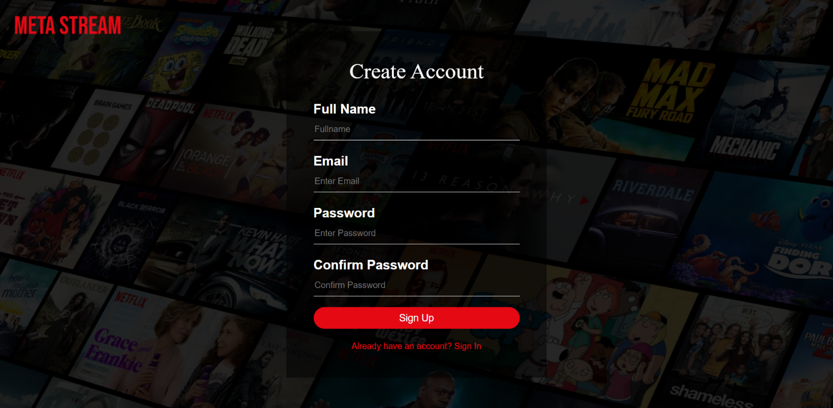

**6.3. Signup Form after Inputs**

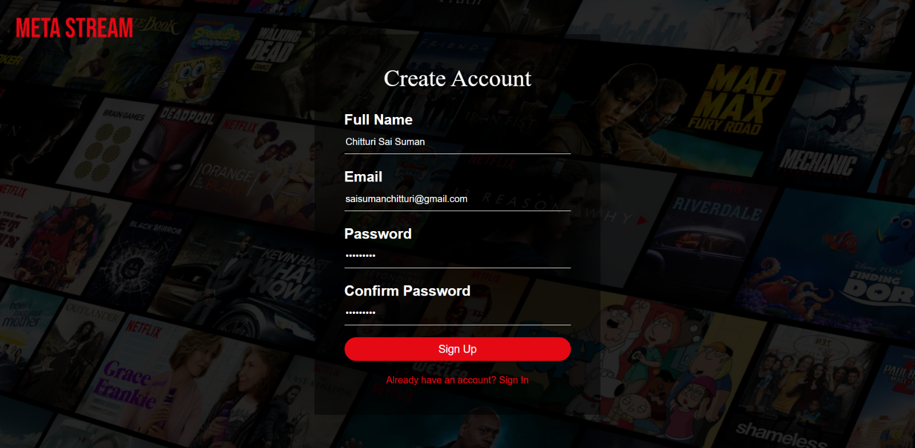

**6.4. Verify Account**

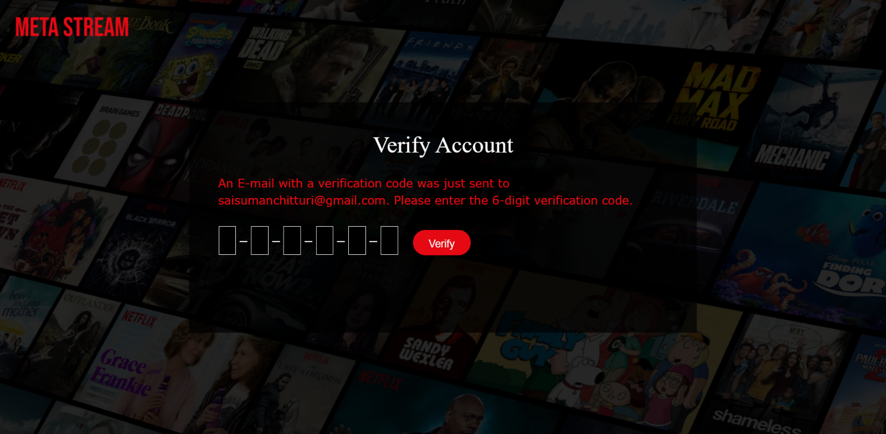

**6.5. Verify Account page with inputs**

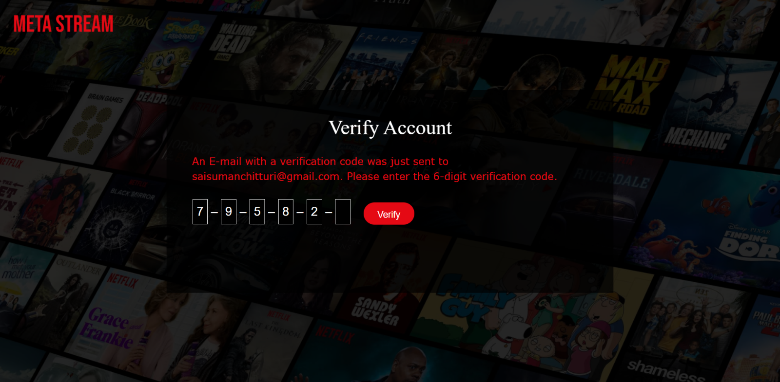

**6.6.1. Login Form**

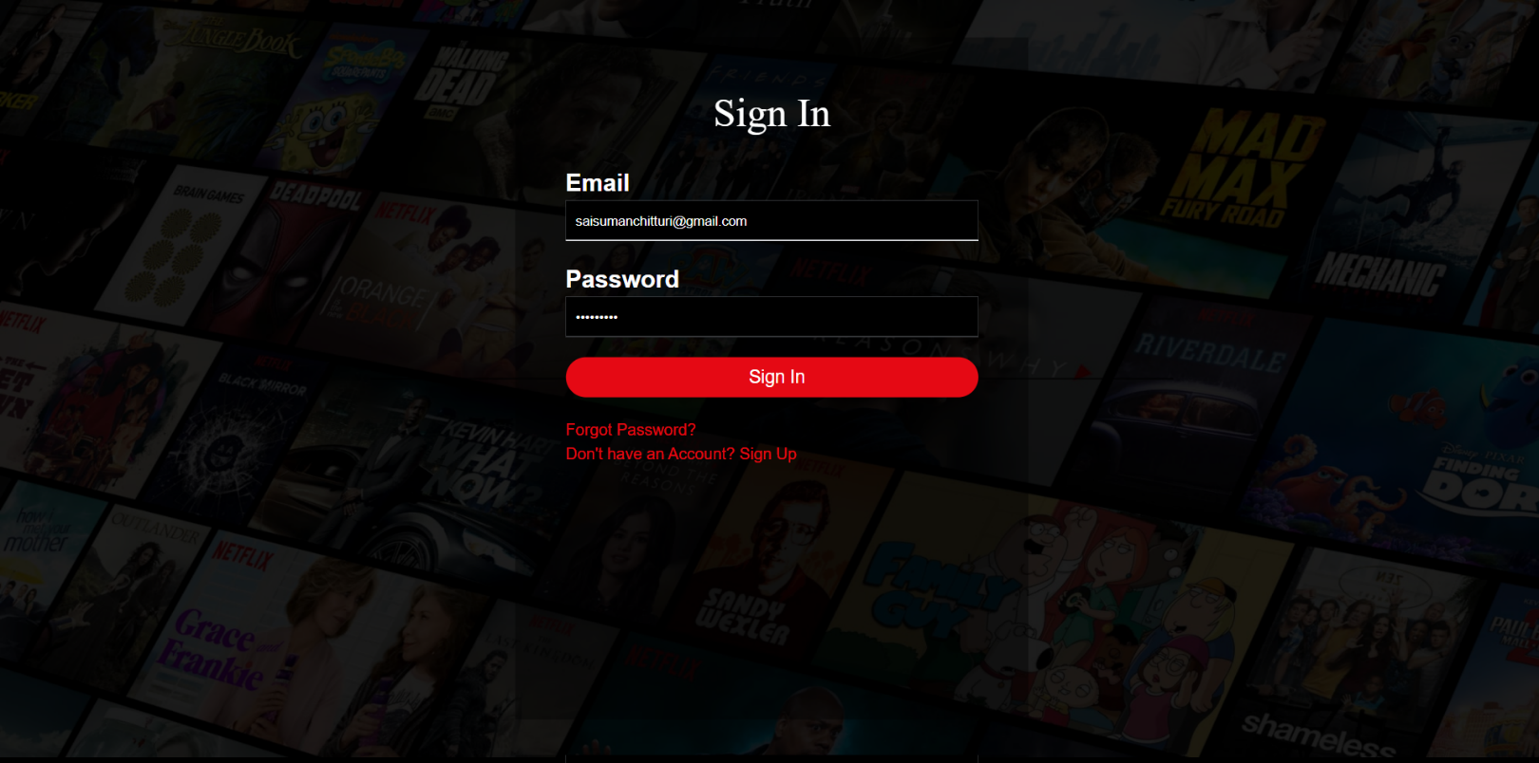

**6.6.2. Login Form**

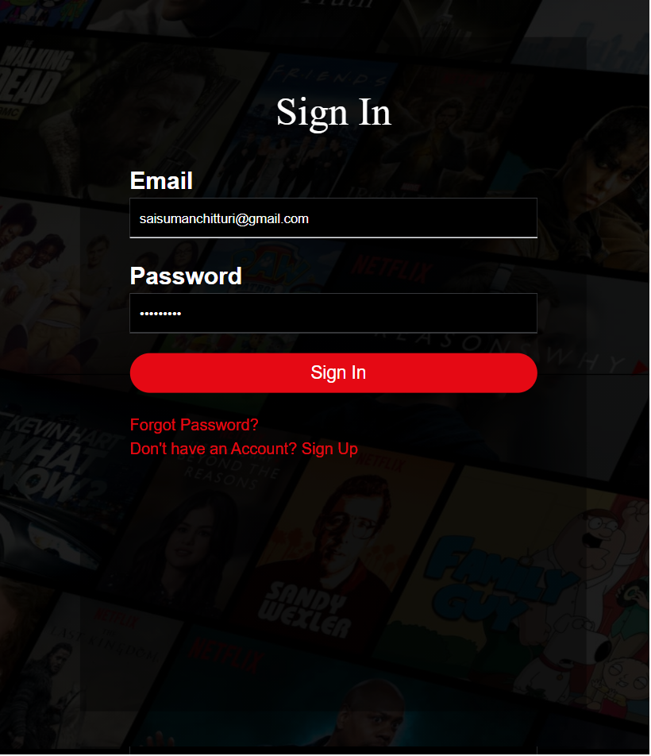

**6.7. Home page after Login**



**6.8. Home page when Explored**

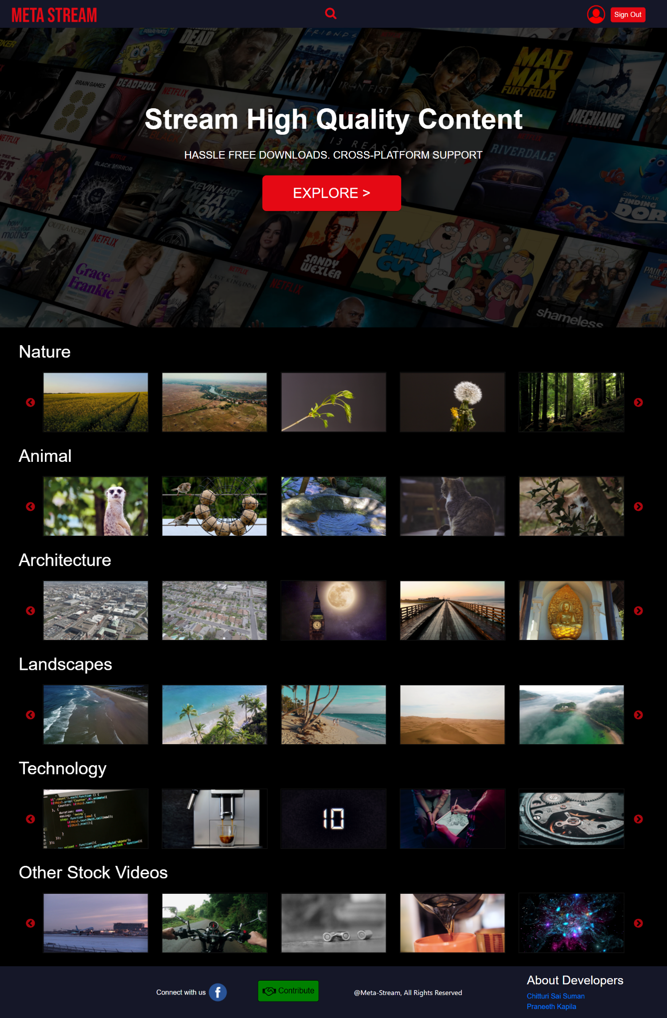

**6.9. Video Playback page**

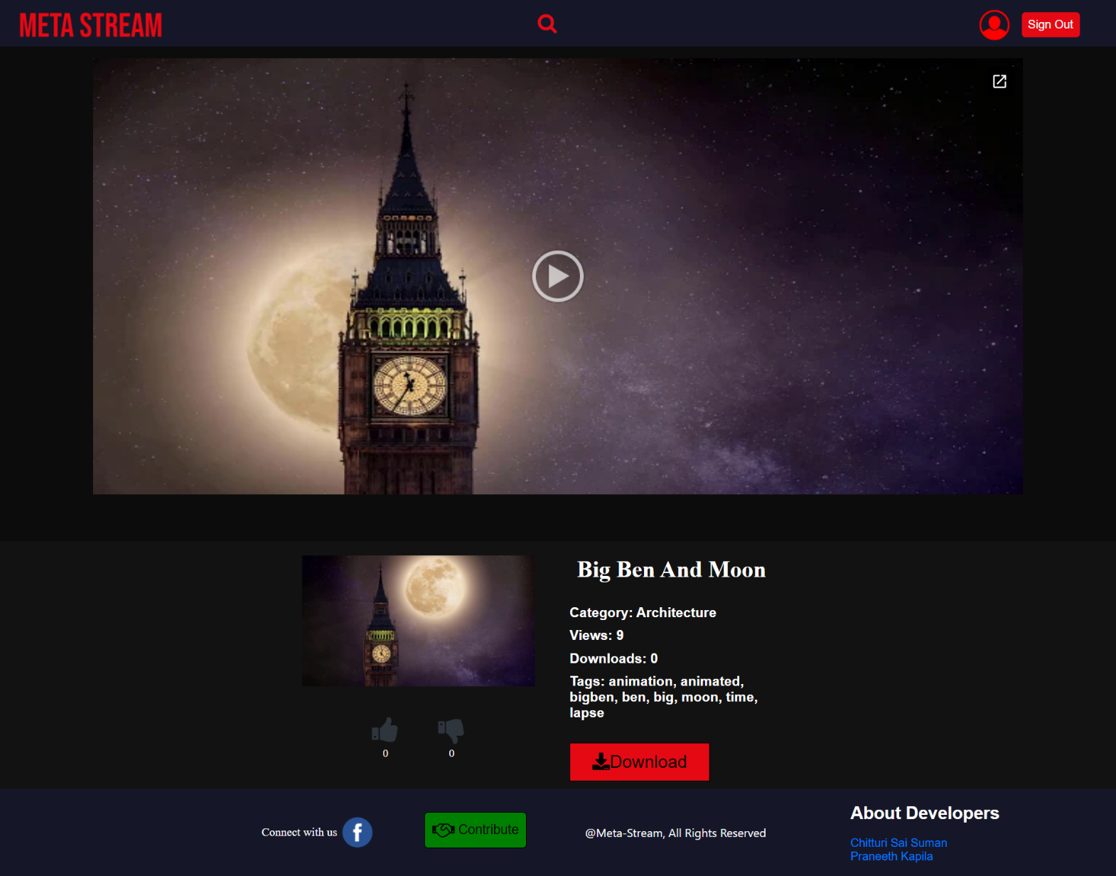

**6.10. Video Playback page after Like Operation**

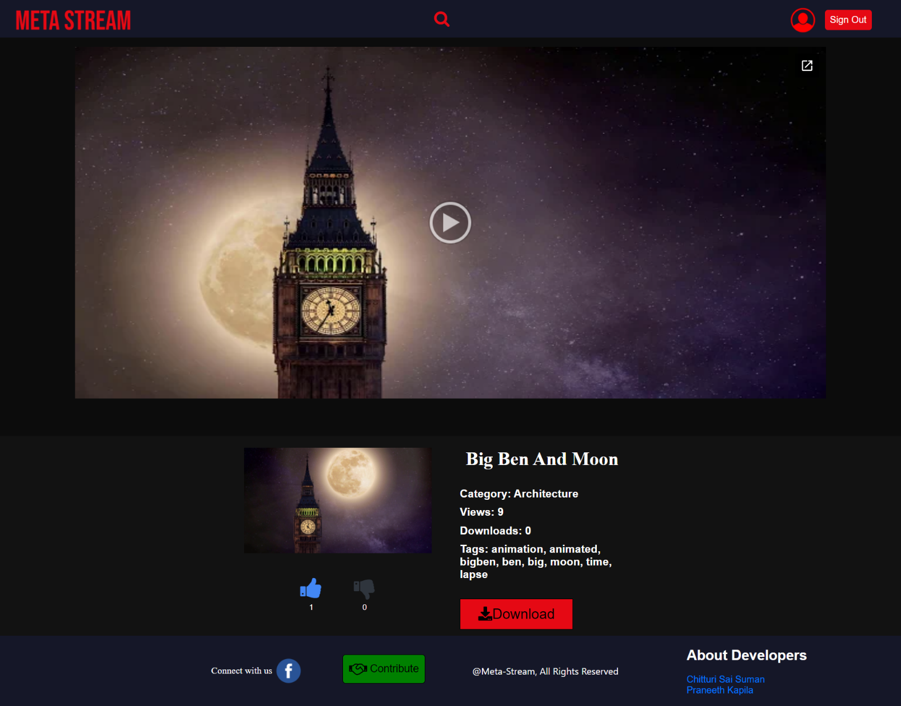

**6.11. Video Playback page after Dislike Operation**

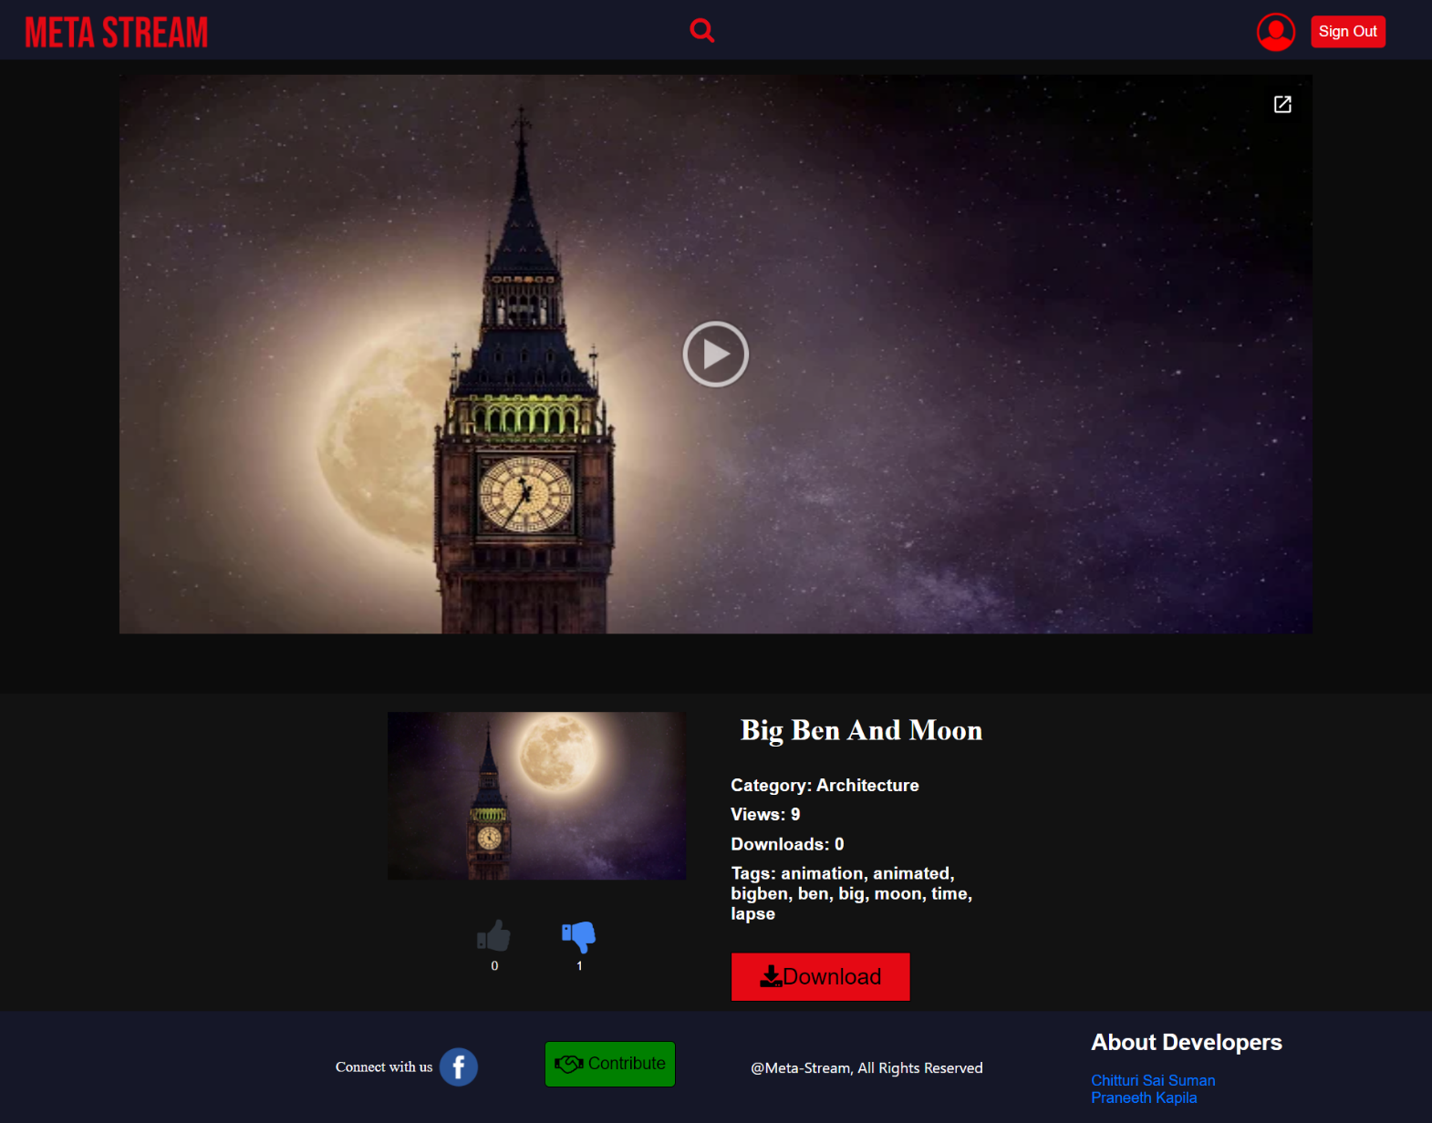

**6.12.1. Home page with Search Bar Active (Full Page)**

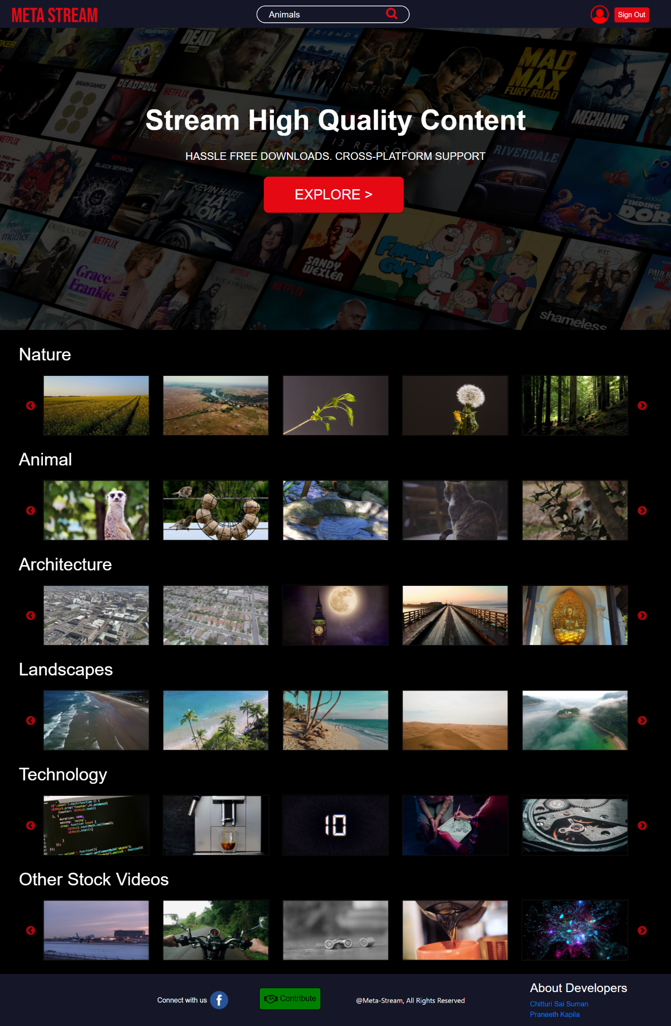

**6.12.2. Home Page with Search Bar Active (Half Page)**



**6.13.1. Search Results Page with Results**

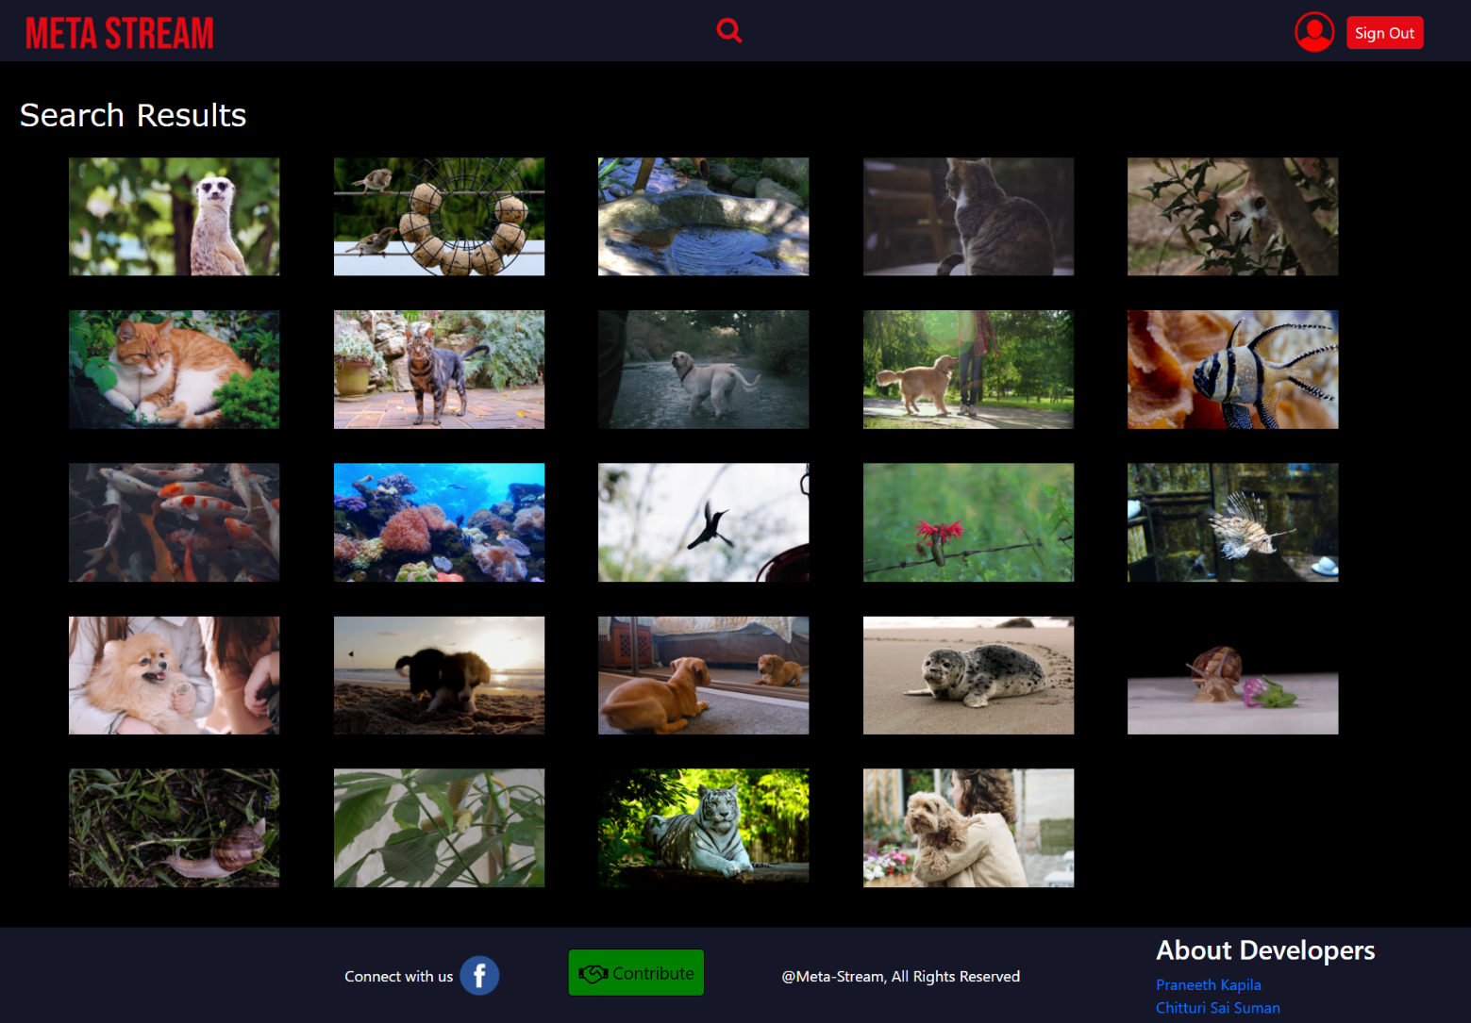

**6.13.2 Search Results page with 0 Results**

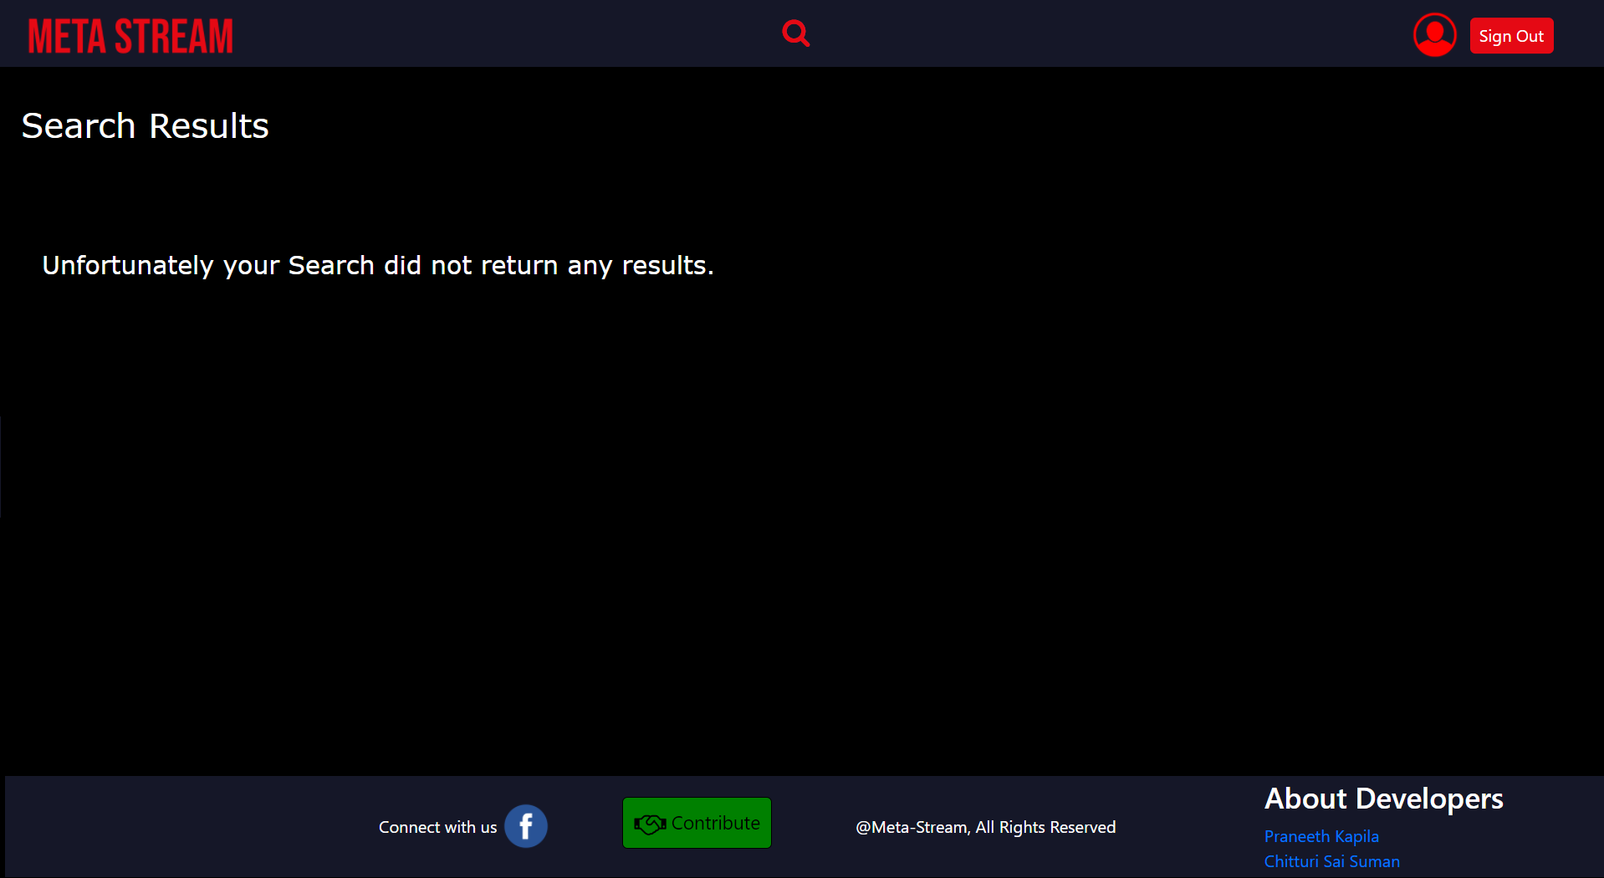

**6.14. My Account Dashboard**

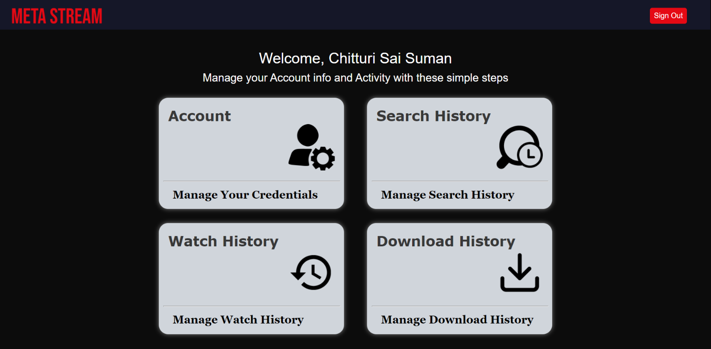

**6.15. Manage Credentials – Change Username**

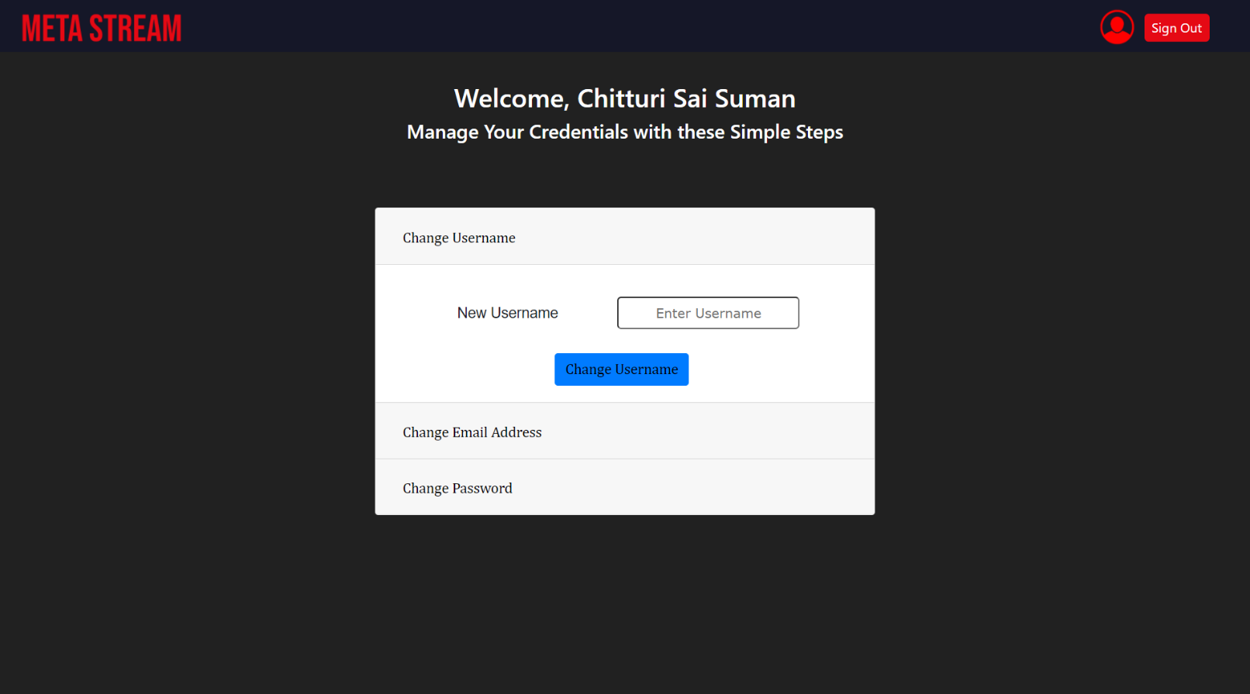

**6.16. Manage Credentials – Change Email**

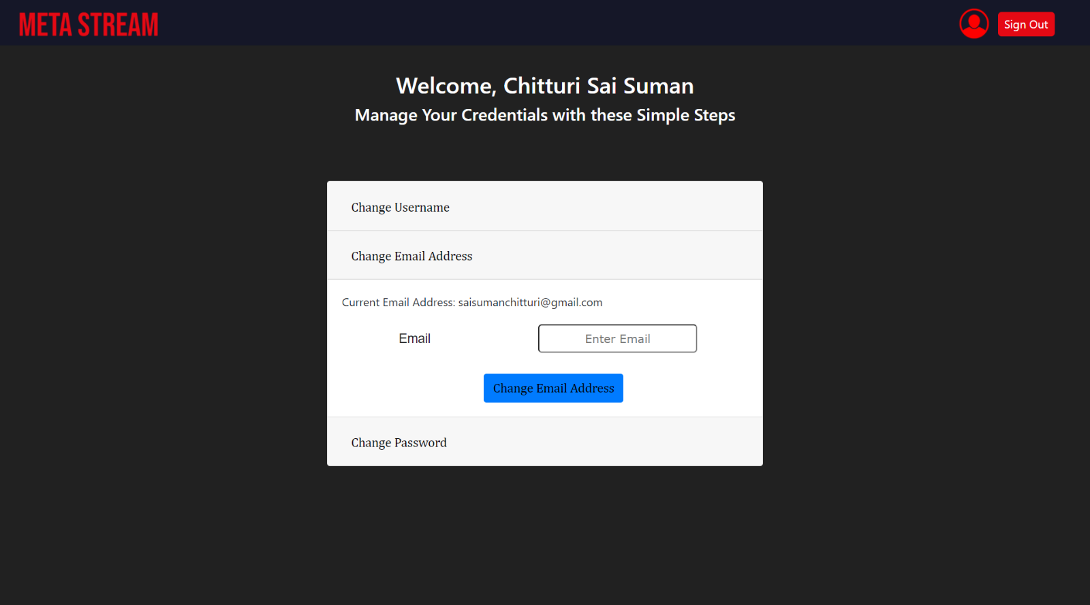

**6.17. Manage Credentials – Change Password**

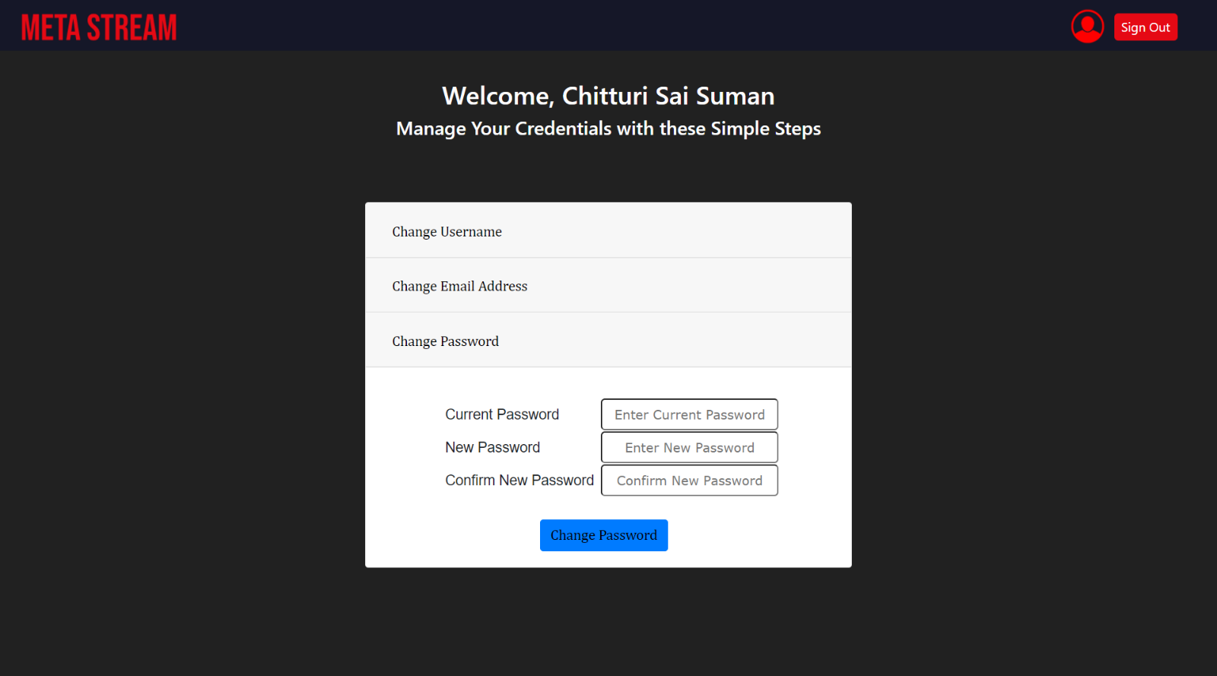

**6.18. Manage Search History**

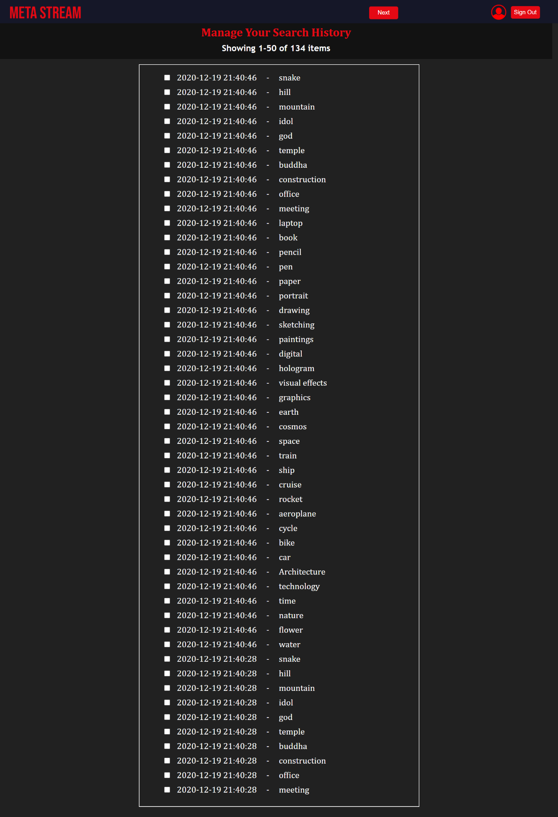

**6.19. Manage Search History – Case 2**

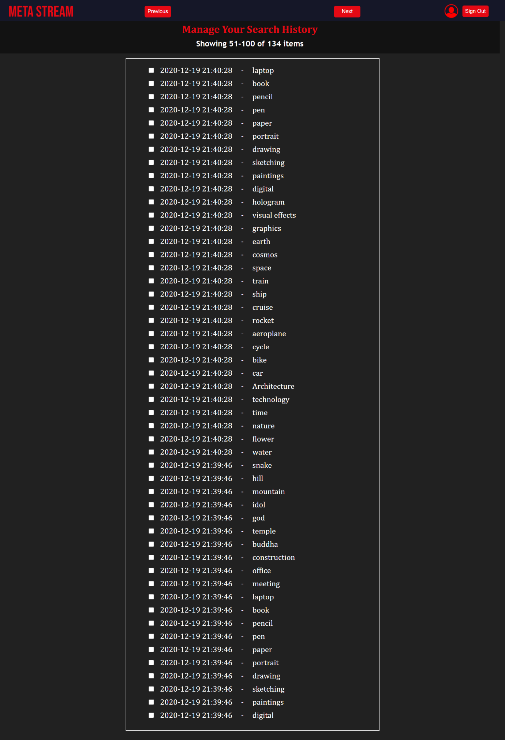

**6.20. Search History – Case 3**

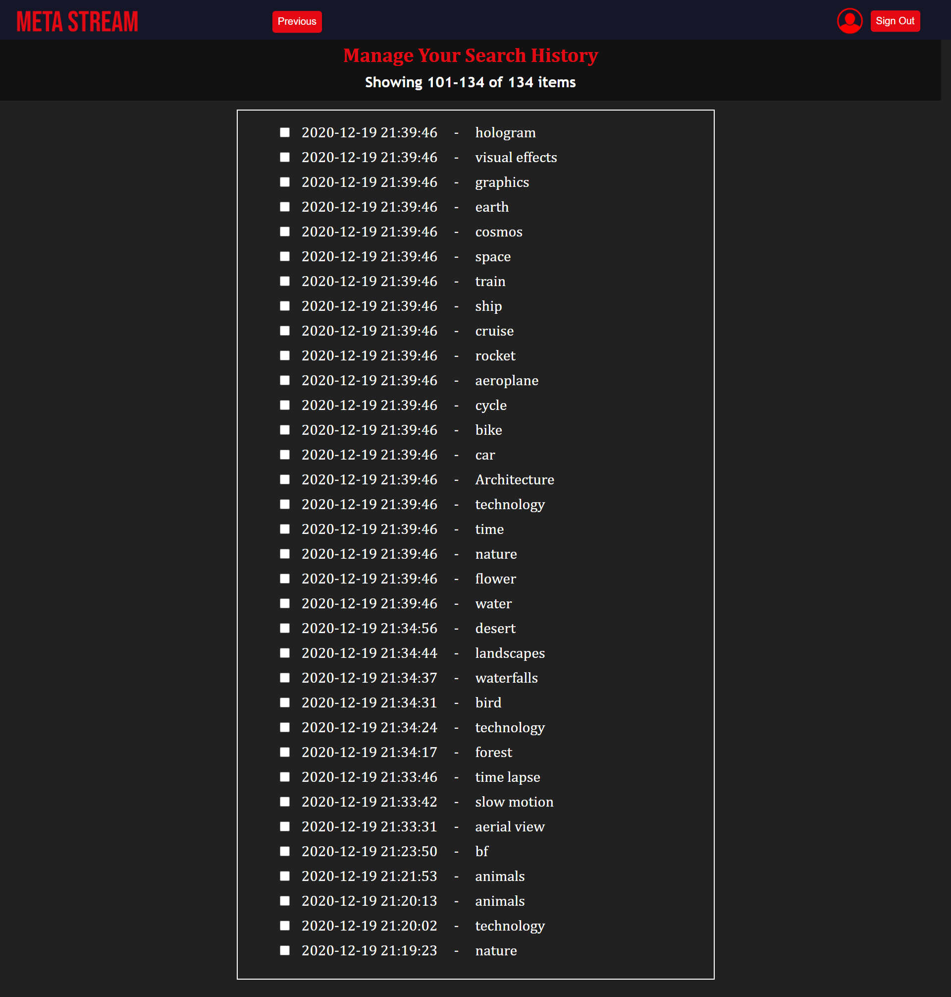

**6.21. Search History – Case 4**

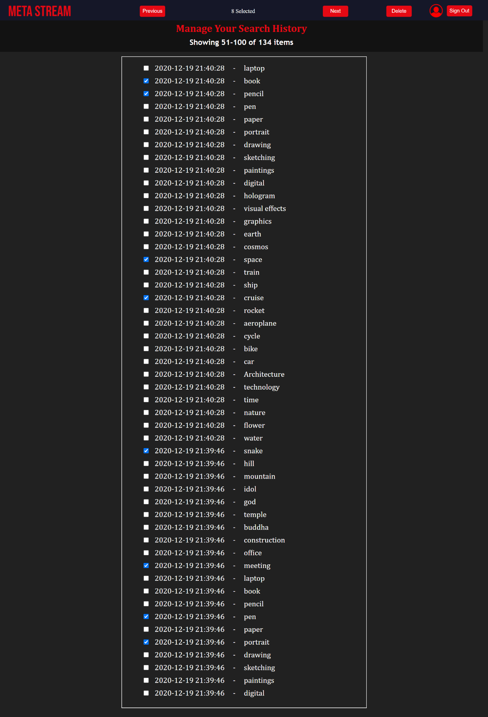

**6.22. Search History – Case 5**

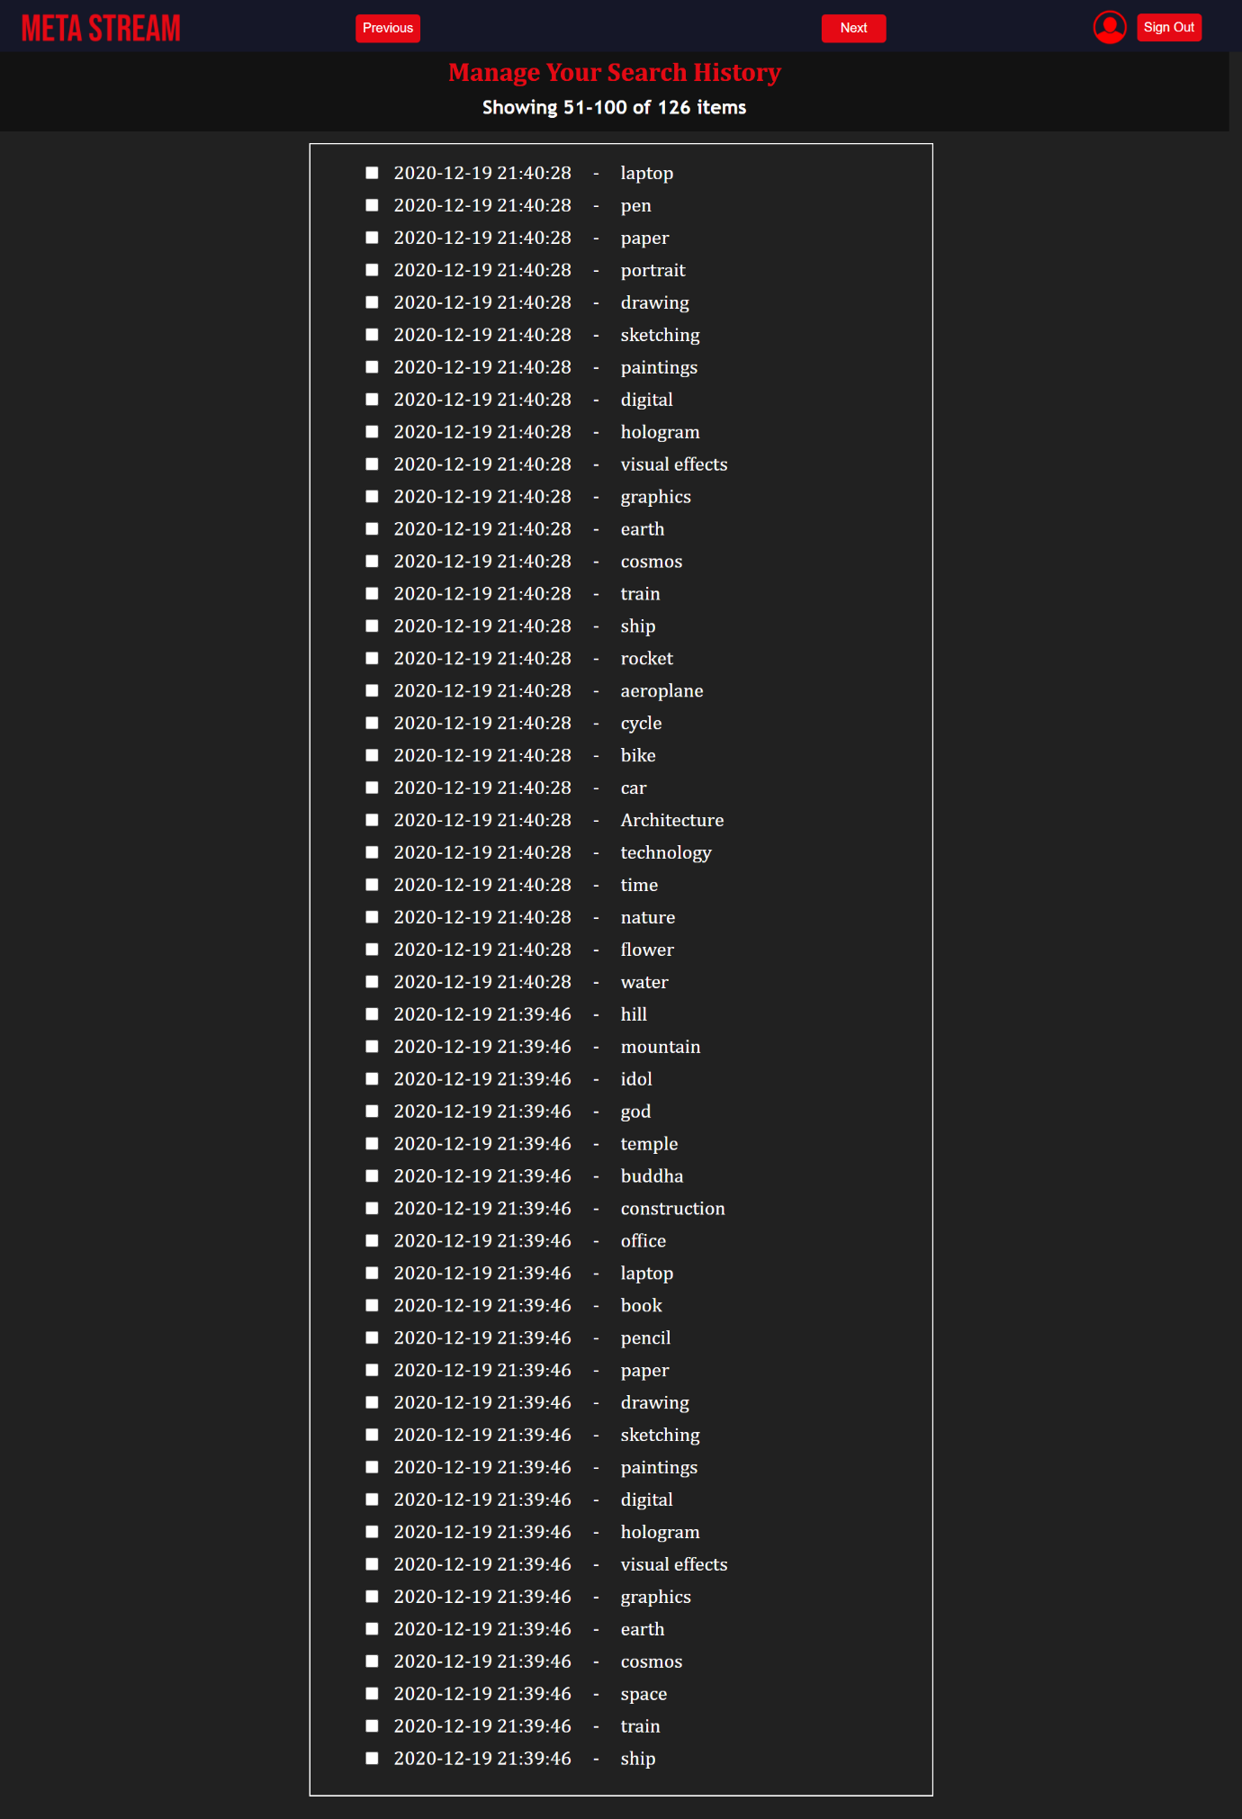

**6.23. Search History – Case 6**

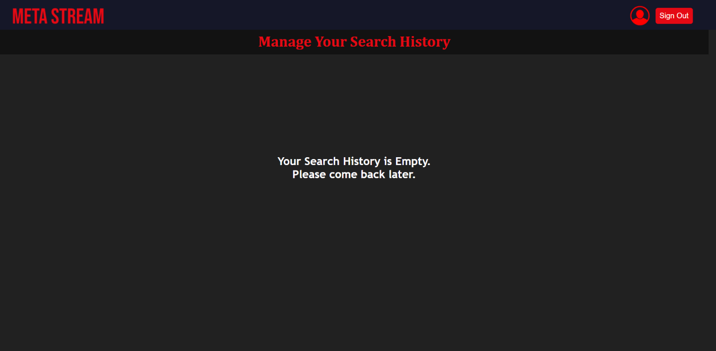

**6.24. Watch History**

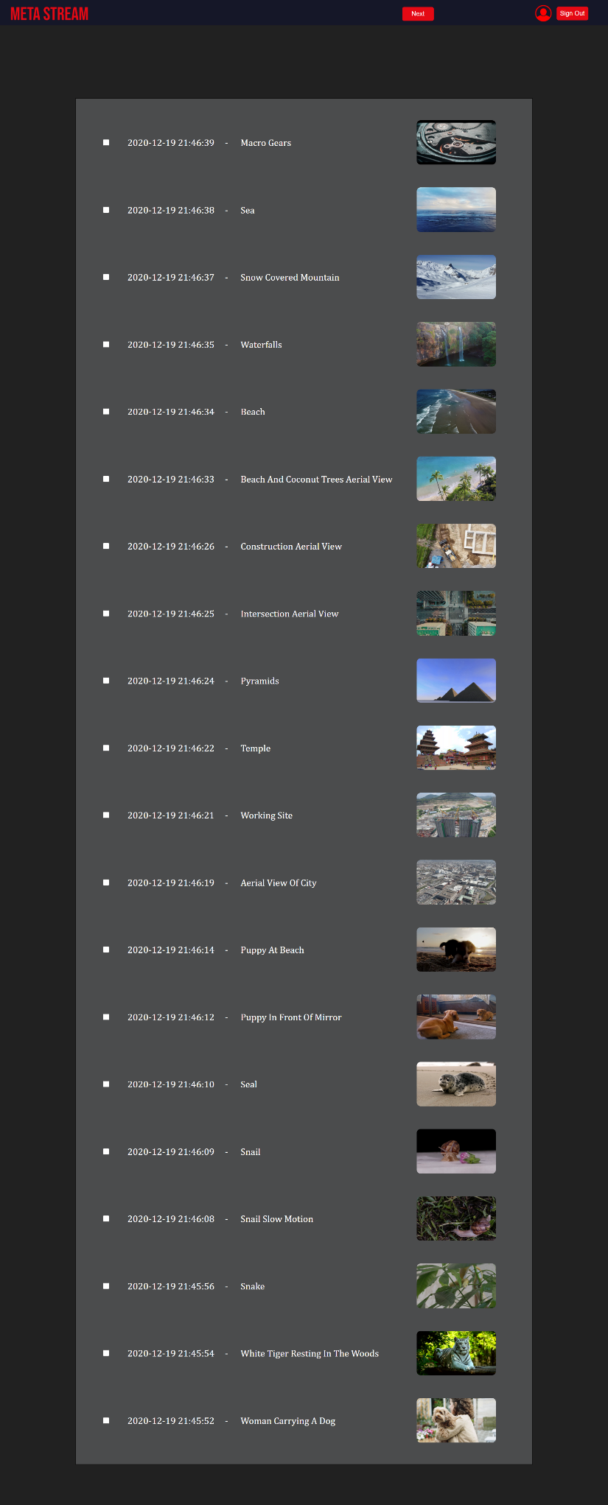

**6.25. Watch History – Case 2**

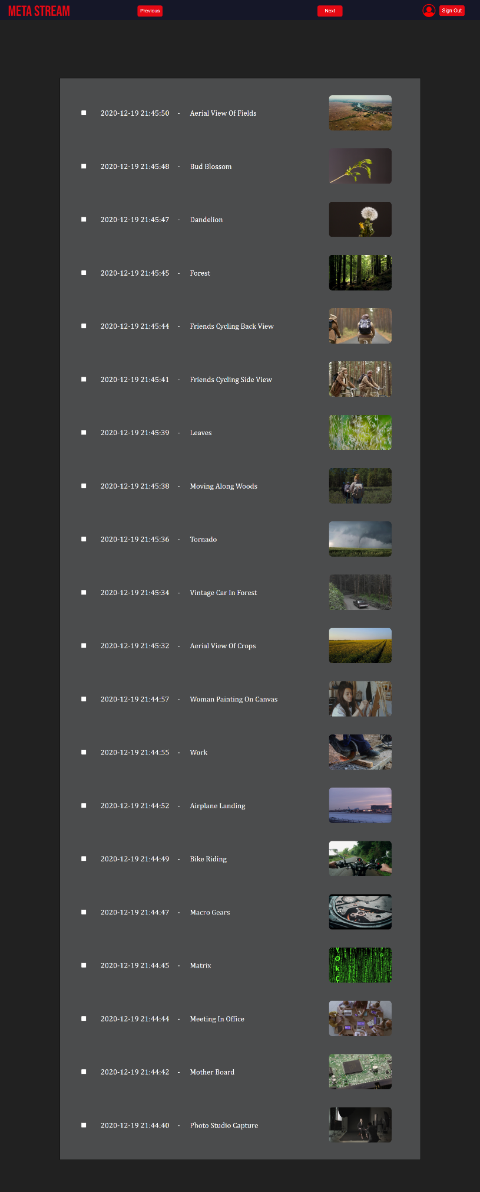

**6.26. Watch History – Case 3**

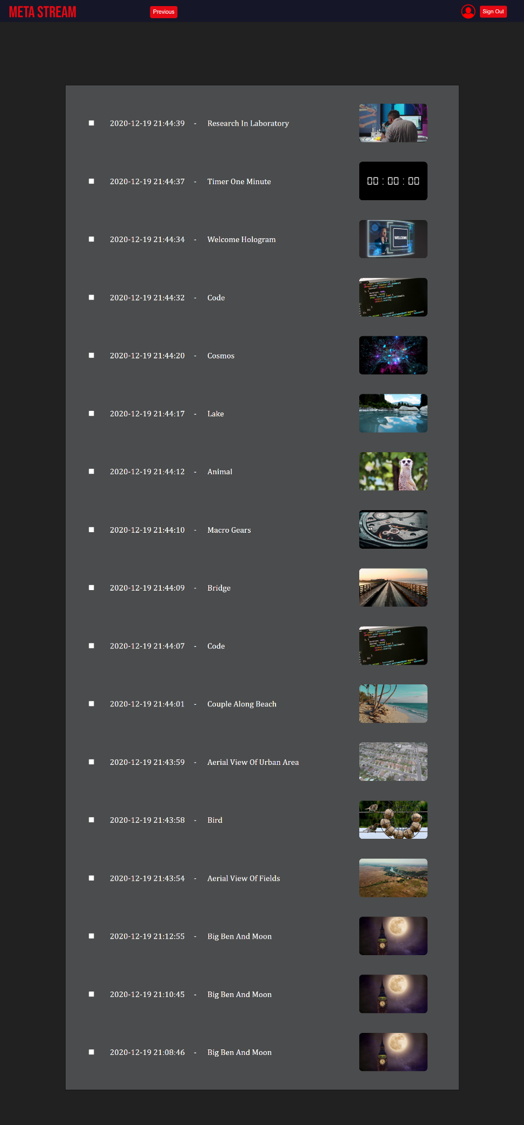

**6.27. Manage Watch History – Case 4**

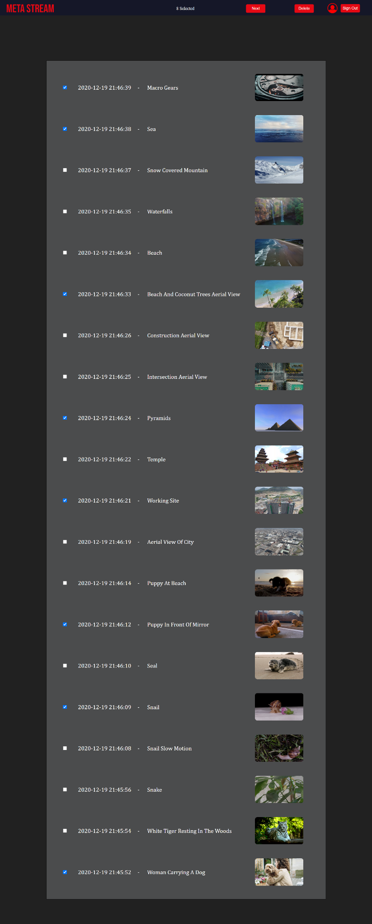

**6.28. Manage Watch History – Case 5**

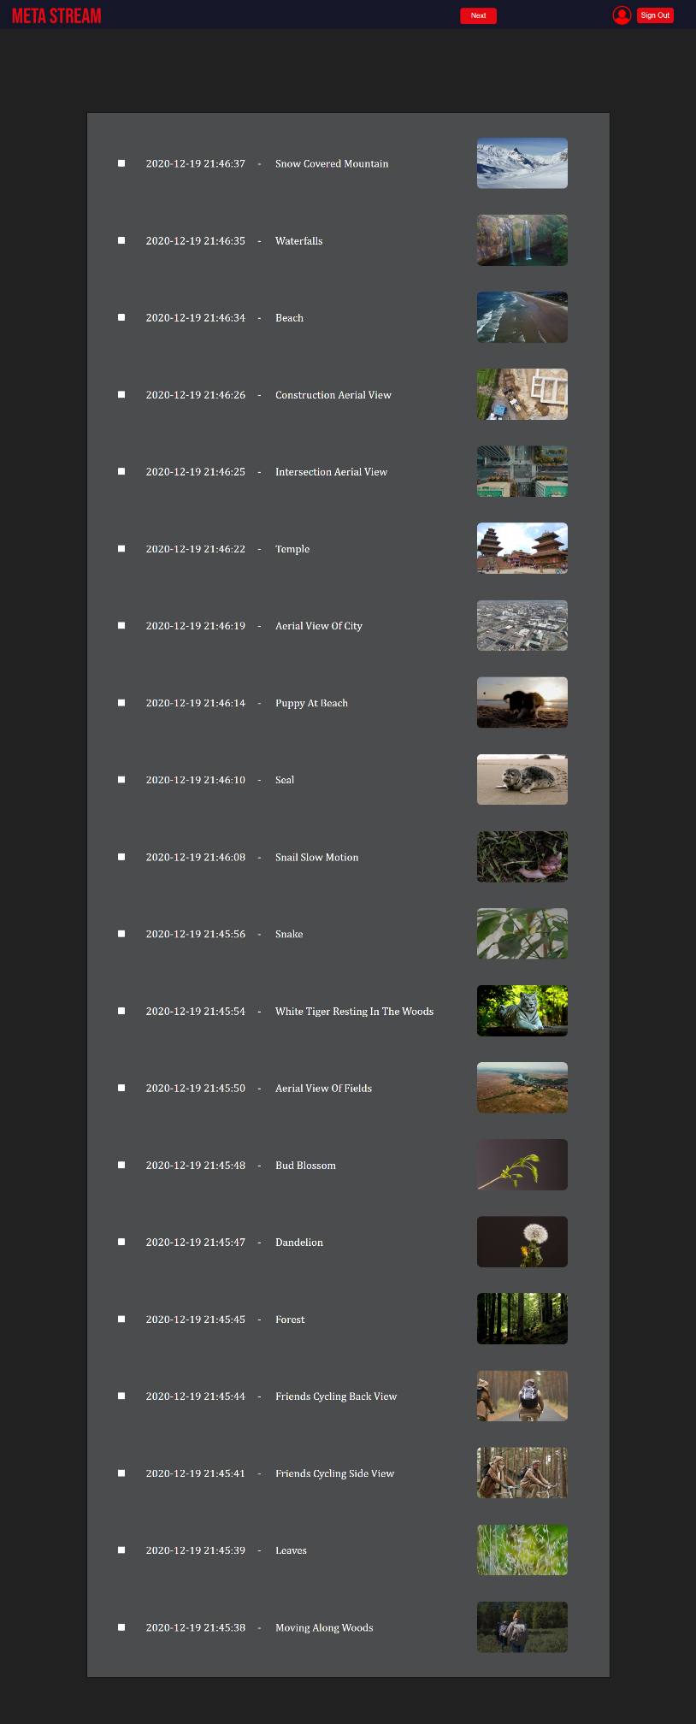

**6.29. Manage Download History**

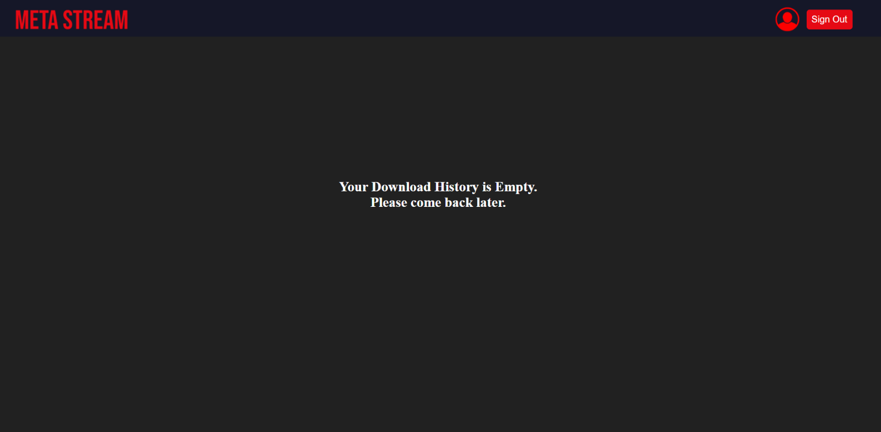

**6.30. Home Page (after log out).**



**7. Conclusion and Future Work**

**7.1. Conclusion**

The project **“Meta Stream”** has been developed as per the requirement specification. The complete functionality has been thoroughly tested, to eliminate bugs and enhance the user experience.

The design, implementation and the output reports are presented in this project report. The entire project was meticulously designed to ensure seamless user experience and easier incorporation of future modules.

**7.2. Future Work**

The goals of this project were purposely kept within what was believed to be attainable within the allotted timeline and resources. As such, many improvements can be made upon this initial design. That being said, it is felt that the design could be replicated to a much larger scale. The following are the features we wish to add in the future:

* Incorporate ML to understand usage patterns of users and improve the recommendation algorithm
* Introduce paid subscriptions which include access to exclusive content from leading content creators.
* Improve the overall security of the platform, making it less vulnerable to data breaches.

**8. References**

[1]. <https://stackoverflow.com>

[2]. <https://www.w3schools.com>

[3]. <https://codepen.io>

[4]. <https://www.geeksforgeeks.org>

[5]. <https://www.freecodecamp.org>

[6]. <https://www.tutorialspoint.com>

[7]. <https://www.javatpoint.com>

[8]. <https://www.coursera.org>

[9]. <https://www.udemy.com>

[10]. <https://stackexchange.com>

[11]. <https://developers.google.com/drive>

[12]. <https://devdocs.io>

[13]. <https://developer.mozilla.org/en-US/docs/Web>

[14]. <https://tympanus.net/codrops/css_reference>

[15]. <https://www.codecademy.com>